LEZ Online Consultation Summary Report

Aberdeen Low Emission Zone Public and Stakeholder Consultation

1 Introduction

Public and stakeholder engagement on options for Aberdeen’s Low Emission Zone (LEZ) took place during September and October 2020. This took the form of:
- an online survey available between 14th September and 25th October hosted by Aberdeen City Council’s preferred consultation platform Citizens Space; and
- a series of stakeholder workshops co-ordinated by SYSTRA, the consultant appointed by the Council for LEZ appraisal and traffic modelling support.
Consultation responses were also accepted via email to the Council’s Transport Strategy address.

This report summarises the responses received to the online survey and via email. 506 responses were received via Citizens Space and 12 via email or letter.

A summary of the outcomes of the stakeholder workshops is provided in a separate report.

2 Citizens Space Questionnaire

2.1 Respondents

Of the 506 responses received, 488 (96.5%) were from individuals, 18 (3.6%) were from businesses.

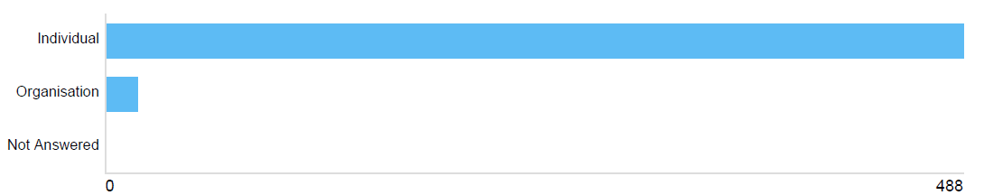
Figure 1: Nature of respondents

Those organisations responding to the online questionnaire were:
- First Aberdeen Limited
- Stagecoach Bluebird
- Blacks of Brechin
- Royal Mail Group
- Road Haulage Association
- The Shore Porters Society
- Leiths (Scotland) Ltd
- Scottish Enterprise
- City Gate Aberdeen Ltd.
- HEAT (no further information provided)
- Friends of the Earth Scotland
- Asthma UK and British Lung Foundation Partnership
- British Heart Foundation Scotland
- Electric Vehicle Association Scotland
- Low Carbon Vehicle Partnership
- Rosemount and Mile End Community Council
- Cults, Bieldside and Milltimber Community Council
- Paths for All.

2.2 Demographic Information (Individual Respondents)

Age

All adult age groups were reasonably well represented in the responses, with perhaps a slight under-representation of the under-24 and significant under-representation of the under 16 age groups.

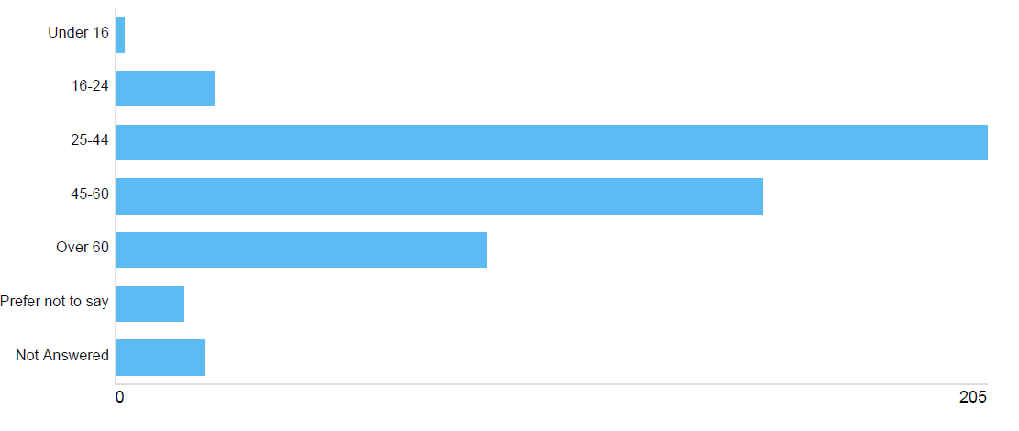
Figure 2: Age of respondents
Gender

More males (60.1% of respondents) than females (31.4%) responded to the questionnaire, with 8.5% of respondents choosing not to answer the question.

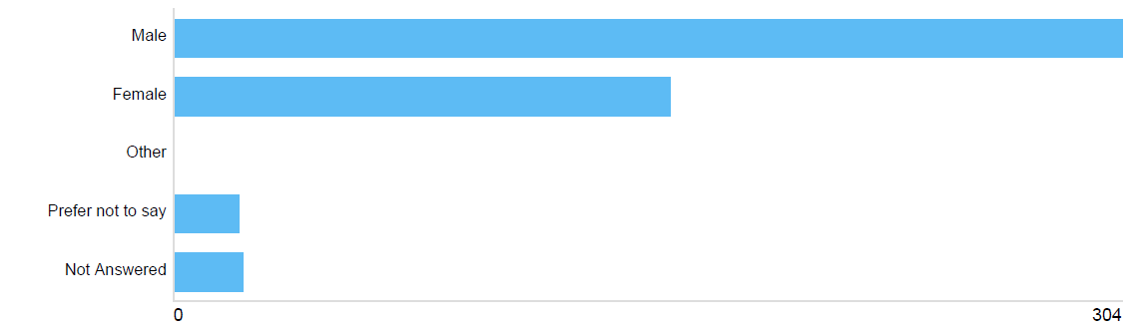
Figure 3: Gender of respondents
Disability

7.5% of respondents stated that they have a disability affecting their travel arrangements, while 80.8% did not, with 11.7% of respondents choosing not to answer the question.

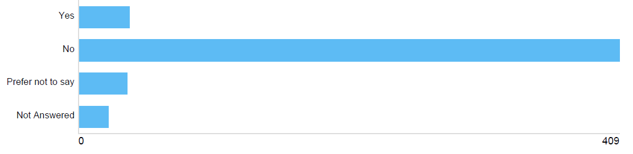
Figure 4: Do respondents have a disability

When travelling to, from and within Aberdeen city, what modes of transport do you typically use?

Respondents were asked to select all forms of transport relevant to them.

The majority of respondents (77.9%) were regular car drivers in the city centre, with 46.4% walking in the city centre, and 32.8% using the bus to access the city centre. Smaller proportions were noted for cycling (20.8%), the train (12.5%), taxi (9.1%), motorcycle (5.9%) and van (3.4%). Users of all main modes of transport in the city centre are therefore represented in the survey results.

Other options given by respondents were: heavy goods vehicle, motorhome, historic vehicle, ferry, and Motability scooter.

Postcodes

Postcode data was requested to understand the locations of respondents. Unsurprisingly, given the local nature of the proposals, the vast majority of respondents were located in Aberdeen City and Aberdeenshire. Responses were also received however from the following postcode areas: Dundee, Edinburgh, Elgin, Glasgow, Livingstone, Luton, Perthshire, Shetland and Southampton.

2.3 Awareness of Air Quality Problems

Before starting this survey, were you aware of the air quality problems in Aberdeen city centre?

Awareness of issues of poor air quality in Aberdeen was good with the majority of respondents (71.2%) aware of Aberdeen’s air quality problems. 23.7% were not aware, while 4.9% were not sure.

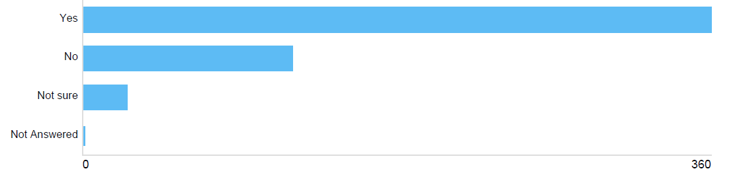
Figure 5: Awareness of air quality problems

2.4 Attitudes Towards Low Emission Zones

Generally, are you in favour of Low Emission Zones to tackle poor air quality?

Nearly half of the respondents (48.4%) were in favour of LEZs, with 40.9% not in favour and 10.3% unsure.
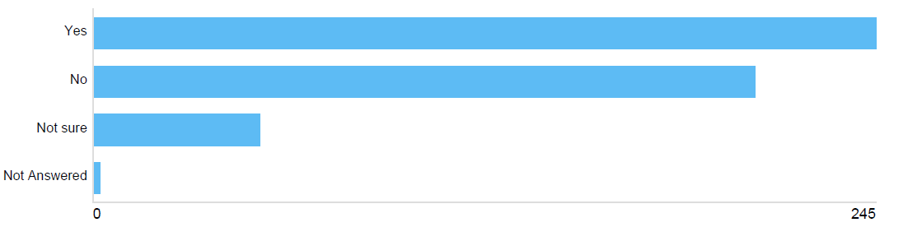
Figure 6: Support for LEZs

Respondents were invited to expand upon their answer to this question. Reflecting the fact that respondents were on the whole more positive than negative on the subject of LEZs, many comments were supportive of the introduction of a LEZ in Aberdeen.

Please note: Italicised sentences in the remainder of the report are comments received in response to open questions in the online questionnaire, in most cases replicated verbatim. They are used as examples to illustrate the main themes emerging in response to the survey questions. Comments from organisations may have been amended slightly to anonymise responses, although please note that responses from organisations have been individually extracted from Citizens Space to be considered fully in the context of affected stakeholder (where appropriate).

In terms of those in support of LEZs, main themes were:
- Recognition of the beneficial health impacts (Poor air quality is a significant contributory factor to respiratory and cardiovascular diseases. It is a modifiable risk factor therefore we can and should reduce pollution to improve public health);
- Recognition of the environmental benefits (Cars are killing the planet and us, no point arguing when the planets on fire);
- Appreciation that LEZs can contribute to improved quality places and quality of life (An LEZ in Aberdeen city centre will improve the experience of visitors to the city (shoppers, tourists, workers etc) but more importantly will improve the lives of those who live there);
- Appreciation that LEZs can improve the city centre (Low Emission Zones are a good way of encouraging…more welcoming spaces for people living, working and shopping in the city);
- Recognition that LEZs can have wider benefits in terms of encouraging more sustainable transport choices (The LEZ zone and associated reduction in vehicular traffic and pollution in the city centre will encourage more sustainable forms of travel through the city centre and across the city - walking, cycling, public transport and low carbon vehicles); and
- Evidence from elsewhere testifying to the success of LEZs (Having lived in Germany for many years, city centres controlled by LEZ were much more pleasant to visit and live. The LEZ compliments pedestrianised city streets well).

A number of respondents stated that a LEZ should form part of a package of measures to support more sustainable travel behaviour and reduce emissions:
- This is particularly important for those who live and work in the town centre but has to be part of a general move to encourage walking, cycling and public transport use in the city as a whole;
- While the idea seems lovely, it needs to be carried out in conjunction with making sure that public transportation provides a viable alternative;
- We note that LEZs may have a role to play in improving local air quality and prioritise vehicle replacements in areas where LEZs are enacted. We also believe there are a number of other ways to reduce transport emissions - such as through the development of electric vehicle charging infrastructure and trialling new low emission solutions such as hydrogen – which could be more effective.
Some felt that there are better ways to reduce emissions such as improving traffic flow through affected areas (Improving traffic flow through and round Aberdeen would have greater benefit without negatively impacting businesses in the centre) or traffic management interventions (You would be better off changing the road layouts so the city centre isn’t a through road), while others felt that proposals should go further (We should be reducing total emissions, not just moving them around; Union street and city centre should be fully pedestrianised).

In terms of those expressing concern about, or objections to, a LEZ, the main issues raised related to:
- The impacts on individuals, particularly the financial implications (It is also a significant issue for residents within these areas, why should they be forced to change their vehicle, likely at financial penalty to themselves), especially given that the impacts of the COVID-19 pandemic may be felt for some time (Unemployment in Aberdeen and Aberdeenshire is on the rise and people cannot afford to change their cars so they can drive in this LEZ);
- Concerns that the less affluent members of society will be disproportionately impacted (Typically these schemes negatively impact low income households most as they cannot afford to upgrade cars that are not compliant and are then either banished from town centres or have to pay significant sums to enter the town centre);
- Concerns about the impacts on the disabled if not granted exemption from the LEZ (I am registered disabled & on benefit. My car is a 2012 diesel. How would you propose me to get around otherwise?!);
- Concerns about the impacts of proposals on the future health and prosperity of the city centre (Now is not the best time to implement this. The city centre is dying on its feet as a result of internet shopping and now covid. It’s dying and this will be the final blow. Remember, people visit the town as a day out, as everything can be bought cheaper and more conveniently on the internet) and local businesses (Concerned about economic effect on small medium businesses in city centre);
- Concern that the LEZ could simply move traffic, and resulting congestion and emissions, elsewhere (Drivers will simply avoid the LEZ by going around the peripheral and greatly intensify the traffic in these areas while at the same time simply shift the problem onto these areas);
- Concern about the current scope of the LEZ, whether it was correct to address all vehicle types (Its mostly buses and lorries that cause the pollution. Pollution reducing efforts should be focused on them), whether the emissions standards being proposed are justified (We are in favour of Low Emission Zones; however, enforcement based on emissions standards and ANPRs is not a valid or fair method since real-world driving emissions are much higher than laboratory tests indicate), and whether the impacts of the harbour should be considered (Not really seeing the point of targeting road vehicles in a city which has the busiest harbour in the UK from which goodness knows how many diesel powered ships enter and exit the harbour area near the town centre);
- Concern that decisions are being made on outdated evidence, questioning whether the impacts of the Aberdeen Western Peripheral Route (Since adoption of the WPR the emissions have drastically reduced in the city centre. There needs to be a re-evaluation of the data as it is currently not historical data) and COVID (Costs involved may not be appropriate now with reduction in traffic post covid 19) have been adequately considered;
- A perception that this is simply a revenue-generating scheme (Its just a money making scheme); and
- Scepticism that the problem in Aberdeen is such that these measures are required (Where there is a public health concern I think Low Emission Zones should be considered. I am not convinced however that the levels faced in Aberdeen warrant a Low Emission Zone).

Given that air quality in Aberdeen city centre exceeds national objectives and EU limit values in a number of areas and the main source of this is road traffic, do you agree that a Low Emission Zone is an appropriate response to this?

29.5% of respondents strongly agreed with a LEZ as a response to air quality issues in Aberdeen, while a further 14.4% agreed. 26.3% strongly disagreed and 16.4% disagreed. 12.7% of respondents were unsure.

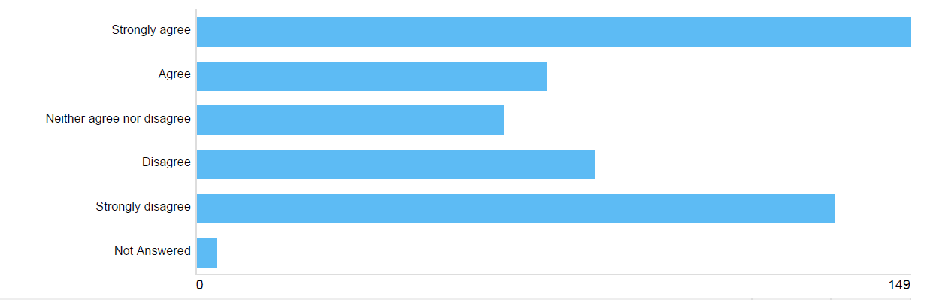
Figure 7: Support for Aberdeen LEZ

Combining responses, there is a near even split between the proportion of respondents supportive (43.9%) and not supportive (42.6%) of a LEZ in Aberdeen. Respondents were invited to expand upon their answer to this question.

In terms of responses supportive of a LEZ, comments were along similar themes to those received for the previous question, in terms of the health and environmental benefits of LEZs (I feel that given the urgency of the climate emergency and also with COVID exposing the impacts of underlying health conditions, we need to clean up our act and the local scale is the most tangible and perhaps one of the most effective ways to do this. Clean air is a human right!). Some respondents felt that a response to this issue is long overdue (A LEZ is not just necessary; it is long overdue) and / or that LEZ proposals don’t go far enough (This should not only be applied to the city centre, but also to other areas of the city where air pollution is high).

Some responses suggest that a LEZ is part of the solution but not the whole solution and must be combined with other measures to encourage behaviour change (I believe it is an appropriate response just now but longer term would like to see removal of traffic in general from the city centre area and more priority given to buses, cyclists and pedestrians; LEZ are a step in the right direction. However, it barely scratches the surface in terms of a sustainable, long term approach) or to reduce overall traffic (Low emission zones are a good response but more should be down to reduce all traffic more generally).
Similar to the responses to the previous question many feel that there are other measures that should be put in place prior to or instead of a LEZ such as measures to reduce congestion and improve traffic flow (A more appropriate response is to remove the congestion in the centre by getting better traffic flow), and improving active travel (encouraging people to use alternative transport is also vital. Cycle lanes in Aberdeen are terrible, often impossible to cycle in due to potholes and sunken manhole/drain covers) and public transport (Possibly explore making public transport more affordable, with more regular and accurate times) opportunities.

Again, concern was raised about the impact of a LEZ on the city centre and businesses (We have an issue with retail in our high streets suffering. Restricting traffic in the city centre will speed up the demise of shops in this area) and individuals (This is just a way to make money at the citizens expense. Stopping people moving around the city freely), particularly the disabled (As a disabled pensioner who relies on my car to reach shopping in town with an older car it would appear if I move from my home in the Bridge of Don I will have to pay. You are effectively making me a prisoner and cutting me off from visiting any of the shopping centres) and the less affluent (People on lower incomes may not be able to afford compliant cars and therefore cannot access the city?).

Comments were received on the scope of the LEZ with some respondents believing that all vehicles should be addressed (All should be tackled, not just cars; Busses and lorries mostly cause the pollution. Personal cars should be exempt), while others singled out particular vehicle types for attention (Ban buses and heavy goods vehicles from the city centre and surrounding areas).

Similar to the previous questions, concerns were also raised about:
- the potential for a LEZ to simply force traffic and emissions elsewhere (If you turn the city centre into a LEZ, you will only be diverting high emission vehicles elsewhere possible into residential areas);
- the timing of LEZs given the disruption resulting from the COVID-19 pandemic (Too much going on with Covid etc and traffic reduced due to the new system in town);
- the data being used, in particular whether this is reflective of the opening of the AWPR in 2019 (Data taken was from before opening of the AWPR) and any recent changes resulting from the pandemic (a survey from 2019 on levels of pollution bears no relation to the actual traffic pollution levels during 2020 given the lack of traffic since March and the town centre basically shut off to all traffic for the foreseeable future);
- the extent of the actual problem in Aberdeen with some scepticism evident (As mentioned above, I think that the figures are hard to believe, as my experience of Aberdeen City centre, compared to other major cities has cleaner air) and a feeling that things will improve naturally over time (Emissions will reduce in time by people replacing their vehicles without the need for another layer of bureaucratic restrictions).

2.5 Views on the LEZ options

Option 1A - Advantages

Respondents were first asked what they believed were the advantages of this option.

One of the main advantages identified was that this option would lead to reduced emissions and improved air quality (This reduces the pollution risk in the areas where large numbers of people will be walking). Respondents also identified knock-on effects such as reduced traffic volumes, less noise, safer streets, and consequently a more welcoming urban realm (This area could be far more pleasant to live, visit and spend time in if this LEZ was implemented) that could encourage more usage of the city centre.

In terms of the scope of the zone, respondents welcomed the fact that the majority of areas of air quality exceedance are captured by this option (it covers the most polluted area), but that accessibility to main destinations such as the main car parks, harbour and ferry terminal are not significantly impacted (Additionally access to shopping centres like union square still possible by family who need to take the car and have an older car; Cohesive central area and allows lorry traffic from and to the Harbour to use market St, Virginia St and King St without hindrance).

The fact that this is the smallest area under consideration was seen as an advantage by some, in terms of being the easiest and possibly cheapest option to implement. Respondents noted that this option would have the least impact on local businesses (Least damage to city) and the travelling public (It's a small zone which would not impact as many people; Minimal impact to traffic transiting through the city to get from point A to point B).

A number of people noted that the area was logical and well-defined and should enable non-compliant drivers to re-route around the area with minimal disruption (Small area, easy to navigate around the LEZ if your vehicle is not compliant). Others noted that starting with a smaller boundary could be a stepping stone to the LEZ expanding over time (First step towards larger roll out).

A significant volume of respondents stated that they saw no advantages of this option, either because they were against the concept of a LEZ itself (Aberdeen does not need a low emission zone) or they felt that the scope of the option was too limited to make much of a difference (Seems pointless if it’s so small). Again, concerns were raised about the LEZ pushing the problem elsewhere (It will cause major congestion elsewhere, leading to red zones appearing elsewhere in the city, so in effect achieving nothing but stress and inconvenience to commuters, shoppers etc.).

Option 1A – Disadvantages

Many respondents saw no disadvantages with this option.

Conversely, many felt that there were no advantages, either because they were opposed to the concept of a LEZ anyway, or felt that this option is too limited in scope in that it doesn’t encompass all problem areas (it doesn't include Market St from Guild St to Victoria Bridge which is heavily polluted) so will have minimal impact (Too small an area to make a difference).

A number of comments were received on the subject of the economy, particularly concerns that a LEZ would discourage people from visiting the city centre, further contributing to its decline (City centre trading is already struggling to survive. Anything that reduces the people coming into town would only exacerbate the problem) and negatively impacting on local businesses (The businesses in the centre would suffer with a lack of footfall). Some respondents also thought that restrictions would also drive people away from living in the city centre (Residents will move out of penalty zones).

Again, many comments were received that such restrictions would simply drive traffic and emissions elsewhere (Potentially circuitous routes will end up being used to avoid the zone and may shift the pollution risk to other areas which are more residential / include school areas), potentially increasing congestion in other areas and perhaps even increasing total emissions overall (It would create more emissions overall from slower longer journeys). Concerns were raised about specific areas/streets becoming ‘rat runs’, particularly residential areas and streets with schools on them.

Again, concerns were raised that it would be the most vulnerable members of society disadvantaged by proposals, particularly the disabled and those unable to afford a newer vehicle (It will prevent people being able to carry out their jobs if they own non compliant vehicles. It targets the less wealthy worker; So the roads will be available only for those who can afford brand new cars). Many were also concerned about residential streets being included (Dee place is a residential street which should not be cut off from the outside world) and / or took offence at the thought of having their movements restricted (Thought it was meant to be a free country). A number of specific areas were mentioned which people felt their accessibility to would be compromised, particularly car parks.

The inclusion of Denburn Road in the LEZ area was also considered a disadvantage by many given that it offers a potential opportunity to avoid the main city centre shopping area (The downside is that the inclusion of the Denburn Road creates an obstacle for drivers seeking to avoid entering an LEZ).
Option 1A - How do you think this option will impact on you either individually or as a business, on a scale of 1-5 (where 1 means a very positive impact and 5 a very negative impact?)

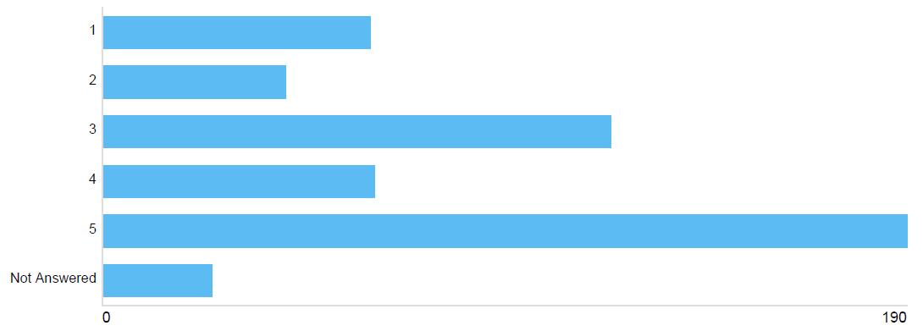
Figure 8: Option 1A Impact

50.2% (combining those selecting options 4 and 5) of respondents believed this would have a negative impact (with 37.6% anticipating a very negative impact), and 21.1% (options 1 and 2) believe this would have a positive impact (with 12.5% anticipating a very positive impact). 23.7% selected option 3, suggesting they anticipated no impacts or a neutral impact.

In terms of those suggesting this option would have negative impacts, a number of these related to personal difficulties or inconveniences likely to arise, such as having to purchase a new car (i am a low paid keyworker with a 2003 car which i cannot afford to replace), problems accessing places they want or need to be (I would no longer be able to get to union square; This option limits my access to my place of work), including the need to take longer circuitous routes (Will have to have large lengthy diversion to access family). Concerns about the impacts on disabled travellers arose again (As a disabled pensioner who relies on my car to reach shopping in town with an older car it would appear if I move from my home in the Bridge of Don I will have to pay).

Similar to responses to the other questions, impact on businesses and the city centre was cited as a key issue with many respondents stating that proposals would drive them to shop and spend time elsewhere (I will no longer use Aberdeen for shopping) and/or not visit the city centre (People will continue to shop on line and this could increase if people cannot use their own cars, being footfall and revenue spent in the shops in the town will fall further). Again, concern was raised that traffic and emissions would simply be displaced elsewhere.

Those anticipating a positive impact cited less pollution and less city centre traffic as key reasons for their answer (Better air quality is great for me personally, and I work on Union Street, where often the choice is to open the window for cooler air - but bad smells, pollution and noise - or keep the window closed and deal with stuffy air), while many stated that they would be more likely to visit the city centre more often as a result (I will be more likely to visit the city centre and spend time on the streets visiting shops, cafes etc) or believed that the proposals would improve the city centre (Make going into city centre a nice experience).

In terms of those who stated this would have a neutral impact, this was largely because respondents’ vehicles would already be compliant (Should not impact me as I believe my cars are above the minimum standards required to enter LEZ); they don’t tend to travel through the area by car anyway (I rarely visit this area of the city centre); or could see reasonable alternatives (It won’t make much difference, I would just have to avoid the Denburn).
Option 1B – Advantages

Given the similarities of this option to Option 1A, many respondents merely referred to their previous comments when providing comments on this option (this was the case throughout the survey, with many respondents merely referring to previous comments as they worked their way through the options). Likewise, some respondents merely provided the same comments for all of the options.

Again, many saw no benefits to this option, either because they oppose the concept of a LEZ or they felt that this option is too limited in scope.

The main benefit raised by respondents was that this option, unlike Option 1A, allows access along the Denburn corridor, keeping a city centre through-route open for all vehicles and reducing potential impacts elsewhere (This allows cars that are not compliant to still have through access. Not having Denburn and guild St included means that surrounding roads that aren't in the LEZ and can't handle larger amounts of traffic will not be negatively impacted by the introduction of the LEZ; Leaving a north-south corridor close to the city centre open seems a highly practical option which could reduce the stress on many motorists who do not wish to engage in great detours around the city centre in order to head north or south. It links very well with South College Street, which is a route many people coming into Aberdeen from the south may wish to take). There is a sense that this improves accessibility to key destinations, such as Union Square and the railway station, compared to Option 1A.

Respondents also noted that it was a clear and logical area (Relatively easily demarcated, less chance of confusion), while some welcomed the fact that it was a small zone that could still have a big impact on emissions, while reducing negative impacts on businesses, or which could act as a stepping stone to development of a larger zone in the future (Although this option only covers a limited area it could form a core LEZ which will have scope for expansion into adjacent areas at a later date). Again, respondents noted that this was likely to be the easiest option to implement but could still bring benefits.

Option 1B – Disadvantages

Similar to Option 1A many respondents saw this option as too limited to have any real impact (too small an area to make a difference) and noted that key exceedance locations were not covered by this option (Market street was recorded to have one of the highest levels of air pollution in the city. I think that taking these roads out of zone would mean no changes to the air quality over this whole area). In contrast to some of the comments in the previous section welcoming the exclusion of Denburn Road, some respondents to this question queried the impact of this or suggested this undermined the concept of a LEZ (Whats the point in having a major road polluting through the centre of a low emission zone; Allowing non-compliant vehicles to use denburn road and guild street would undermine the whole intent behind introducing a low emission zone. Air pollution in these areas affects union street, and would continue to damage the health of those who live and work there. This is an unacceptable option in my opinion). There was also a concern that this would make Denburn Road and Guild Street much busier. Similar to the responses to previous questions, other potential disadvantages noted included: impact on businesses and the city centre; potential for traffic and emissions to be displaced elsewhere, to more sensitive areas; impacts on the disabled and less affluent; and personal inconvenience, in terms of it being harder to access a particular destination.

Option 1B - How do you think this option will impact on you either individually or as a business, on a scale of 1-5 (where 1 means a very positive impact and 5 a very negative impact?)
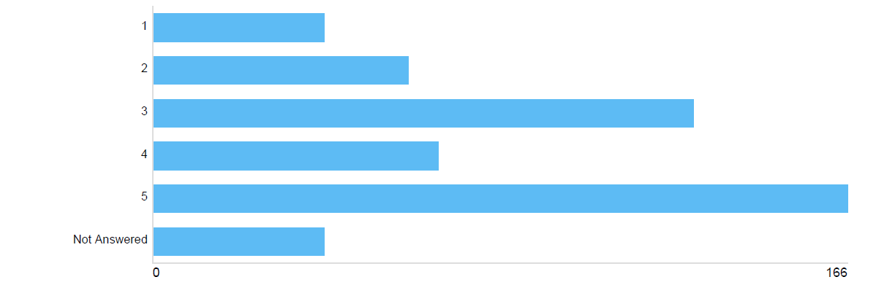
Figure 9: Option 1B Impact

46.3% (combining those selecting options 4 and 5) of respondents believed this would have a negative impact (with 32.8% anticipating a very negative impact), and 20.2% (options 1 and 2) believe this would have a positive impact (with 8.1% anticipating a very positive impact). 25.5% selected option 3, suggesting they anticipated no impacts or a neutral impact.

In common with the responses to the previous option, those anticipating a positive impact cited the anticipated health benefits of cleaner air.

In terms of those suggesting this option would have negative impacts, comments again related to: negative impacts on businesses; people choosing to avoid the city centre as a result; impacts on current travel habits and accessibility of certain destinations; concerns about the cost of upgrading vehicles; concerns that the option is not enough to improve pollution and health; and the potential for traffic to increase on adjacent routes, potentially causing problems elsewhere.

On the subject of the exclusion of the Denburn Road / Guild Street corridor from the LEZ, opinion was split between those welcoming the fact that this would still allow a route through the city centre (Provides better options for passing through the city centre) and those questioning whether this would simply make this corridor more unpleasant than it already is (Walking along Guild Street is bad enough now. It would not be improved by having traffic which couldn't use Union Street added to it).

In terms of those who stated this would have a neutral impact, again this was on the basis of already having a compliant vehicle or not frequenting the areas under consideration.

Option 2A – Advantages

Many saw no advantages to this option, noting that it does not address any additional sites of air quality exceedances beyond options 1A and 1B.

Many welcome the increase in scope of the LEZ beyond Option 1A/1B, noting that this would bring even greater air quality improvements (The larger the exclusion area the better for our environment). Many welcomed the extension into wider shopping and residential areas, with particular benefits for George Street (This is great, as it begins to take in a far greater area of residential and mixed use buildings. It could also help to make George Street a more desirable shopping street, after years of neglect; Still easy to implement but covers the high density built environment better by including the George Street area). Some respondents noted that the zone was clear (Easily demarcated) and allowed for easy re-routeing of non-compliant vehicles (The main ‘circular’ routes are still available. So vehicles can avoid entering the LEZ more easily).
Option 2A – Disadvantages

A number of respondents did not see any disadvantages with this option.

One of the key disadvantages noted in relation to this option was that it is not large enough to fully address the problem, and some key areas of emissions are excluded (However, historic hot spots for pollution are not included in the road. West North Street and King Street in particular have had persistent air quality issues. Aberdeen's Low Emission Zone must, at least include areas where we know air pollution is worst in the city). Some felt that the LEZ does not go far enough in addressing the root cause of problems (We need to deter people from bring their cars into the centre of cities completely, not just cause minor inconvenience).

Conversely, many comments were received that this option is too large, further restricts access to key destinations (This includes lots of the city centre parking) and encompasses large residential areas (More residential areas now covered, reducing transport options for many more people). Many recognised that it does not encompass any more exceedance locations than the first option (There are currently no significant air quality issues in the George St area or additional proposed area from option 1 so, from an air quality perspective, I can't see the benefit of this option above option 1 so the additional impacts may be to little benefit).

Given that this option, compared to Option 1, extends into significant residential areas in and around George Street, the impacts on residents who may be forced to purchase a compliant vehicle (personal ownership of vehicles that are not compliant would be an issue for residents in the area) was raised as a concern. Again it was suggested that proposals disproportionately impact the less well-off and those with disabilities. The additional businesses that this option would encompass, especially smaller local businesses in the area was likewise a concern (I think this would have a very detrimental effect on businesses in George Street which is already really suffering).

Similar to the responses to other questions, negative impacts on the economy and the city centre were raised, as was concern about the potential displacement of congestion and emissions, and a recognition that LEZ needs supporting active travel and public transport improvements to be successful.

Option 2A - How do you think this option will impact on you either individually or as a business, on a scale of 1-5 (where 1 means a very positive impact and 5 a very negative impact?)

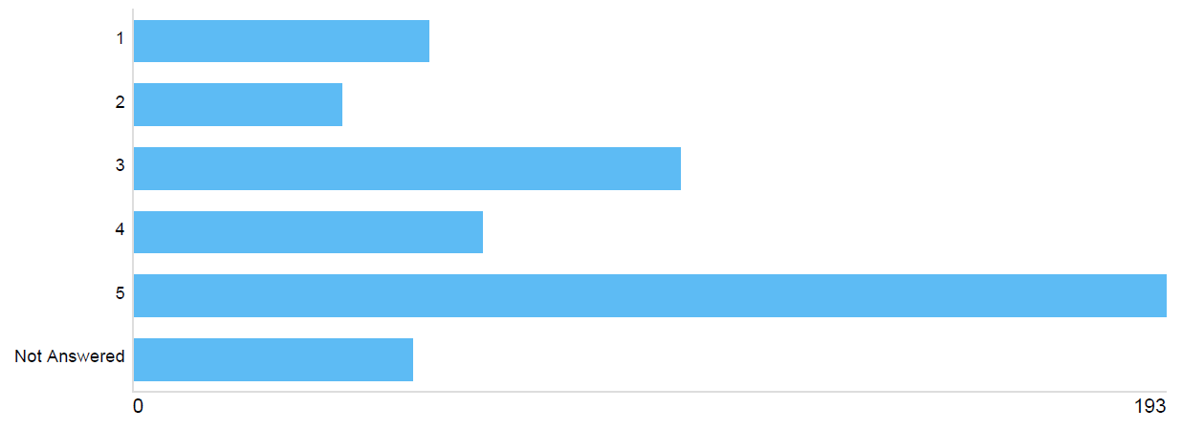
Figure 10: Option 2A Impact

51.0% (combining those selecting options 4 and 5) of respondents believed this would have a negative impact (with 38.1% anticipating a very negative impact) and 18.6% (options 1 and 2) believe this would have a positive impact (with 10.9% anticipating a very positive impact). 20.2% selected option 3, suggesting they anticipated no impact or a neutral impact.

As with previous questions, positive impacts were anticipated in terms of cleaner air and a healthier environment.

Those neutral on the option again stated that they tended not to use these streets or already had a compliant vehicle.

In terms of negative impacts, the same issues occur again as in previous comments:
- economic impact, especially with the extension into the George Street area;
- respondents stating that they would avoid using the city centre;
- concerns about the displacement of traffic and emissions, with particular concerns that traffic will be moved to narrow, residential streets that are not able to cope with this increase (Increased flow of Non LEZ compliant cars on Westburn Drive, Argyll Place and Craigie Loanings);
- a greater impact on residents now the boundary extends into the George Street area (I live on Maberly St and this zone would mean I would need to buy a new car (which I can't currently afford due to Covid!) to be able to access my own home and parking space by car); and
- restrictions on the ability of people and businesses to access the city centre.

Option 2B - Advantages

The main advantage identified for this option, compared to 2A, was that the Denburn Road / Guild Street corridor remains open for all vehicles. People welcomed a north-south route through the city centre being maintained as well as full accessibility to key destinations such as the rail station.

Other advantages cited were again the air quality and health benefits, and the fact that this option covers a sizeable area (My preferred option. The zone is reasonably big so will have a good impact on air quality. There are good alternatives for people to circumnavigate the zone without adding to congestion and defeating the purpose of the zone. The zone covers some popular parking and shopping areas which will encourage both businesses and the public to use lower emission vehicles.)

Again, a number of respondents stated that there are no advantages to this options, largely on the basis that they object to LEZs in any form.

Option 2B – Disadvantages

Again, many respondents saw no disadvantages with this option.

While many respondents commented that the scope of the zone was a disadvantage, this was split between:
- those who thought the area too extensive (Much too large an area), takes in a large residential area (Too much of George St residential area covered), and restricts access to a number of city centre car parks; and
- those who stated that the area is not extensive enough (Too small - minimal effect) and misses key pollution hotspots (It doesn’t cover all areas where there is a problem, so again seems pointless).
The exclusion of Denburn Road and Guild Street was also noted as a disadvantage by a number of respondents (This will reduce the potential for behavioural change by maintaining routing for polluting vehicles; allowing car fumes into the middle of the LEZ, thus negating much of its effectiveness).

A number of respondents thought that this option was potentially confusing to drivers (Seems like the shape will be confusing for motorists to remember where is covered).

As with previous questions, respondents again expressed concerns about:
- impacts on businesses and the city centre;
- negative impacts on accessibility for the less affluent and mobility impaired;
- displaced traffic and emissions, especially along the Berryden corridor.

Option 2B - How do you think this option will impact on you either individually or as a business, on a scale of 1-5 (where 1 means a very positive impact and 5 a very negative impact?)

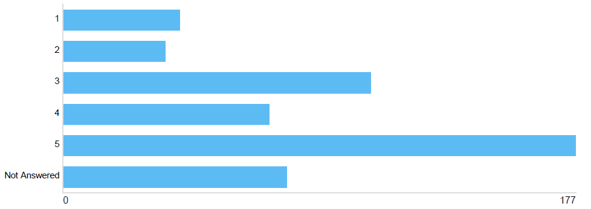
Figure 11: Option 2B Impact

49.0% (combining those selecting options 4 and 5) of respondents believed this would have a negative impact (with 35.0% anticipating a very negative impact), and 14.8% (options 1 and 2) believe this would have a positive impact (with 7.9% anticipating a very positive impact). 21.0% selected option 3, suggesting they anticipated no impact or a neutral impact.

Again, positive impacts on air quality and health were anticipated.

In terms of those who felt the impact would be neutral, this tended to be because they did not frequent the area or already have a compliant vehicle.

In terms of negative impacts these again tended to be around: the need to buy a new car; impacts on regular journeys; impacts on business operations (It would severely impact me being able to run my business as I only travel to my clients by car due to the nature of my business and the heavy, fragile equipment that I use); impact on local businesses and the city centre; and the potential to increase congestion and emissions elsewhere, especially Berryden.

Option 3A - Advantages

Aside from cleaner air, the main advantages of this option identified by the responses were in relation to its scope in terms of
- it covering a wider area than previous options (LEZ now covers more area, which is great, the bigger the area the better; The wider the perimeter of the zone the better - lets get these vehicles off our roads for the sake of our environment) and additional air quality exceedance locations, such as King Street and Market Street;
- Alignment with the City Centre Masterplan area (Great idea to match the master plan area - gives a good succinct vision for the future: Uses an existing defined area); and
- Maintaining full accessibility to key destinations such as Union Square, the Harbour and the beach.

Many respondents stated that they saw no advantages to this option, presumably as they do not agree with the concept of LEZs at all.

Option 3A – Disadvantages

The main disadvantage identified was in relation to this option covering too large an area and a perception that this will be extremely disruptive, in terms of requiring lengthy detours to key destinations (Bigger area means it gets more and more difficult for commuters to get from one side of the LEZ to the other. This coupled with all the one way systems we have because of COVID-19, can cause total chaos), or making such destinations inaccessible to non-compliant vehicles, particularly the main shopping centres and their car parks (I guess that all of union square will end up inside the LEZ. Preventing me from ever visiting there again), the rail and bus stations, the beach, the harbour area and ferry terminal (This will completely devastate trade associated with the harbour and will also have an extremely detrimental impact on trade and travel for the Orkney and Shetland islands).

A number of respondents expressed concern that more and more main roads are included in this option, such as King Street and West North Street, and the number of routes available to non-compliant vehicles is much reduced (not enough alternative routes). Concerns were again expressed about the displacement of traffic and emissions, especially to residential West End streets and to the beach area. Displacement of heavy goods vehicles (HGVs) emerges as a particular concern, especially as options starts to impact on the accessibility of the harbour.

Conversely a number of comments were received that the LEZ is still not large enough (Still not a big enough area to really make the emission reductions needed) and still doesn’t encompass heavily polluted areas such as the whole of Market Street (In my view if an LEZ is going to be introduced (which I strongly believe it should) it should cover as much ground as possible. Given the work that goes into setting up an LEZ it seems a wasted opportunity to leave untouched Market Street South. Furthermore, it seems to me that people who feel inconvenienced by the LEZ are more likely to accept this if they can see that it is actually tackling the problem that Aberdeen has with poor air quality (whether through first hand experience or through scientific analyses following the implementation).

The potential for confusion amongst drivers was again noted, as was the need for supporting measures in order for a LEZ to be successful particularly improved public transport offering and improved opportunities for switching to electric vehicles.

Again, comments were received in terms of the economic impacts, especially on the harbour, and personal impacts in terms of the cost of new vehicles, impacts on the disabled, less affluent and rural communities, and difficulties accessing workplaces and other key destinations.

Option 3A - How do you think this option will impact on you either individually or as a business, on a scale of 1-5 (where 1 means a very positive impact and 5 a very negative impact?)
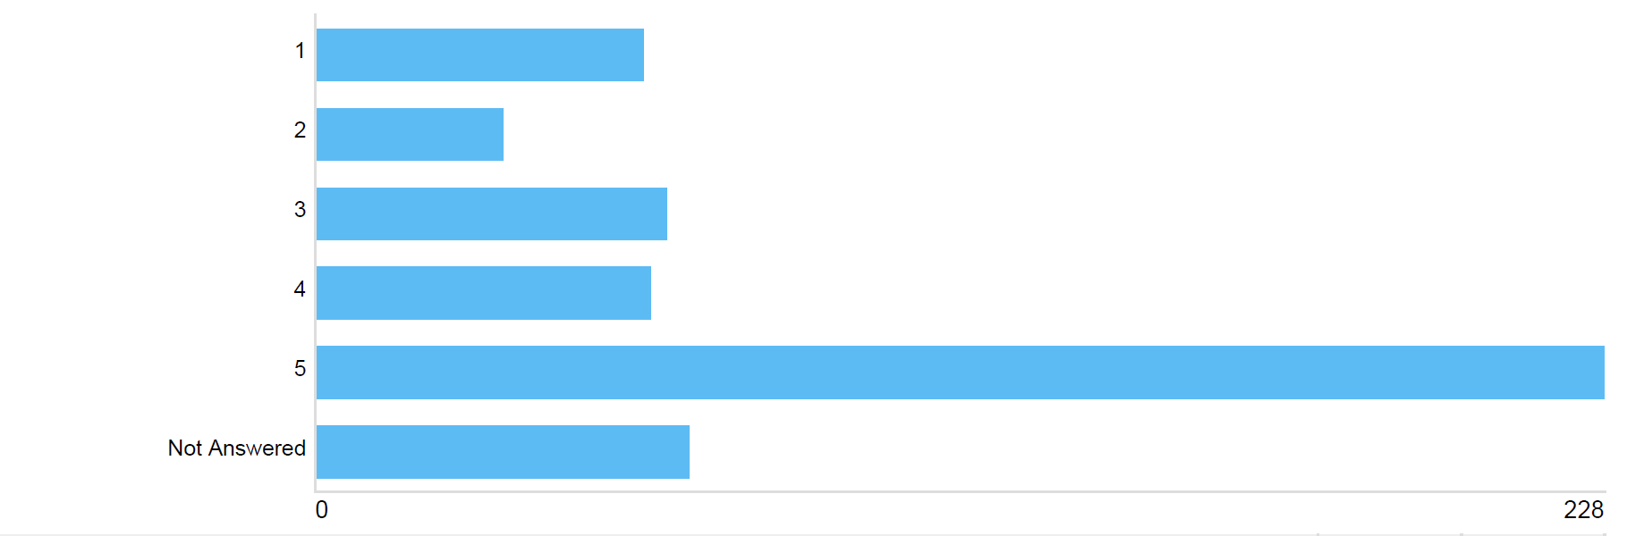
Figure 12: Option 3A Impact

56.7% (combining those selecting options 4 and 5) of respondents believed this would have a negative impact (with 45.1% anticipating a very negative impact), and 18.0% (options 1 and 2) believe this would have a positive impact (with 11.5 % anticipating a very positive impact). 12.3% selected option 3, suggesting they anticipated no impact or a neutral impact.

Again, positive impacts were anticipated in terms of cleaner air and public health, and negative impacts in terms of accessibility of key destinations and longer journey times; cost implications of purchasing a new vehicle; impacts on businesses, especially those around the Harbour; and confusion for people trying to get round the area. Again there were contrasting comments around this option being too large or too small.

Option 3B – Advantages

The main advantage identified for this option was its contrast to option 3A, in terms of the Denburn corridor remaining open to all vehicles. Many respondents welcomed that this still offered a north-south route through the area for non-compliant vehicles which could soften some of the negative impacts of the LEZ (Not closing off the north-south corridor of Denburn Road could help the city centre economically and with regard to future development. It also eases the stress on motorists by maintaining a route north and south close to centre, avoiding major detours of the centre). Some also commented that keeping the corridor open maintained accessibility to key destinations such as the station and Union Square. At the other end of the spectrum, many felt that this corridor should be included (I can't really see why exempting Guild St & Denburn would be advantageous). In contrast, some mentioned the scope of this option as one of its advantages, noting that it covers a wider area and many exceedance locations (A large area that would benefit many people living in it).

Again, many respondents commented that there were no advantages to this option.

Option 3B – Disadvantages

Respondents were split between those who felt that the scope is too big, encroaching onto residential areas and limiting car parking opportunities for non-compliant vehicles, and those who felt it was too small and excluded key pollution hotspots.

The exclusion of Denburn Road and Guild Street was noted as a disadvantage as much as an advantage, with respondents feeling that such an exclusion undermined the whole LEZ (The exclusion of Denburn Road and Guild Street doesn't make sense. To be effective, the zone should cover a large area, and be clear to all road users. These exclusions would undermine the zone's effectiveness, and would lead to higher traffic of non-compliant vehicles around the edge of the zone; Guild Street is the first street which bus and rail passengers leaving the station on foot meet - therefore high emission vehicles on this street aren't desirable).

Similar to the responses to previous questions, comments were received in relation to: displacement of traffic and emissions to sensitive, residential areas; impacts on the less affluent and disabled; impacts on personal journeys and accessibility; and the economic impacts especailly as these options start to impact upon access to the harbour (We are concerned that access to the port from northern and westen approaches will be impeded by this option. Re-routing freight unnecessarily via a southern approach to the port unnecessarily increases journey distances and time, and potentially creates congestion and increased emissions. This option should be dropped).

Option 3B - How do you think this option will impact on you either individually or as a business, on a scale of 1-5 (where 1 means a very positive impact and 5 a very negative impact?)

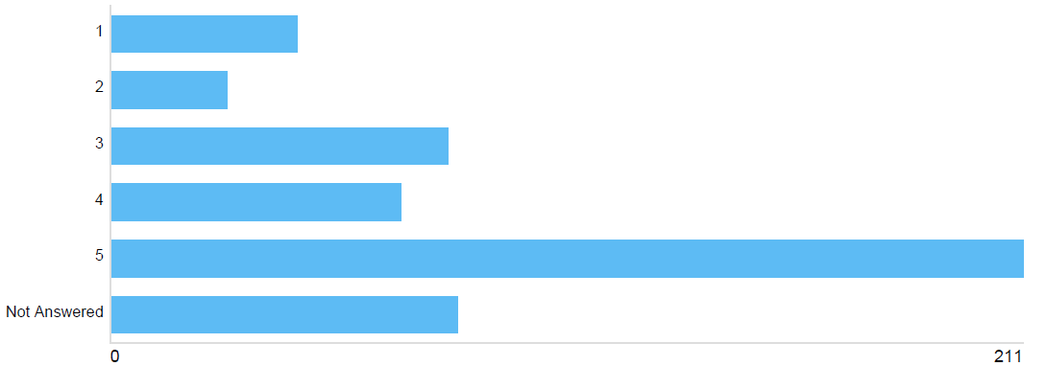
Figure 13: Option 3B Impact

54.9% (combining those selecting options 4 and 5) of respondents believed this would have a negative impact (with 41.7% anticipating a very negative impact) and 13.8% (options 1 and 2) believe this would have a positive impact (with 8.5% anticipating a very positive impact). 15.4% selected option 3, suggesting they anticipated no impact or a neutral impact.

Comments on this question follow similar themes to previous comments in terms of: air and health benefits; accessibility of homes, workplaces and other destinations; impacts on businesses and the city centre economy, especially in terms of maintaining full access to the Harbour; and displacement effects.

Option 4A – Advantages

The main advantage cited of this option by respondents was its size and scope compared to other options. There was significant support for this as the largest option under consideration, and the one which addresses all city centre pollution exceedances (It gives the greatest area of relief from the toxic levels of pollution. As this covers the largest area it would make the most positive impact. I think that maybe the largest area would see less non compliant vehicles travel by the edges. This is the best option. You should do it. It would be a good thing for Aberdeen to do for the environment), with many stating in the text that this is their preferred option (This is the best option, and is really ambitious).

It was noted that this option could result in additional benefits, not just an improvement in air quality (This is a comprehensive option, covering many of the ongoing hotspots for air pollution problems in Aberdeen. It is large enough to lead to the changes we need to see - modal shift in the city centre, fleet turnover, lower overall traffic levels. It would reduce air pollution, leading to public health benefits for the city. It could also have an impact on reducing climate emissions, and making the city centre a better place to spend time for residents, workers, and visitors), although it was noted that the benefits would be maximised with the concurrent delivery of complementary measures (There is a great opportunity for Aberdeen City Council to introduce this zone, as outlined in Option 4A, alongside a range of other travel measures, such as active travel infrastructure, pavement widening, bus gates, and pedestrianisation).

At the other end of the spectrum, a number of respondents saw no advantages of this option.

Option 4A – Disadvantages

A number of respondents felt the LEZ is still not big enough, with some commenting that the north-west of the city centre is still not captured.

Conversely, a number of comments that this option is too big, noting that many residential areas are covered and that access to key destinations such as city centre car parks, the harbour and the beach will be affected for non-compliant vehicles (Could make the whole city centre inaccessible for certain people). Some respondents suggested that, while this option may be too large as a first step, it could be something to work towards in the future.

Again, negative impacts on the city centre economy and local businesses are anticipated and concerns increase in proportion with the increasing scale of the options. This is certainly the case now that Option 4 impacts all routes around Aberdeen Harbour (This will destroy commerce associated with the harbour; The inclusion of Aberdeen Harbour and Union Square could prove challenging in terms of compliance from the freight sector and bus operators).

Likewise, concerns about the displacement of vehicles and emissions increase as the scope of options increase (The expansion of the area covered means that the issues identified in my earlier responses would be exacerbated. It would shunt a third of vehicles, or thereabouts, to other streets nearby. It would also mean that those vehicles were corralled into the Denburn car park, with no access to Loch St or Harriet St. I cannot help thinking that this would concentrate fumes there, as well as making it more difficult for any segment of society less able to afford a new vehicle to access the town centre; Displaced traffic (and potentially a lot more of it) would be pushed further out into residential streets - the St Swithin St/Ashley Rd, Willowbank areas are not suited to lots of traffic. Bridge of Dee is a potential bottleneck).

Similar personal disadvantages were foreseen as previous sections (cost, accessibility of key destinations, impacts on mobility impaired and less affluent) as well as a suggestion that this might be confusing for users to navigate.

An additional key theme emerging from this option is the impact on those travelling to Aberdeen via ferry from the islands (It will mean people coming from Shetland or Orkney via the ferry will be immediately be impacted by the LEZ. The islands tend to have older vehicles and as such may not be within the exclusion list and so people who are already significantly disadvantaged by the cost of ferry and air transport will now be hit once more).

A number of respondents stated that there were no disadvantages with this option or felt that the benefits outweighed the disadvantages (This option would cause the greatest inconvenience to road users and businesses. However when dealing with a serious issue such as air pollution we have to be willing to accept inconvenience and adapt).

Option 4A - How do you think this option will impact on you either individually or as a business, on a scale of 1-5 (where 1 means a very positive impact and 5 a very negative impact?)

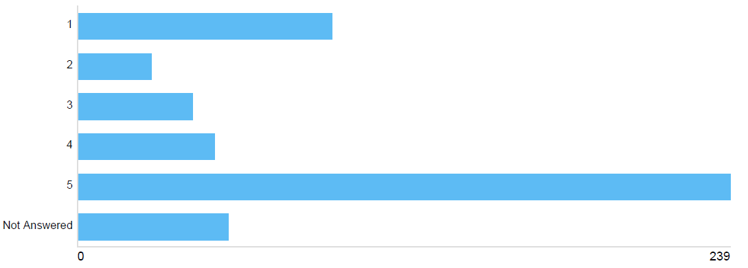
Figure 14: Option 4A Impact

57.1% (combining those selecting options 4 and 5) of respondents believed this would have a negative impact (with 47.2% anticipating a very negative impact) and 23.7% (options 1 and 2) believe this would have a positive impact (with 18.3% anticipating a very positive impact). 8.3% selected option 3, suggesting they anticipated no impact or a neutral impact.

Again, similar impacts were identified as had been for the other options (in terms of economic impacts, displacement and personal disadvantages, although, commensurate with the scale of this option, additional positive impacts were noted such as this potentially acting as a catalyst for wider improvements in terms of economic regeneration (A pleasant city centre environ will attract businesses back into the heart of the city) and reduced traffic volumes.

Option 4B – Advantages

The main advantage identified was in comparison with 4A, in terms of respondents welcoming that this option allows access through the city centre for non-compliant vehicles via the Denburn (fairer to allow some older vehicles a route through the city centre) and maintains full accessibility to key destinations such as the station.

Again, many respondents welcome the scope and size of this option, recognising that this will bring the greatest air quality benefits, although many expressed a preference for Option 4A on the grounds that its scope is even greater.

Many respondents see no advantages with this option.

Option 4B – Disadvantages

Similar to the responses to other ‘B’ options, the exclusion of Denburn Road and Guild Street from the LEZ is seen as a major disadvantage, potentially undermining any benefits of the LEZ. Again, there was a split in opinion in terms of this option being considered too big by some and too small by others. Again, displacement, business and economy impacts and personal impacts were noted.

Some people saw no disadvantages of this option.

Option 4B - How do you think this option will impact on you either individually or as a business, on a scale of 1-5 (where 1 means a very positive impact and 5 a very negative impact?)

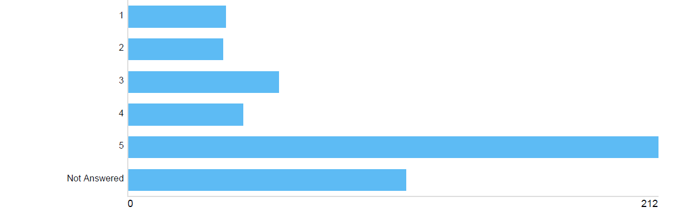
Figure 15: Option 4B Impact

51.0% (combining those selecting options 4 and 5) of respondents believed this would have a negative impact (with 41.9% anticipating a very negative impact) and 15.2% (options 1 and 2) believe this would have a positive impact (with 7.7% anticipating a very positive impact). 11.9% selected option 3, suggesting they anticipated no impact or a neutral impact.

The main impacts noted were again around the economy, displacement and personal disadvantages.

2.6 Option Ranking
Having considered all the LEZ options and their potential impacts, respondents were asked to rank them in order of preference (where 1 was the most preferred option and 8 the least preferred option).

Considering the options identified by respondents as their preferred option (given a rating of 1), there is a clear preference for the options at the extreme ends of the scale, with Option 4A receiving the most preferred option votes overall.

Figure 16: Preferred Option Votes

Combining all the rankings for each of the options, the smallest option, 1A, emerges as the most popular option overall, with 4B the least popular. Looking at the rankings as a whole, there is a general preference for the smaller options (with 1A, 1B and 2A being the top 3 options), while those options excluding the Denburn and Guild Street areas from the LEZ were less well received, with 2B, 3B and 4B being the least acceptable options.

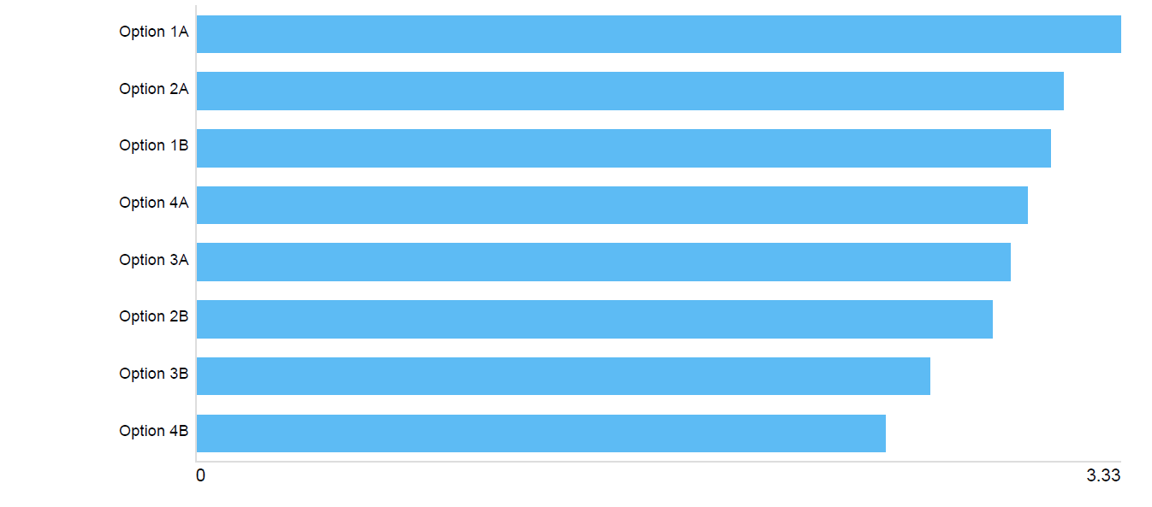
Figure 17: Combined Option Rankings

2.7 Grace Periods
Respondents were asked what they thought were appropriate grace periods for residents and non-residents. The maximum allowable grace periods were the most popular although there is significant support for the minimum grace period, especially for non-residents.

Length of Grace Period (Residents) | % of respondents selecting this as preferred option
1 year | 19.2%
2 years | 10.5%
3 years | 8.5%
4 years | 4.7%
5 years | 7.1%
6 years | 45.1%
Table 1: Preferred Grace Periods (Residents)

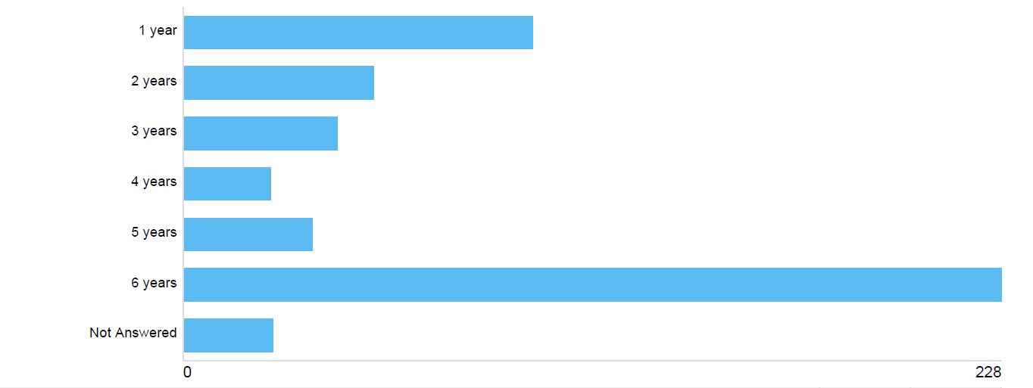
Figure 18: Preferred Grace Periods (Residents)

Length of Grace Period (Non - residents) | % of respondents selecting this as preferred option
1 year | 34.4%
2 years | 6.52%
3 years | 6.32%
4 years | 47.8%
Table 2: Preferred Grace Periods (Non-Residents)

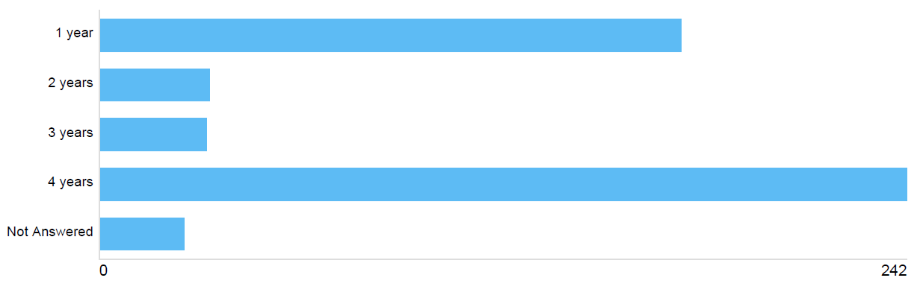
Table 19: Preferred Grace Periods (Non-Residents)

2.8 Additional Comments

The final question in the survey was an open question, allowing respondents to make any final points about LEZs and the options presented.

Some people used this section to express their opposition to a LEZ, saying it is not required or that the Council and Government should be using resources elsewhere. Many questioned whether the impacts of the opening of the AWPR and COVID are being factored into considerations, and whether the impacts of an operational harbour in the city centre are being taken into account.

A number of suggestions were provided for what the Council could do to improve air quality as an alternative to a LEZ:
- Improving road layouts and traffic management;
- Improving the public transport offering;
- Pedestrianisation;
- Improving the cleanliness of the bus fleet;
- Public transport and active travel improvements;
- Incentivising fleet improvement rather than restricting access;
- Increasing 20pmh zones; and
- Discouraging through traffic.

In terms of those in favour of LEZ, comments were received stating that plans should be rolled out as quickly as possible and extended even further with some calling for the Council to be even more ambitious, but with a reiteration that the LEZ must be easily understood by the general public.

A strong theme to emerge in the responses to this question was that a LEZ must not be delivered in isolation but must be supported by complementary measures to ensure it achieves its objectives and maximises the benefits. Measures identified include:
- Improving the public transport offering and park and ride opportunities;
- Improving active travel routes;
- Increasing car parking opportunities around the zone;
- Increasing electric vehicle charging opportunities;
- Improving roads around the zone;
- Working with businesses to further improve the city centre; and
- Financial support for vehicle upgrades.

Again, similar comments about the economic impacts, personal impacts and displacement were received in relation this this question.

A number of comments were received in relation to grace periods with a split between those favouring the minimum (Grace periods should be as short as possible to drive reductions in carbon emissions as radically as possible. The nation has declared a climate emergency, we need to act like it) and maximum (If plans that include the George St area is introduced (as well as any LEZ's that include a larger residential area), a significant grace period will be needed for residents in those areas. The coronavirus situation has negatively impacted the livelihoods of many people in Aberdeen and it's unfair on residents who might not be able to afford a new car just now, or for a couple of years due to job loss or lost income).

3 Email Responses

Email or letter responses were received from the following:
- Aberdeen Cycle Forum;
- Aberdeen Friends of the Earth;
- Enterprise Holdings;
- Federation of Small Businesses;
- Hammerson;
- Logistics UK;
- NHS Grampian Public Health Directorate;
- RAC Motoring Services Ltd.
- Robert Gordons College;
- UPS;
- A group of MSPs representing the Orkney and Shetland islands;
- One individual.

The main points raised by email respondents match closely those raised within the online survey. These include:
- The need for a LEZ to be integrated with other improvements, such as general traffic reduction measures, an improved sustainable transport offering and Mobility as a Service (MaaS);
- Concerns about the economic implications, particularly for city centre businesses;
- Concerns about the accessibility of key sites for non-compliant vehicles;
- Concerns about the impact on those travelling to Aberdeen from Orkney and Shetland who have no option but to arrive and depart from the ferry terminal;
- Concerns about the displacement of traffic and emissions;
- Concerns that the impacts of AWPR and COVID are not reflected in the modelling undertaken to date;
- Concerns that the impacts of shipping emissions are not being considered;
- A split between those who feel that proposals do not go far enough in scope and ambition, and those who believe the LEZ should be as small as possible.

4 Summary of Key Themes

Clearly, while a lot of support for LEZs has been expressed in the questionnaire and email responses, many respondents have quite negative attitudes to the introduction of a LEZ in Aberdeen, or at the very least have valid concerns that they would like to see addressed as the option appraisal process continues. These concerns are summarised in the table below, along with some information about how the Council and partners are addressing these as we move towards the identification of a preferred LEZ option.

Area of Concern | Response
The impacts of the opening of the AWPR on traffic has not been considered | The air quality modelling undertaken to date used 2018 air quality data as this was the most up to date information available at the time. Interim 2019 data suggested little change in air quality in the city centre following opening of the AWPR therefore this approach was considered valid at the time.  A new City Centre Paramics traffic model has recently been developed to predict the traffic and air quality implications of the LEZ options, and this is a 2019 model, based on traffic counts undertaken after the opening of the AWPR. It is the outputs from this model that will be used to predict the future impacts of the different LEZ scenarios as we continue through the appraisal process.
The impacts of COVID-19 on travel habits and patterns have not been considered | There is considerable uncertainty over the long-term impacts of COVID-19 on future transport and traffic behaviours and Transport Scotland and all the LEZ cities recognise that this must be addressed as we progress through the LEZ assessment and development process.  Work has been commissioned by Transport Scotland on behalf of the LEZ cities to identify plausible future scenarios for a post-COVID world, and this is currently underway. The likelihood and potential impacts of these various scenarios will be considered, and a judgement made as to whether or not any change in approach to LEZ planning is required as a result.
The impacts of the Spaces for People measures have not been considered | The models can only include infrastructure changes that are committed to be permanently in place by the anticipated LEZ opening year. The Spaces for People measures are temporary changes in response to the COVID-19 pandemic and there is no commitment to make these permanent, therefore they do not form part of the modelling considerations. Should any new permanent road changes be introduced in the proposed LEZ area, these will be factored into the modelling.
Concerns that a LEZ will move traffic, congestion and emissions elsewhere | Clearly, this would be contrary to the aims and objectives of the LEZ therefore the likely impacts of non-compliant vehicles re-routeing to avoid the LEZ will be modelled within the traffic model and the outcomes of this will feed into the option appraisal process. It is unlikely that an option that results in significant volumes of traffic moving to inappropriate roads outside the LEZ will perform well in subsequent stages of the appraisal. In cases where some displacement is anticipated to occur, the model will help determine what form of mitigation (in the form of traffic management measures) will be required to ensure the majority of traffic remains on appropriate streets.
Concerns about the scope of the LEZ options in terms of size and vehicles encompassed | LEZ options focus on the city centre as this is where air quality exceedances are largely concentrated.  Various LEZ options were considered at the outset of the option appraisal process but were sifted out on numerous grounds including public and stakeholder acceptability. In order to be acceptable and stand up to scrutiny when proposals are presented to Elected Members and Scottish Ministers, the LEZ must be proportionate to the scale of the problem and look to achieve immediate air quality objectives without incurring significant negative impacts on the city (especially in areas where air pollution is currently within accepted limits) and its people and businesses.  The current city centre options are of various sizes and scopes so that we can understand the impacts of the different options on city centre residents, businesses and other users.  It has not yet been determined which classes of vehicles will be included or excluded from Aberdeen’s LEZ. This will be informed by ongoing traffic and air quality modelling.  The LEZ ultimately recommended for implementation will be that which best meets air quality (and wider) objectives, while minimising negative impacts.
Differences in opinion between the inclusion / exclusion of Denburn Road and Guild Street | The Council accepts that there will be different advantages and disadvantages of each approach and this is clearly reflected in the consultation findings. As well as the consultation responses, the decision on which option to implement will be informed by the traffic and air quality modelling which will enable a better understanding of the likely traffic and air quality impacts of each of the options.
Implications on the less affluent members of society who may have difficulty changing transport mode or purchasing a compliant vehicle. | Support is available from Transport Scotland for households and small businesses within a 20km radius of a planned LEZ. The LEZ Support Fund will financially support eligible households on specific means-tested benefits, with a grant to move away from older petrol and diesel vehicles. Further information is available from the Energy Saving Trust.  Furthermore, the Legislation requires grace periods between the declaration of a LEZ and enforcement commencing to allow residents and businesses sufficient time to consider how they can best comply with a LEZ.
Concerns over the impacts on the city centre economy and local businesses | See above in terms of support available to small businesses and the requirement for grace periods before LEZ enforcement will commence.  The Council believes a less polluted city centre will result in a more pleasant and attractive environment for people and businesses and, if accompanied by complementary transport improvements (see below), can act as a catalyst for more people visiting and spending time in the city centre. Evidence from similar schemes elsewhere in the world show that such changes can be delivered to the benefit of the city centre economy, rather to its detriment.  The majority of businesses responding to the consultation supported the principle of a LEZ, provided it is delivered in the correct way - ongoing dialogue with businesses will be required as the LEZ moves to design and delivery. An Economic Impact Assessment will be undertaken if deemed necessary.
The need for complementary measures to support a LEZ | The Council agrees that a LEZ delivered in isolation will be insufficient to address all transport and air quality concerns in the city centre. We see the LEZ as one piece of a much wider transport jigsaw and recognise that various other measures are required to achieve the city centre transformation we aspire to, including: continued delivery of City Centre Masterplan and Sustainable Urban Mobility Plan projects to devote more space to walking, cycling and public transport in the centre; implementation of the revised Roads Hierarchy, particularly enhanced active travel and bus priority on radial corridors to and from the city centre; continued expansion of the Aberdeen Car Club; delivery of the Hydrogen Strategy and further deployment of hydrogen buses on our streets; and continued roll out of electric vehicle charging infrastructure,
Implications on accessibility of the city centre for disabled travellers | A possible exemption from LEZs for blue badge holders is being considered at national level and was consulted upon by Transport Scotland as part of the emerging LEZ Regulations and Guidance. An Equalities Impact Assessment will be undertaken prior to the delivery of the LEZ.
Implications on the accessibility of key destinations for all users | Please see the above in terms of complementary measures to improve accessibility to the city centre for non-car and low-emission forms of transport, the support available for people and businesses to switch to compliant vehicles or alternative modes, and grace periods.  Clearly the different sizes of options will have varying impacts and these will be taken account of as we continue through the option appraisal process.  The vast majority of private cars will be LEZ compliant in any case (around 70% in 2019) and accessibility for these users will not be compromised.
Emissions from the Harbour are not included within the analysis | Harbour emissions have been included in the air quality modelling. The results show that nitrogen oxides (NOx) originating from shipping makes a small contribution to total NOx with road traffic and background sources making much larger contributions. Therefore, whilst emissions from shipping do contribute to existing exceedances in the city centre, and to the total regional emissions, they are localised and for roads that are remote from the harbour the contribution from shipping is negligible. Therefore, it is considered that road traffic is the main source of emissions and should remain the focus for air quality improvements in the future. Generally the impacts from shipping are less than 5% of the total ambient nitrogen dioxide (NO₂) concentration.

5 Next Steps

As mentioned in section 4, the various LEZ options are now being tested in the transport and air quality models to better understand the likely traffic and air quality impacts of each. This will also take account of the outcomes of the COVID-19 scenario testing.

Assuming the current approach to LEZ planning is still considered valid, the outcomes of the consultation exercise will be combined with the modelling outputs to inform completion of the National Low Emission Framework (NLEF) Stage 2 Appraisal which is anticipated to culminate in a preferred LEZ option. This will be reported to Elected Members in spring/summer 2021, and thereafter the LEZ will undergo detailed design and further engagement.

