Aberdeen Emissions Analysis Report

Main Points to Note
- As a consequence of the cyber-attack that significantly impacted SEPA’s internal IT systems, an alternative approach for carrying out the modelling for the development of proposed LEZs was agreed. This focuses on identifying changes to traffic emissions inside and outside the boundary of the proposed LEZ.
- A fully compliant bus fleet (89% Euro VI and 11% Hydrogen) has been included in the analyses described below. A fully compliant bus fleet will bring air quality benefits across the whole of the city.
- Introducing a Low Emission Zone combined with City Centre Masterplan (CCMP) interventions planned for Union Street will reduce total NO_{x} emissions by 29% when compared to the 2024 Reference Case.
- The highest concentrations of annual-average NO₂ occur along roads dominated by bus emissions within Aberdeen City Centre. Diesel car emissions dominate other key routes in and out of the City Centre.
- Significant emission reductions occur on key bus routes inside the LEZ boundary where vehicles are required to meet strict exhaust emission standards.
- Although the traffic modelling identified some vehicle displacement around the edge of the LEZ the emissions analysis carried out so far doesn’t identify any potential new pollution hotspot areas.
- The traffic model suggests an overall increase in traffic flows along Anderson Drive between Garthdee Roundabout and Kings Gate which is reflected in a 40% increase in NO_{x} emissions. Previous AQ model predictions based on a 2019 fleet highlighted that the average annual average NO₂ concentration was 32µgm⁻³ along this section of Anderson Drive.
- The traffic model identifies a slight change in traffic flows on Wellington Road but NO_{x} emissions are predicted to fall by approximately 20%.
- Emissions analysis work will continue and further AQ modelling will be carried out during the summer (2021).

Scope of Report
Air Quality (AQ) modelling in Aberdeen is ongoing as part of the National Modelling Framework (NMF) in support of the Scottish Government’s Cleaner Air for Scotland Strategy (CAFS). This report summarises work carried out to calculate tail-pipe emissions of Nitrogen Oxides (NO_{x}) using outputs from the Aberdeen traffic model which has been used to inform the planning of a Low Emission Zone (LEZ) for Aberdeen City Council (ACC). This work has been carried out in line with the NMF, which has the aim to deliver a detailed and consistent approach to assessing AQ in Scotland’s major cities. This report provides an early indication of where traffic-related emissions are likely to increase or decrease following the implementation of the LEZ.
Earlier reports (Aberdeen’s Proposed Low Emission Zone - Interim Report for Aberdeen City Council, 2018; National Low Emission Framework-Interim Stage 2 Assessment, SYSTRA 2020) show that the NMF Aberdeen AQ model performs well when compared against observed AQ data, highlights how fleet composition changes can improve AQ on a city-wide basis and looks at source apportionment for different vehicle sectors. Some of the key findings from this work are included below.
It is important to note that this is an interim report due to technical issues described below. Further detailed AQ modelling will resume during the summer of 2021 to inform the final LEZ design and will focus on the changes in Nitrogen Dioxide (NO₂) concentrations associated with the changes in traffic patterns summarised below. Particulate Matter (PM) modelling will be included in further work.

SEPA Cyber Attack – and the Alternative Approach Taken
On Christmas Eve, the Scottish Environment Protection Agency (SEPA) was subject to a serious and complex criminal cyber-attack that significantly impacted our internal systems and our AQ modelling capabilities.
As part of SEPAs recovery plan a phased rollout to restore critical services to re-establish communication in order to continue providing priority regulatory, monitoring, flood forecasting and warning services was initiated. This included the delivery of our NMF obligations to assist in the final assessments of the LEZ options for each city.

Due to SEPAs inability to carry out AQ modelling, an alternative approach to allow for local authorities to report to committee in Spring 2021 was discussed at the LEZ Leadership Group meeting held on the 3rd of February 2021. The following steps were recommended by Scottish Government and SEPA on a way forward:

- Continuation of traffic modelling to define a small number of potential LEZ options or a preferred LEZ option for each city.

SEPA to carry out emissions analysis on the traffic model outputs using the established NMF methodology. This will assess the impact of the LEZ by comparing traffic and emissions between the reference/base case and LEZ scenarios.

SEPA to continue detailed AQ modelling during the consultation phase over the summer of 2021 to support the local authorities in finalising the preferred LEZ scheme for Ministerial approval.

Introduction and Background
Air quality management activities (including AQ monitoring) in Scotland have been primarily driven by the 2008 European Union Directive on ambient air quality and cleaner air for Europe (Directive 2008/50/EC), which was incorporated into Scottish law through the Air Quality Standards (Scotland) Regulations 2010 and 2016. At a domestic level, the Environment Act 1995 and Regulatory Reform (Scotland) Act 2014 set out the Local Air Quality Management (LAQM) regime to assist local authorities in achieving compliance with legal AQ standards and objectives set to protect human health.
The CAFS Strategy, published in 2015, sets out how Scottish Government and its partner organisations propose to further reduce air pollution and improve AQ to protect human health and fulfil Scotland’s legal responsibilities as soon as possible. CAFS provides a clear commitment to the NMF to ensure that a consistent approach to modelling AQ in areas associated with the highest levels of poor AQ in all four major cities is taken. The NMF provides tools and evidence to support the National Low Emissions Framework (NLEF). The NLEF is an evidence-based appraisal process developed to help local authorities consider transport related actions to improve local AQ.
In September 2017, the Scottish Government’s Programme for Government committed to the introduction of LEZs in Scotland’s four biggest cities (Glasgow, Edinburgh, Aberdeen and Dundee) by 2020, with the first introduced in Glasgow in 2018. With the advent of COVID-19 and the subsequent lock-down restrictions and recovery measures the decision was made to temporarily pause the implementation of LEZs. The Scottish Government have since set a revised timetable for LEZs to be introduced across all four cities between February and May 2022.
CAFS has been subject to a formal review, with an updated strategy (CAFS2) expected to be published shortly in 2021 (to run to 2026). The initial findings of the review identified that Scotland was performing well on AQ, with the major pollutants continuing to fall as a result of actions taken to date. However, the review also recommended that there is more work to be carried out and Scotland must take a precautionary public health approach to further AQ reductions.

Emissions Analysis
A traffic model has been developed by SYSTRA to assess how traffic flows and composition could change in response to the implementation of an LEZ in Aberdeen. The traffic model predicts how non-compliant vehicles could be displaced around the LEZ. The extent of the proposed LEZ is shown in Figure 1.
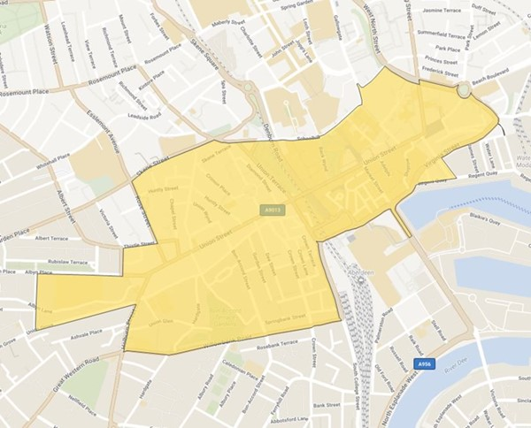
Figure 1. Extent of the proposed LEZ covering the area of Aberdeen City Centre bound between Willowbank Road to Virginia Street to the south, Commerce Street to West North Street to the east, Littlejohn Street to Skene Street to the north and Rose Street to Albyn Grove to the west.

AQ modelling carried out earlier in the NMF process concluded that a LEZ alone is not enough to reduce all exceedances across the City Centre. Aberdeen City Council’s proposed City Centre Master Plan (CCMP) includes several transport related projects. The traffic model was utilised to identify if any elements of the CCMP would reduce traffic further to support the LEZ in meeting its objectives (Figure 2). Traffic modelling sensitivity tests identified that the CCMP Union Street Scheme was shown to complement the proposed LEZ by reducing traffic and associated emissions further within the City Centre. The CCMP Union Street Scheme involves limiting traffic to buses, taxis and pedal cycles only along the sections of Union Street and Union Terrace highlighted in black in Figure 2. As part of the same scheme the southern end of Rose Street will be pedestrianised. Additional testing identified that a revision to the operation of the Milburn Street/South College Street junction will also be required to manage displaced traffic from the City Centre in the area to the south and west of the LEZ and limit the routing of all traffic through the Milburn Street and the Ferryhill corridor.
A comparison has been made between a 2024 ‘Reference’ case (referred to as ‘Reference’ case below) and a 2024 LEZ + CCMP Union Street Scheme scenario (referred to as ‘LEZ scenario) below).
  - ‘Reference’ case traffic flows are based on those observed in 2019 adjusted for 2024 with Committed Developments taken into account. The vehicle fleet composition for 2024 is based on the predicted trends in national fleet composition/compliance (2019-2024) which was applied to local observed ANPR data gathered in 2019. The bus fleet is fully compliant with the LEZ requirements and comprises 89% Euro VI and 11% hydrogen fuel cell (based on the 2021 fleet) components.
  - Traffic flows in the LEZ scenario are based on the ‘Reference’ case with the added intervention of the LEZ scenario and additional measures which include the CCMP Union Street Scheme and the Milburn Street junction revision.
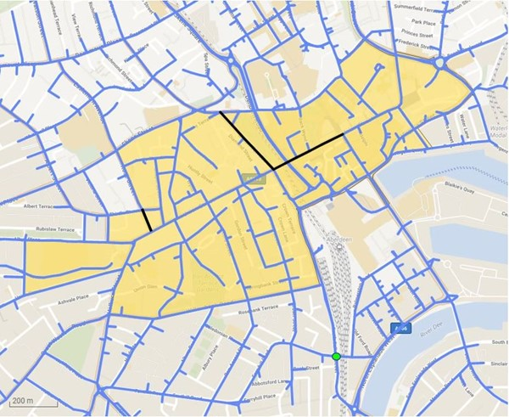
Figure 2. Key elements of the CCMP Union Street Scheme are shown in black and the location of the Milburn Street junction improvements are shown by the green marker. The extent of the LEZ is shown in yellow.

Traffic model outputs were processed to make them compatible with the CERC emissions database tool (EMIT). This included expanding the number of vehicle types in the traffic model outputs into 11 vehicle categories and the conversion of 12 hour traffic flows into 24 hour flows using conversion factors derived from observed traffic data. Emission rates (g/km/s) could then be calculated for every road in the traffic model for the ‘Reference’ case and LEZ scenario. Comparing emissions between these enables any changes due to the LEZ scenario to be identified.
The EMIT software used contains the latest emission factors from the Emission Factor Toolkit (EFT) version 10.

Traffic Pollutants described in this Report
The focus of the LEZ is on reducing concentrations of total Nitrogen Dioxide (NO₂). Vehicles directly emit both NO₂ and Nitrogen Oxide (NO) (known as primary NO₂ and primary NO) to the atmosphere. These two pollutants are referred to collectively as Nitrogen Oxides (NO_{x}). Once in the atmosphere, they chemically interact with each other in the presence of Ozone (O₃) and sunlight. When primary NO chemically reacts to form NO₂, this is known as secondary NO₂. Due to this chemical interaction, there may not be a direct relationship between an increase in road traffic emissions and NO₂ concentrations.
AQ modelling carried out earlier in the NMF process focused on predicting concentrations of NO₂, which is how compliance against AQ Standards is assessed. The AQ model was also used to estimate the proportions of vehicle pollution that comes from different vehicle types, e.g. diesel cars vs buses. This type of analysis is usually performed for NO_{x}, rather than NO₂. It is difficult to calculate the breakdown of NO₂ for different vehicles accurately because of the additional component of NO₂ that is created in the atmosphere. Therefore, in this report we focus on total NO_{x} emissions from traffic sources to assess emission reductions, whilst further analysis will be conducted to model NO₂ concentrations.
Air Quality Model: Pollutant Concentrations
AQ modelling carried out earlier in the LEZ development phase was used to predict concentrations of NO₂ at a network of regular kerbside points across the city. The pink markers in Figures 3 and 4 show predicted exceedances of the annual average NO₂ limit value of 40µgm⁻³ and the small number of black markers show predicted exceedances above 55µgm⁻³ based on conditions in 2019. The main areas of exceedance are focused in the City Centre along Union Street, Holburn Street and King Street (these are major bus routes), and Market Street, Virginia Street and Commerce Street.
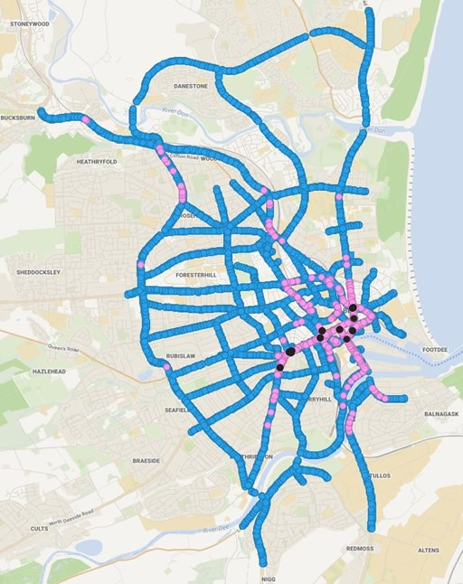
Figure 3. Modelled concentrations of annual-average NO₂ above (pink and black) and below (blue) the objective limit value of 40µgm⁻³.
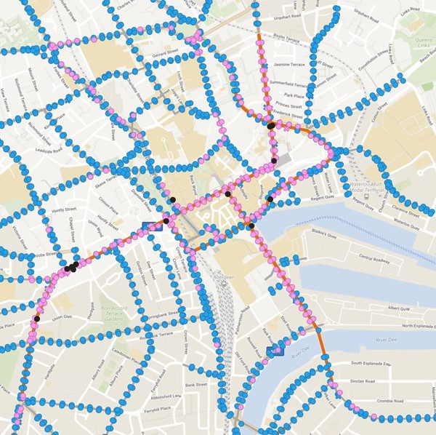
Figure 4. Modelled concentrations of annual-average NO₂ above (pink and black) and below (blue) the objective limit value of 40µgm⁻³. The City Centre AQMA is shown in orange.
EMIT: Emissions by Vehicle Type
During emissions analysis undertaken earlier in the NMF process EMIT was used to estimate the relative contribution to total levels of NO_{x} from different types of vehicles. This analysis showed that the greatest contributors to NO_{x} across the city are buses and diesel cars. Bus emissions are most dominant on roads inside the City Centre where the highest pollutant concentrations are measured and predicted (Figure 5). Diesel car emissions are dominant on other key routes in and out of the city (Figure 6).

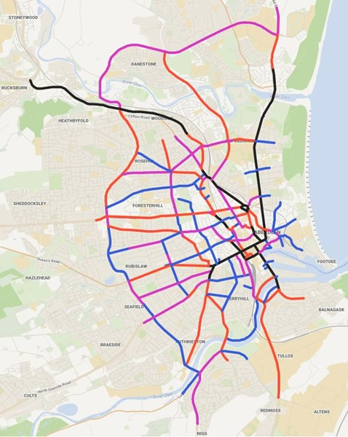
Figure 5. The roads coloured in black are those dominated by bus emissions (highest 25%).
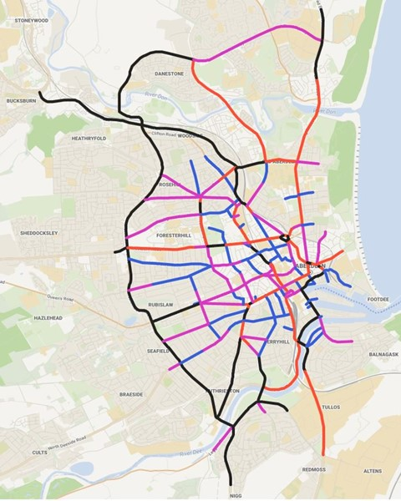
Figure 6. The roads coloured in black are those dominated by diesel car emissions (highest 25%).

Traffic Model Analysis
The effects of the LEZ + CCMP Union Street Scheme have been investigated both inside and outside of the LEZ boundary. The most significant emission reduction occurs inside the boundary where vehicles are required to comply with LEZ rules. Some vehicles that do not meet the emission standards of the LEZ re-route around the edges of the LEZ boundary. This displacement of non-compliant vehicles has the potential to increase vehicle emissions on these roads.

LEZ + CCMP Union Street Scheme

On the roads highlighted in black in Figure 7 there is a reduction in total NO_{x} emissions of over 30%. On key bus routes inside the LEZ there is a significant reduction in NO_{x} emissions. For example, on the sections of Union Street where only buses and taxis are permitted as part of the CCMP Union Street Scheme (Figure 1) there is an average reduction of 87% in NO_{x} emissions. The bus fleet in 2024 is considered to be fully compliant and therefore this improvement is due to the removal of all other vehicle types, mainly diesel cars and goods vehicles from these roads as part of the CCMP Union Street Scheme. Along the remaining sections of Union Street there is a reduction in NO_{x} emission rates of on average 57% (ranging between 34% and 72%). Along Union Terrace there is a reduction of on average 77% (ranging between 47% and 91%). Many of these roads that see the greatest reduction in emissions in the LEZ scenario coincide with those highlighted in the previous AQ modelling results shown in Figures 3 and 4 where the highest pollutant concentrations are found.
The two charts in Figure 8 show the ranked NO_{x} emission rates on all roads covered in the traffic model. They allow the significance of the changes in the NO_{x} emission rates between the ‘Reference’ case (top) and LEZ scenario (bottom) in relation to the maximum NO_{x} emission rates to be visualised. Two sections of Union Street (US1 and US2 within the CCMP Union Street Scheme), Market Street (MS), Virginia Street (VS) and King Street (KS) within the proposed LEZ have been highlighted in the map. The corresponding reductions in NO_{x} emission rates at these locations in the LEZ scenario are highlighted in the charts. The effect of implementing the traffic restriction on Union Street as part of the CCMP Union Street Scheme on NO_{x} emission rates at these locations offers significant reductions across streets previously shown to have some of the highest emission rates and kerbside concentrations in 2019.
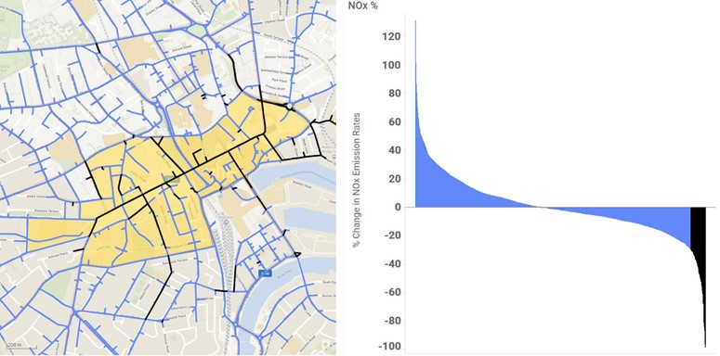
Figure 7. Roads highlighted in black are predicted to see over 30% reduction in NO_{x} emissions. These are mostly key bus routes within the City Centre which coincide with high pollutant concentrations and exceedances of the NO₂ annual limit value. The extent of the LEZ is shown in yellow.
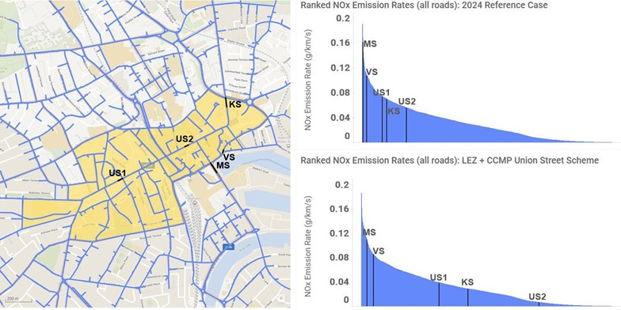Figure 8. The charts on the right show the NO_{x} emission rates on all roads in the traffic model for the ‘Reference’ case (top) and LEZ scenario (bottom). The changes in NO_{x} emission rates on Union Street (US1 and US2), Virginia Street (VS), King Street (KS) and Market Street (MS) are highlighted in black. The extent of the LEZ is shown in yellow.

There are some roads located on the periphery and just outside the proposed LEZ boundary where NO_{x} emissions increase following the implementation of the LEZ + CCMP Union Street Scheme. On the roads highlighted in black, on Victoria Street and Thistle Street in Figure 9 there is an increase in NO_{x} emissions of over 40%. The two charts in Figure 10 show the corresponding increases in NO_{x} emission rates at these locations in the LEZ scenario when compared to the ‘Reference’ case. These figures highlight that while there may be a large percentage increases in NO_{x} emission rates on some roads this can actually correspond to small increases in NO_{x} emission rates whilst overall emission rates remain low. The increase in NO_{x} emission rates on these roads is due to an increase in compliant vehicles routing through these areas.
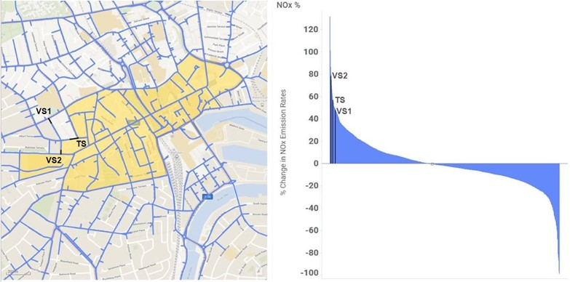
Figure 9. The highlighted sections of Victoria Street (VS1 and VS2) and Thistle Street (TS) see over a 40% increase in NO_{x} emissions. The extent of the LEZ is shown in yellow.
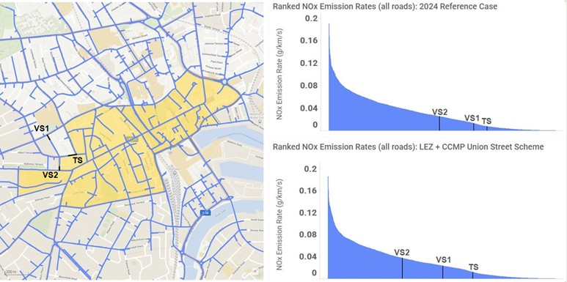
Figure 10. The charts on the right show the NO_{x} emission rates on all roads in the traffic model for the ‘Reference’ case (top) and LEZ scenario (bottom). The changes in NO_{x} emission rates on Victoria Street (VS1 and VS2) and Thistle Street (TS) are highlighted in black. The extent of the LEZ is shown in yellow.

Market Street to Commerce Street

Overall, there is a reduction in traffic flows along Market Street, Virginia Street and Commerce Street. Virgina Street, Commerce Street and the section of Market Street highlighted in Figure 11 below are included within the proposed LEZ. The reduced flows combined with the change to compliant vehicles in the LEZ scenario results in reductions in NO_{x} emission rates of up to 30% on the highlighted roads. The two charts in Figure 12 show the corresponding reduction in NO_{x} emission rates at these locations in the LEZ scenario when compared to the ‘Reference’ case.
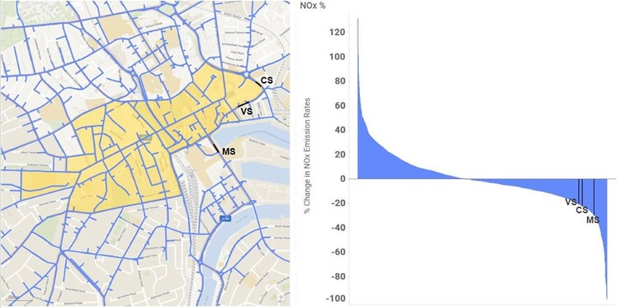
Figure 11. The highlighted sections of Market Street (MS), Virginia Street (VS) and Commerce Street (CS) see over a 40% increase in NO_{x} emissions. The extent of the LEZ is shown in yellow.
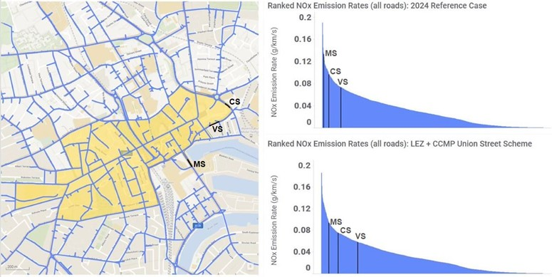
Figure 12. The charts on the right show the NO_{x} emission rates on all roads in the traffic model for the ‘Reference’ case (top) and LEZ scenario (bottom). The reductions in NO_{x} emission rates on Market Street (MS), Virginia Street (VS) and Commerce Street (CS) are highlighted in black. The extent of the LEZ is shown in yellow.
Skene Square
On the roads highlighted in black in Figures 13 and 14 there is a reduction in total NO_{x} emissions of up to 25%. The Council recorded that observed NO₂ concentrations were just at or below the 40µgm⁻³ objective on Skene Square for 2019. The AQ modelling carried out earlier in the NMF modelling process aligned with the local authority observations with a kerbside annual average NO₂ concentration of 38µgm⁻³ (ranging between 30µgm⁻³ and 48µgm⁻³) along this road.
The results from the traffic model suggest that there is a predicted 10% reduction in car traffic and a 17% reduction in LGV traffic along Skene Square compared to the ‘Reference’ case. Therefore, in absolute terms, the reduction in traffic and increase in compliant traffic will result in a decrease in NO_{x} emissions and therefore a reduction in annual average NO₂ concentrations along these roads. This will be examined further in future AQ modelling to ensure compliance within these streets. The two charts in Figure 14 show the corresponding reduction in NO_{x} emission rates at these locations in the LEZ scenario when compared to the ‘Reference’ case. Denburn Road was included within the LEZ boundary to minimise the potential for large numbers of non-compliant vehicles to travel north along Skene Square.

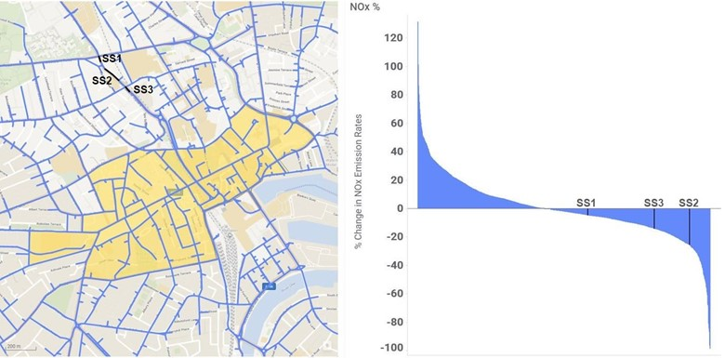
Figure 13. The highlighted sections of Skene Square (SS1 to SS3) (DB) see up to a 25% reduction in NO_{x} emissions. The extent of the LEZ is shown in yellow.
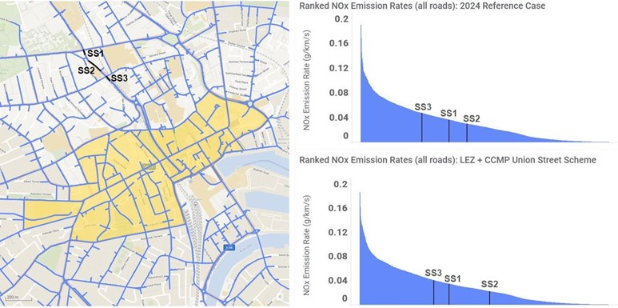
Figure 14. The charts on the right show the NO_{x} emission rates on all roads in the traffic model for the ‘Reference’ case (top) and LEZ scenario (bottom). The reductions in NO_{x} emission rates on Skene Square (SS1 to SS3) are highlighted in black. The extent of the LEZ is shown in yellow.

Ferryhill Area
The change in NO_{x} emissions for a selection of roads in the Ferryhill area to the south of the proposed LEZ are highlighted in black in Figure 15. Wellington Place is included within the proposed boundary and Ferryhill Road and Millburn Street are both located outside the boundary. The sections of Wellington Place (WP) and Ferryhill Road (FH) show increases in NO_{x} emissions of 37% and 21% respectively whilst Millburn Street shows a reduction in NO_{x} emissions of 26%. The traffic modelling and emissions analysis suggests that this increase is due to a large number of additional compliant vehicles; 4485 cars and 358 LGVs using this route each day compared to the flows in the Reference case.
The two charts in Figure 16 show the corresponding reduction in NO_{x} emission rates at these locations in the LEZ scenario when compared to the ‘Reference’ case.
In AQ modelling carried out earlier in the NMF process annual average NO₂ concentrations of 32µgm⁻³ (ranging between 29µgm⁻³ and 37µgm⁻³) were predicted on Wellington Place and concentrations of 29µgm⁻³ (ranging between 28µgm⁻³ and 31µgm⁻³) were predicted on Millburn Street. We will undertake further AQ modelling to ensure continual compliance within these streets.

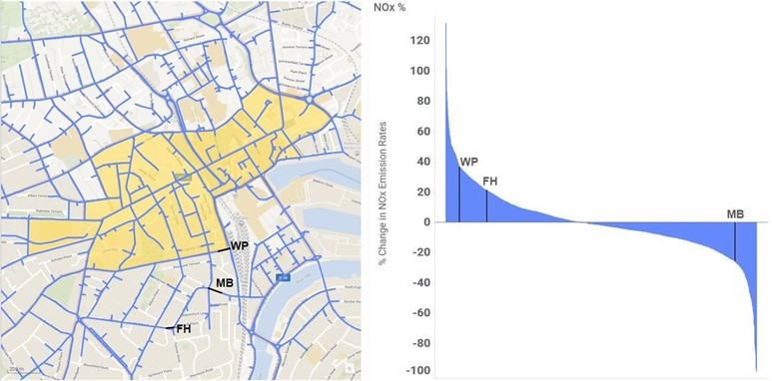
Figure 15. The highlighted sections of Wellington Place (WP), Ferryhill Road (FH) and Millburn Street (MB) to the south of the proposed LEZ show both positive and negative changes in NO_{x} emissions. The extent of the LEZ is shown in yellow.

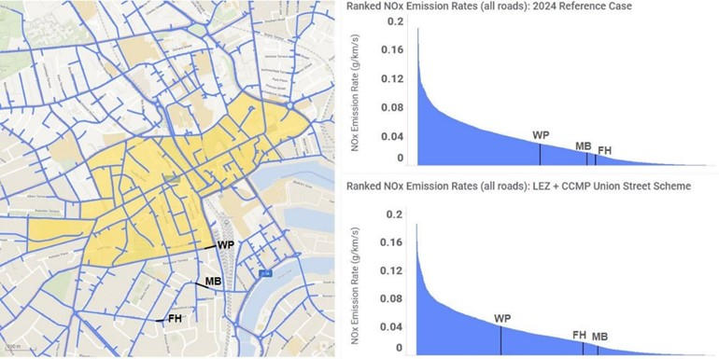
Figure 16. The charts on the right show the NO_{x} emission rates on all roads in the traffic model for the ‘Reference’ case (top) and LEZ scenario (bottom). The change in NO_{x} emission rates on Wellington Place (WP), Ferryhill Road (FH) and Millburn Street (MB) to the south of the proposed LEZ are highlighted in black. The extent of the LEZ is shown in yellow.

Rosemount Place
Increases in NO_{x} emission rates of over 40% occur along Rosemount Place, Maberly Street and Spring Garden (Figures 17 and 18). An increase in NO_{x} emission rates of 61% occurs along a stretch of Rosemount Place. Smaller increases in absolute NO_{x} emission rates occur along Maberly Street and Spring Garden.
In AQ modelling carried out earlier in the NMF process annual average NO₂ concentrations of 34µgm⁻³ (ranging between 28µgm⁻³ and 40µgm⁻³) were predicted at kerbside along these roads. The Council recorded that observed NO₂ concentrations were well below the 40µgm⁻³ objective (24µgm⁻³ and 30µgm⁻³) on Rosemount Place for 2019￼Therefore, in absolute terms, the increases in NO_{x} emissions are not expected to take them above the 40µgm⁻³ objective. This will be examined further in future AQ modelling.

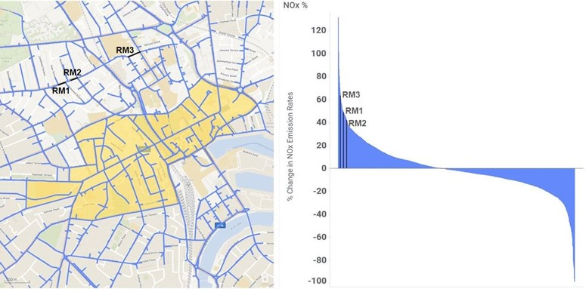
Figure 17. The highlighted sections of Rosemount Place (RM1 to RM3) to the north of the proposed LEZ show positive changes in NO_{x} emissions. The extent of the LEZ is shown in yellow.

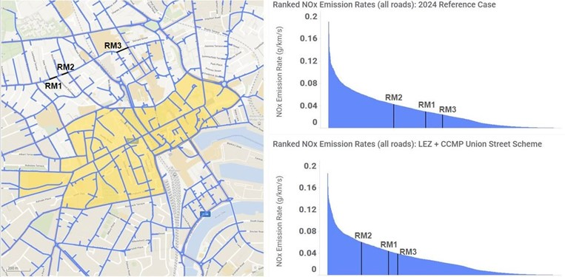
Figure 18. The charts on the right show the NO_{x} emission rates on all roads in the traffic model for the ‘Reference’ case (top) and LEZ scenario (bottom). The change in NO_{x} emission rates on Rosemount Place (RM1 to RM3) to the north of the proposed LEZ are highlighted in black. The extent of the LEZ is shown in yellow.

Anderson Drive AQMA
Increases in NO_{x} emission rates of over 40% occur along some sections of Anderson Drive between Garthdee Roundabout and Kings Gate (Figure 19). Car and LGV flows increase by up to 17% (an additional 4200 cars) and 41% (an additional 1200 LGVs) per day respectively on some of the sections. Similarly, Rigid HGV and Articulated HGV flows increase by up to 17% (100 vehicles) and 22% (76 vehicles) per day respectively. The two charts in Figure 20 show the corresponding increase in NO_{x} emission rates at these locations in the LEZ scenario when compared to the ‘Reference’ case.
The increases are along roads that were predicted to be below the 40µgm⁻³ objective in previous AQ modelling. In 2019 the annual average NO₂ concentration measured at the automatic monitor on Anderson Drive was 17µgm⁻³ and the two diffusion tubes located nearby measured annual average NO₂ concentrations of 24µgm⁻³ and 48ugm⁻³ respectively. AQ model predictions highlighted that the vast majority of kerbside points were below the objective value of 40µgm⁻³ along this section of Anderson Drive with an average annual average NO₂ concentration of 32µgm⁻³ (ranging between 25µgm⁻³ and 40µgm⁻³). It is not expected that NO₂ concentrations will increase above the 40µgm⁻³ objective. However, further AQ modelling will assess for continued compliance against the objective.
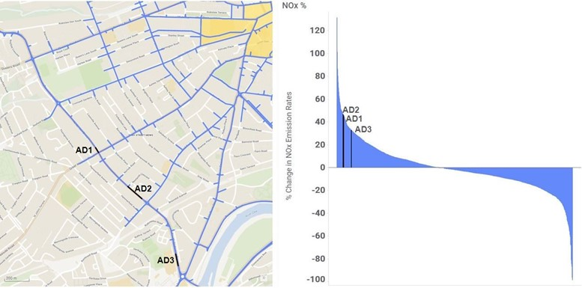
Figure 19. The highlighted sections of Anderson Drive (AD1 to AD3) to the north of the proposed LEZ show positive changes in NO_{x} emissions. The LEZ is shown in yellow.

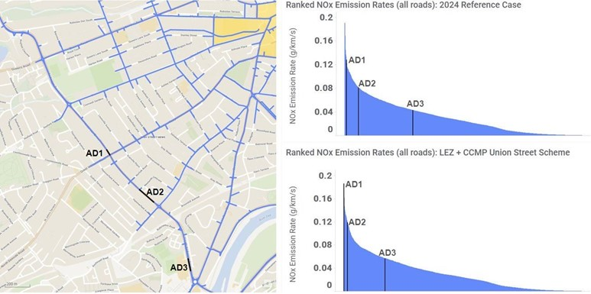
Figure 20. The charts on the right show the NO_{x} emission rates on all roads in the traffic model for the ‘Reference’ case (top) and LEZ scenario (bottom). The change in NO_{x} emission rates on Anderson Drive (AD1 to AD3) are highlighted in black. The extent of the LEZ is shown in yellow.

Wellington Road AQMA
On Wellington Road there is a slight change in traffic flows. However the NO_{x} emissions show a general reduction which will have a positive effect upon kerbside annual average NO₂ concentrations (Figure 21).
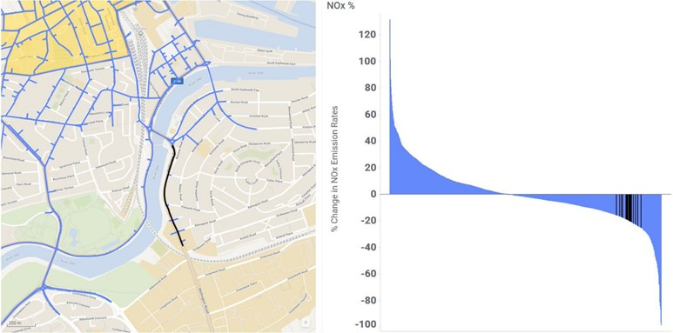
Figure 21. The highlighted sections of Wellington Road to the south of the proposed LEZ show positive changes in NO_{x} emissions. The LEZ is shown in yellow.

Next Steps
The next stage of the analysis will be to process the traffic model outputs for the 2019 Base case. The predicted emission rates for the Base case along with the 2024 ‘Reference’ case and LEZ + CCMP Union Street Scheme scenario described above will form the input for the AQ model to predict kerbside concentrations for each scenario.
Emission rates on each of the traffic model links will be mapped onto the larger air-quality model links. The area covered by the traffic model overlaps the area covered by the AQ model so the roads that have seen increases in traffic flows and emission rates will be covered in the AQ modelling. The results of this modelling will be visualised in a series of interactive maps and charts and made available to the Aberdeen City Council. Specific areas could be modelled in more detail if required. Additional traffic data collection will be necessary to monitor the performance of the LEZ + CCMP Union Street Scheme in the future.

