Proposal to make a LEZ Scheme – Aberdeen City Council
1 Introduction
Under the powers granted by the Transport (Scotland) Act 2019, and in accordance with The Low Emission Zones (Emission Standards, Exemptions and Penalty Charges) (Scotland) Regulations 2021 and The Low Emission Zones (Scotland) Regulations 2021, Aberdeen City Council (ACC) proposes to introduce a Low Emission Zone (LEZ) in Aberdeen.

2 Statement of Reasons

ACC believes a LEZ is required and is an appropriate response to longstanding issues of poor air quality in the Aberdeen City Centre Air Quality Management Area (AQMA) for the following reasons:

- Air pollution is believed to be a contributing factor in a number of serious health problems suffered by individuals and the number of health concerns linked to poor air quality is growing every day. This has a disproportionate impact on the most vulnerable members of society, particularly the young, the elderly and those with chronic heart, lung and respiratory conditions. Air pollution is therefore a significant Public Health concern and a LEZ is one of the most effective ways of responding to this;

- Although pollution levels have been reducing in Aberdeen in recent years and since the publication of Aberdeen’s Air Quality Action Plan in 2011, in many City Centre locations monitoring stations still show regular exceedance or near exceedance of the Scottish Government’s annual mean Nitrogen Dioxide (NO₂) objective. This can be seen in the map below where the red dots show exceedances of legal air quality levels and the amber dots show levels close to exceedance in 2019. As most of the exceedance locations are along busy roads, it is clear road traffic is the main source of pollution.
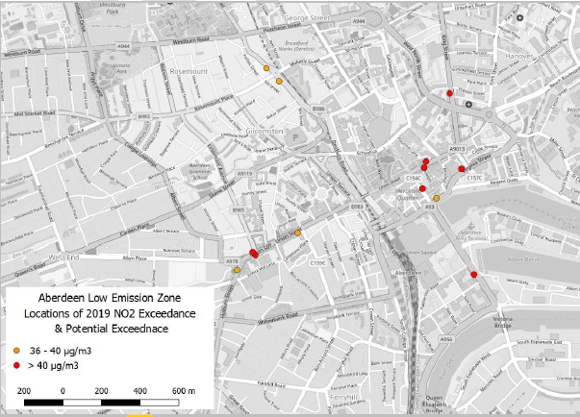
Figure 1: Locations of NO₂ exceedance and near-exceedance in Aberdeen City Centre

- While the opening of the Aberdeen Western Peripheral Route (AWPR) in 2019 has reduced traffic levels within the City, the impact on emissions in the City Centre has not been so great that all air quality objectives are being met;

- Air Quality modelling has shown that, even with the delivery of ambitious transport improvements in the City Centre, such as those identified in the Aberdeen City Centre Masterplan, emissions exceedances will remain unless tailpipe emissions are also addressed;

- While the COVID-19 pandemic and resulting travel restrictions have positively impacted on air quality in the short term, the medium to long term impacts on transport and travel remain uncertain, therefore the pandemic should not be a reason for delaying action. Indeed, monitoring undertaken by ACC throughout the pandemic has shown that, as restrictions on movement ease, traffic levels slowly rise again to near pre-pandemic levels. It would take a significant and sustained long-term decrease in traffic for a LEZ to no longer be necessary in the City Centre. Scenario Planning has been undertaken, looking at the impacts of a LEZ on a range of plausible post-COVID scenarios. Although the impacts of a LEZ vary between scenarios, it is clear that a LEZ will reduce pollution and protect the City Centre in all scenarios;

- As well as the Public Health benefits, ACC believes that there are wider benefits to improving air quality, in terms of making Aberdeen and the City Centre safe, desirable and welcoming environments for living, working, shopping and leisure. In this regard, we anticipate the LEZ will support economic recovery and city centre regeneration as we emerge from the COVID-19 pandemic;

- The LEZ supports and contributes to national, regional and local plans and policies, which seek to reduce unnecessary traffic, encourage modal shift to sustainable transport, and reduce transport’s impact on the environment. In this regard, the LEZ is fully compliant with the aims and objectives of Scotland’s National Transport Strategy, the Nestrans Regional Transport Strategy, the Aberdeen Local Transport Strategy, the Cleaner Air for Scotland Strategy, Aberdeen’s Air Quality Action Plan, and the Aberdeen City Centre Masterplan and supporting Sustainable Urban Mobility Plan. Transport changes engendered by the LEZ may also contribute to meeting national and local net-zero carbon aspirations;

- The proposed LEZ has been subject to a robust option appraisal process which has included public and stakeholder engagement, traffic microsimulation modelling, sensitivity testing against various future scenarios, and emissions analysis. This process, which has culminated in the identification of the preferred LEZ option, is described in detail within the ‘National Low Emission Framework - Interim Stage 2 report’.

3 LEZ Objectives

The following objectives for the LEZ have been agreed by ACC.

- Primary Objectives:
  - Improve air quality in Aberdeen by reducing harmful emissions from transport and delivering on the Scottish Government’s statutory air quality objectives (prescribed under section 87(1) of the Environment Act 1995);
  - Support climate change targets (as set out in Part 1 of the Climate Change (Scotland) Act 2009) by reducing road transport’s contribution to emissions.
- Secondary objectives:
  - Protect public health and wellbeing;
  - Support local and regional transport strategies by contributing to the development of a vibrant, accessible and safe city centre, where the volume of non-essential traffic is minimised and active and sustainable transport movements are prioritised; and
  - Contribute to ongoing transformational change in Aberdeen, helping promote the city as a desirable place to live, visit and invest in.

4 Proposed LEZ Boundary

A map of the proposed LEZ boundary is shown in Figure 2 below.

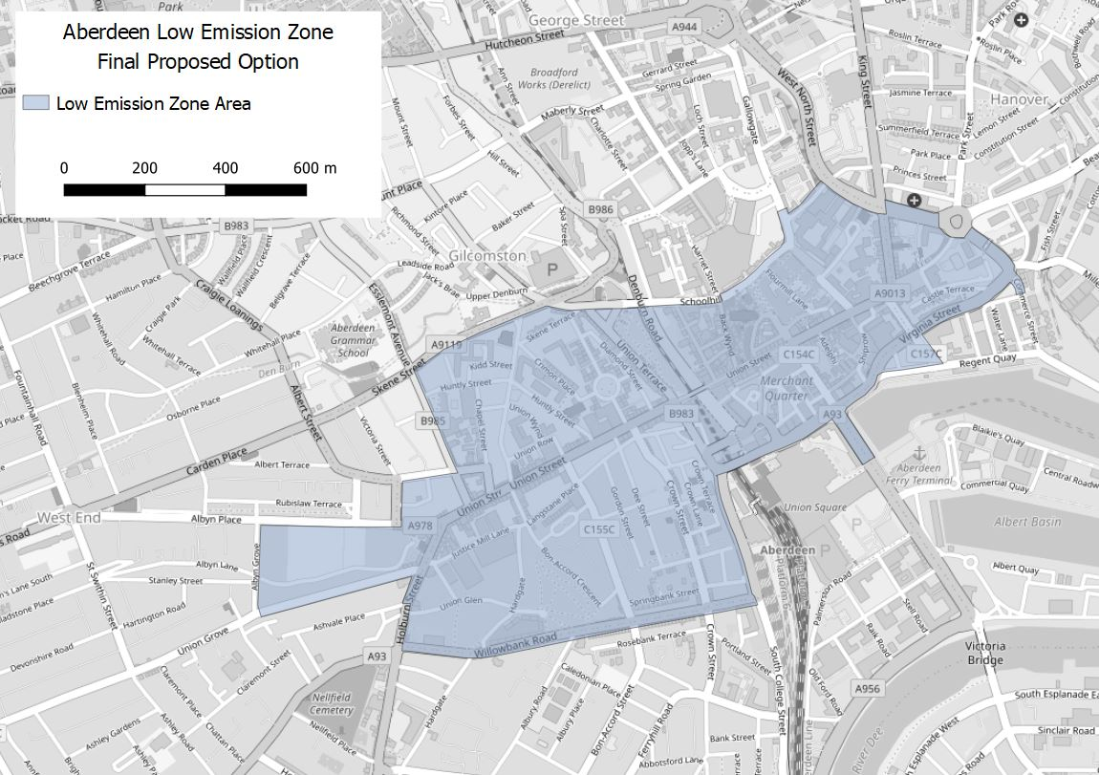
Figure 2: Proposed LEZ

A list of roads falling within the proposed LEZ area are provided in Table 1 below.

Table 1 : Schedule of Streets within Proposed LEZ
Roads within LEZ Boundary | Detail
Academy Street | Full length
Adelphi | Full length
Affleck Place | Full length
Affleck Street | Full length
Albany Court | Full length
Albyn Lane | From Albyn Grove Junction to end of lane by Holburn Street
Albyn Place | From Albyn Place Junction to Albyn Place Junction (semi crescent by Harlaw Academy)
Alford Place | Full length
Back Wynd | Full length
Bath Street | Full length
Belmont Street | Full length
Board Street | Full length
Bom-Accord Crescent | Full length
Bom-Accord Crescent Lane | Full length
Bon-Accord Lane | Full length
Bon-Accord Square | Full length
Bon-Accord Street | Full length
Bon-Accord Terrace | Full length
Bridge Place | Full length
Bridge Street | Full length
Carmelite Lane | Full length
Carmelite St | Full length
Castle Street | Full length
Castle Terrace | Full length
Castlehill | Full length
Chapel Street | Full length
College Street | From Windmill Brae Junction to Wapping Street
Commerce Street | From Beach Boulevard Roundabout to Mearns Street Junction
Concert Court | Full length
Correction Wynd | Full length
Craibstone Lane | Full length
Crimon Place | Full length
Crown Lane | Full length
Crown Street | Full length
Crown Terrace | Full length
Dee Place | Full length
Dee Street | Full length
Denburn Road | Full length
Diamond Lane | Full length
Diamond Place | Full length
Diamond Street | Full length
East Craibstone Street | Full length
East Green | Full length
East North Street | Full length
Exchange Lane | Full length
Exchange Street | Full length
Flourmill Lane | Full length
Gaelic Lane | Full length
Gallowgate | From Upperkirkgate Junction to Littlejohn Street Junction
Gilcomstoun Court | Full length
Golden Square | Full length
Gordon Street | Full length
Guild Street | Full length
Hadden Street | Full length
Hardgate | Full length
Holburn Street | From Union Street Junction to Ashvale Place Junction
Huntly Street | Full length
Imperial Place | Full length
Justice Mill Brae | Full length
Justice Mill Lane | Full length
Justice Street | Full length
Kidd Street | Full length
King Street | From Marischal Street Junction to West North Street Junction
Langstane Place | Full length
Lindsay Street | Full length
Little Belmont Street | Full length
Little Chapel Street | Full length
Littlejohn Street | Full length
Marischal Street | Full length
Market Street | From Union Street Junction to Union Square bus station
Market Stance | Full length
Marywell Street | Full length
Minister Lane | Full length
North Silver Street | Full length
Netherkirkgate | Full length
Oldmill Road | Full length
Peacock's Close | Full length
Poultry Market Lane | Full length
Queen Street | Full length
Rennie's Court | Full length
Rennie's Wynd | Full length
Rose Place | Full length
Rose Street | From Thistle Street Junction to Union Street Junction
Ruby Lane | Full length
Ruby Place | Full length
South Silver Street | Full length
Schoolhill | From Upperkirkgate to Back Wynd Junction
Shiprow | Full length
Shoe Lane | Full length
Shore Brae | Full length
Shore Lane | Full length
Skene Terrace | Full length
Springbank Street | Full length
Springbank Terrace | Full length
St John's Place | Full length
St Mary's Place | Full length
St Nicholas Lane | Full length
St Nicholas Street | Full length
Stirling Street | Full length
Strawberry Bank Parade | Full length
Summer Street | Full length
The Green | Full length
Theatre Lane | Full length
Thistle Place | Full length
Thistle Street | From Rose Street Junction to Chapel Street Junction
Trinity Lane | Full length
Trinity Quay | Full length
Trinity Street | Full length
Union Bridge | Full length
Union Glen | From Holburn Street Junction to Bon Accord Gardens
Union Glen Court | Full length
Union Grove | From Albyn Grove Junction to Holburn Street Junction
Union Row | Full length
Union Street | Full length
Union Terrace | Full length
Union Wynd | Full length
Upprtkirkgate | Full length
Virginia Court | Full length
Virginia Street | Full length
W Craibstone Street | Full length
Wapping Street | Full length
Weigh-House Square | Full length
Whitehouse Street | Full length
Willowbank Road | Full length
Willowgate Close | Full length
Windmill Brae | Full length
Windmill Lane | Full length

The option being proposed is considered by ACC and delivery partners as the optimum LEZ for Aberdeen following option appraisal in accordance with the National Low Emission Framework (NLEF) and Scottish Transport Appraisal Guidance (STAG). This has encompassed:
- Identification of a longlist of possible LEZ options which were sifted into a manageable number of realistic options for appraisal;
- Ongoing and iterative sifting and appraisal of options against a range of criteria, supplemented by traffic and air quality modelling; and
- Public and stakeholder engagement on options to understand the likely impacts on residents and businesses.
The option being proposed is the one that, upon completion of the above processes, is considered feasible and deliverable and has been shown to strike the most appropriate balance between maximising the air quality and public health benefits and minimising disbenefits, in terms of traffic displacement and impacts on local residents and businesses. Based on previous consultation it is also anticipated that this option will have a reasonably high degree of public acceptability compared to other options previously consulted upon.
The traffic and air quality modelling suggests that, even with the LEZ in place, some areas of pollution will remain unless further traffic reduction measures are introduced, therefore it is likely that the LEZ will be accompanied by changes to roads in the city centre to prioritise people walking, wheeling, cycling and using public transport.
The modelling also suggests that the LEZ may cause traffic increases on certain streets to the south and west of the zone that are not suitable for such an increase. The LEZ will also therefore require access restrictions to and from Millburn Street at its junction with South College Street / Palmerston Place to mitigate these impacts.
The full option appraisal process that has culminated in the identification of the preferred option is described in detailed within the Interim NLEF Stage 2 report, which is available to view alongside the consultation materials.
5 Introduction Date and Grace Period
It is ACC’s intention to introduce the LEZ on 30th May 2022.
A 2-year grace period (during which enforcement of the LEZ will not take place) is proposed for both residents and non-residents of the LEZ area and for all non-exempt vehicle types, meaning enforcement will commence on 30th May 2024.
The decision to apply a 2-year grace period has been informed by feedback obtained through previous consultation and stakeholder engagement as to how quickly those affected by the introduction of the LEZ may become compliant. In addition, the unprecedented impact of the COVID-19 pandemic on society, including the wider environment and economy, needs to be considered. Potential implications for city centre businesses and bus operators suggests that a grace period greater than the required 1 year minimum is appropriate. The 2-year grace period would be applicable to all vehicle types from the same date to ensure consistency and ease of enforcement and wider communications. No additional grace period for residents of the zone is proposed.
6 Hours of Operation
It is proposed that the LEZ operates for 365 days a year, 24 hours a day. The legislation allows for the LEZ to be suspended for the duration of events of local or national significance. These will be determined on a case by case basis but could include events such as the Winter Festival. The LEZ can also be suspended in emergency situations, such as an incident on the wider road network that requires all vehicles to be temporarily diverted through the LEZ area (but only where vehicles follow prescribed diversionary routes).
7 LEZ Scope
The LEZ will apply to all vehicle types specified in the table below, unless subject to an exemption (see section 8):
Table 2: Vehicle types within scope of the LEZ
Vehicle | Vehicle Category | Description
Light passenger vehicles | M1 | Vehicles designed and constructed for the carriage of passengers and comprising no more than eight seats in addition to the driver’s seat.
Minibus | M2 | Vehicles designed and constructed for the carriage of passengers, comprising more than eight seats in addition to the driver’s seat, and having a maximum mass not exceeding 5 tonnes.
Bus and coach | M3 | Vehicles designed and constructed for the carriage of passengers, comprising more than eight seats in addition to the driver’s seat, and having a maximum mass exceeding 5 tonnes.
Light Goods Vehicles (LGVs) | N1 | Vehicles designed and constructed for the carriage of goods and having a maximum mass not exceeding 3.5 tonnes.
Heavy Goods Vehicles (HGVs) | N2 | Vehicles designed and constructed for the carriage of goods and having a maximum mass exceeding 3.5 tonnes but not exceeding 12 tonnes.
 | N3 | Vehicles designed and constructed for the carriage of goods and having a maximum mass exceeding 12 tonnes.
Vehicles will be permitted access to LEZs on the basis of their exhaust emissions standard. Mandatory nationally consistent emission standards for Scottish LEZs have been set for virtually all petrol and diesel vehicle classifications (e.g. buses, taxis, vans, HGVs, cars, motorcycles) within The Low Emission Zones (Emission Standards, Exemptions and Penalty Charges) (Scotland) Regulations 2021). These are shown in Tables 3 and 4.
Table 3: LEZ emission standard for compression ignition (diesel) engines
Vehicle category | Emission standards | Euro Categories
Heavy-duty vehicles (e.g. HGVs and buses/coaches) | Euro VI | M2, M3, N2, N3
Light passenger and light goods vehicles | Euro 6 | M1, M2, M3, N1, N2
Special category vehicles:  - an ambulance (which is not exempt under the Regulations);  - a hearse;  - a motor caravan. | Euro 6 | M1, M2, M3
Table 4: LEZ emission standard For positive ignition (petrol and gas) engines
Vehicle category | Emission standards | Euro Categories
Heavy-duty vehicles (e.g. HGVs and buses/coaches) | Euro IV | M2, M3, N2, N3
Light passenger and light goods vehicles | Euro 4 | M1, M2, N1, N2
Special category vehicles:  - an ambulance (which is not exempt under the Regulations);  - a hearse;  - a motor caravan. | Euro 4 | M1, M2, M3
Vehicles can be retrofitted with emission abatement technology to improve emissions. Suitably certified retrofitted or repowered vehicles - where the emission standards are confirmed to a Euro 6/VI standard equivalent - will also be LEZ compliant.
Aberdeen's LEZ will not apply to motorcycles and mopeds given the limited contribution these make to NO₂ emissions.
8 Exemptions
As identified in The Low Emission Zones (Emission Standards, Exemptions and Penalty Charges) (Scotland) Regulations 2021, a number of vehicle types will be exempt from LEZs in Scotland, meaning that any restrictions will not apply to them.
Table 5: National Exemptions
Vehicle type or classification | Description
Emergency vehicles | The vehicle is being driven by any person who is:  - undertaking their duty as a constable;  - providing a response to an emergency at the request of the Scottish Ambulance Service Board;  - exercising the functions of the Scottish Ambulance Service Board, the Scottish Fire and Rescue Service, Her Majesty's Coastguard or the National Crime Agency.
Naval, military or air force vehicles | - Vehicles being used for naval, military or air force purposes.
Historic vehicles | - The vehicle was manufactured or registered under the Vehicle Excise and Registration Act 1994 for the first time at least 30 years ago;  - The vehicle is no longer in production; and  - The vehicle has been historically preserved or maintained in its original state and has not undergone substantial changes in the technical characteristics of its main components.
Vehicles for disabled persons | - The vehicle is being driven by any person who is in receipt of a badge (a blue badge) that has been issued under Section 21(2) of the Chronically Sick and Disabled Persons Act 1970,  - a passenger in the vehicle has been issued with a badge under that Section of that Act; or  - a badge for the vehicle has been issued under Section 21(4) of that Act; or  - a reduction in annual rate of vehicle excise duty applies because the vehicle is being used by a disabled person in receipt of personal independence payment at the standard rate; or  - Vehicles registered with a 'disabled' or 'disabled passenger vehicles' tax class e.g. the vehicle is exempt from payment of vehicle excise duty under paragraph 19(1) or 20(1) of schedule 2 of the Vehicle Excise and Registration Act 1994 (exemptions from excise duty for vehicles used by disabled persons).
Showman vehicles | - Vehicles described as either “showman’s goods vehicle” or “showman’s vehicle” according to Section 62(1) of the Vehicle Excise and Registration Act 1994. Note: these are highly specialised vehicles used for the purposes of travelling showmen, where the vehicle is used during the performance, used for the purpose of providing the performance or used for carrying performance equipment.
* Note: blue badges are assigned to a person, not a vehicle, so a blue badge holder could travel in any vehicle and the rules of the blue badge would be applied to that vehicle on that day of travel.
ACC can also grant and renew time-limited exemptions to any vehicle type that is not covered by a national exemption, meaning the registered keeper of the vehicle would be exempt from LEZ enforcement for the period of time that the exemption applies. Such exemptions are likely to only be granted in exceptional circumstances where it can be clearly demonstrated that vehicle operators or groups are doing all they can to comply with the LEZ but may require longer time than the agreed grace period. There are no exemptions proposed at the moment, although there may be examples raised during consultation that ACC will consider prior to making final proposals.

9 Penalty Charges and Surcharges
Should ACC believe a vehicle is in contravention of the LEZ, it will serve a Penalty Charge Notice (PCN) on the registered keeper.
The default penalty charges for LEZs are set in Schedule 4 of the Low Emission Zones (Emissions Standards, Exemptions and Enforcement) (Scotland) Regulations 2021 and therefore are consistent across all of Scotland.
The initial penalty charge for all non-compliant vehicles is set at £60, reduced by 50% if it is paid within 14 days. The penalty amount doubles with each subsequent breach of the rules detected in the same LEZ. The penalty charges are capped at £480 for cars and light goods vehicles and £960 for buses and HGVs. Where there are no further breaches of the rules detected within the 90 days following a previous violation, the penalty is reset to the base tier of charge i.e. £60.
Table 6 – LEZ Penalty Rates and Surcharges
Vehicle category | Initial Penalty Charge | Subsequent Penalty Charges
 | 1 | 2 | 3 | 4 | 5
Light passenger vehicle | £60 | £120 | £240 | £480
Mininbus | £60 | £120 | £240 | £480 | £960
Bus and coach | £60 | £120 | £240 | £480 | £960
Light goods vehicles | £60 | £120 | £240 | £480
Heavy goods vehicle | £60 | £120 | £240 | £480 | £960
Special Purpose Vehicles | £60 | £120 | £240 | £480

Enforcement will commence following the end of the 2-year grace period and will be via Automatic Number Plate Recognition (ANPR) cameras.

10 Representations and Next Steps
ACC is now inviting responses to our LEZ proposals. A consultation period will run from 28th June to 22nd August 2021. Those wishing to respond can:
- Submit a response via the online consultation page:
https://consultation.aberdeencity.gov.uk/planning/lowemissionzone;
- Email a response to transportstrategy@aberdeencity.gov.uk; or
- Submit a written response to: Transport Strategy and Programmes, Aberdeen City Council, Ground Floor North, Marischal College, Broad Street, Aberdeen, AB10 1AB
Responses received will help inform the final LEZ scheme submitted to Scottish Ministers later in the year.

