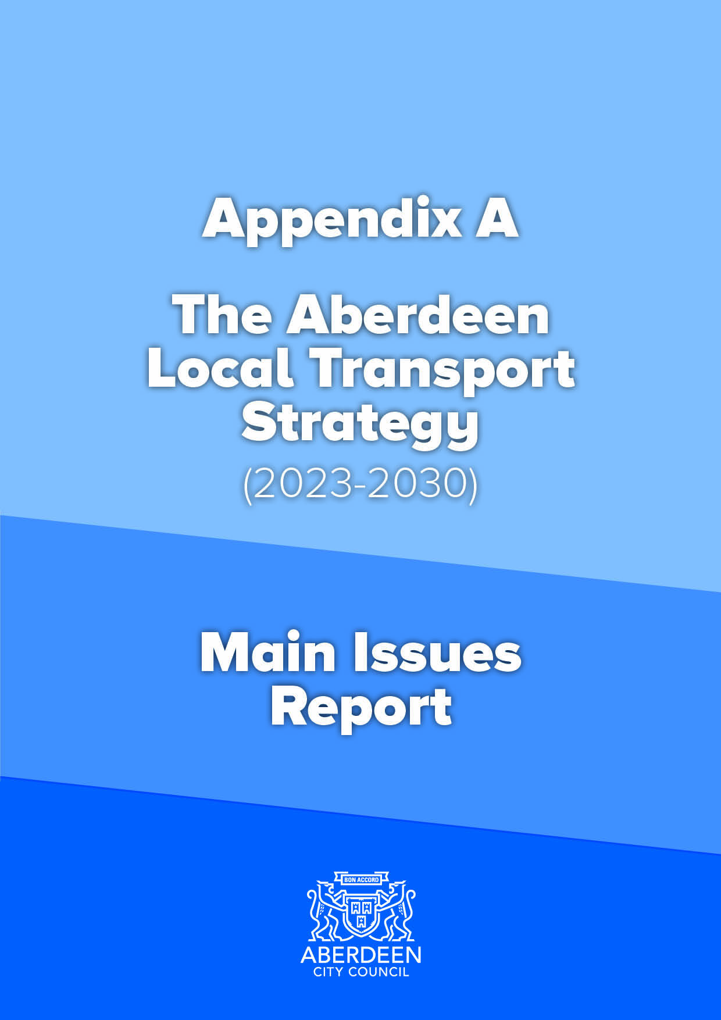

Appendix A
Aberdeen Local Transport Strategy (2023-2030) – Main Issues Report

Executive Summary
The Aberdeen Local Transport Strategy (LTS) sets out the City’s ambitions for the development of the transport network, traditionally over a five-year period.
Aberdeen’s current LTS covers the time period from 2016 to 2021. Since it was developed, a lot has changed, both in terms of the City’s transport network and also in the wider policy, plan and strategy context.
“Working in Partnership for Aberdeen”, Aberdeen’s SNP and Liberal Democrat partnership statement, contains a commitment to “Delivering a revised Local Transport Strategy”. Furthermore, Aberdeen City Council’s delivery Plans for 2021/22 and 2022/23 contain the policy statements to “Refresh the Local Transport Strategy” and note that this should be done following the review of the Regional Transport Strategy (RTS). The RTS was formally adopted in November 2021 so development of the next LTS can begin.
To begin this process, it is necessary to establish the main issues that the next LTS will have to cover. This involved.
- Reviewing the 190 actions from the previous LTS (2016-2021) to see what had been achieved, what was still under development and what had not been taken forward.
- Reviewing progress against the 43 Key Performance Indicators (KPIs) in the previous LTS.
- Undertaking a round of public and stakeholder consultation to ask respondents what they thought the main issues were. This attracted 387 responses.
- Reviewing the relevant policies, plans, strategies and projects at National, Regional and Local level to establish what had changed since the previous LTS.

From this, and in line with Scottish Transport Appraisal Guidance (STAG) principles, the main drivers, challenges and opportunities for the next LTS have been established. This has allowed Transport Planning Objectives (TPOs) to be developed to ensure that the next LTS is able to meet these, along with Outcomes, Outputs and a new Vision to tie these all together.
Given that so many targets, already set at National level, go to 2030, it is proposed that the next LTS will span the period to 2030, rather than just being a traditional 5-year window.
Having undertaken these aspects, the next stage of the STAG process is to generate options, or approaches, for the next LTS to take. Six draft options have been developed.
These six draft options will then be taken forward for appraisal against the TPOs and the STAG Criteria. These are presented in the table below.
Table 1 – TPOs and STAG Criteria
Transport Planning Objectives (TPOs) | Scottish Transport Appraisal Guidance (STAG) Criteria
TPO1 – Climate and Environment - Reduce the negative impact of transport on the climate and the environment in Aberdeen | S1. Environment
TPO2 – Health – Improve transport opportunities in Aberdeen that help enable and promote healthy lives and give access to healthcare | S2. Climate Change
TPO3 - Safety – Improve the safety of the Aberdeen transport network and reduce safety issues for users. | S3. Health, Safety and Wellbeing
TPO4 - Economy - Ensure more efficient movement of people and goods across, into and from both Aberdeen city and the whole region. | S4. Economy
TPO5 - Accessibility/ inclusivity/ user-friendly – Improve the user-friendliness of the Aberdeen transport network, making it more accessible and inclusive | S5. Equality and Accessibility
TPO6 - Resilience - Ensure the Aberdeen transport network is more resilient and can react to unplanned circumstances and extreme weather | S6. Feasibility
TPO7 – Technology – Ensure Aberdeen has a transport network that can better adapt to changes in technology and capitalises on existing technological opportunities. | S7. Affordability
TP08 – Modal shift – Reduce the need to travel and reduce dependency on the private car in Aberdeen | S8. Likely public acceptability

This will then allow the best scoring approach to be selected and a draft LTS to be developed.

Section 1 – A New Local Transport Strategy
1.1 What is an LTS and why do we need a new one?
1.1.1 The Aberdeen Local Transport Strategy (LTS) sets out the city’s ambitions for the development of the transport network, traditionally over a five-year period. This includes a vision and objectives for the city’s transport network which will inform an action plan to be completed over the lifespan of the strategy to improve the transport network. It deals with all modes and aspects of transport including walking, wheeling, cycling, public transport, freight, taxis, motorcycles, car sharing, car clubs, car and van use, parking and low carbon fuels as well as the relationship between transport and other areas such as land use, placemaking, the economy, development of communities, health and the environment. The LTS is informed by the national and regional transport policies, strategies, plans and projects, along with those relating to economic, environmental, health and social factors at national, regional and local levels. It also relies on input from members of the public and stakeholders to ensure it reflects the needs of people and businesses.

1.1.2 The current Aberdeen LTS was adopted in 2016. “Working in Partnership for Aberdeen”, Aberdeen’s SNP and Liberal Democrat partnership statement, contains a commitment to “Delivering a revised Local Transport Strategy”. Furthermore, In its Council Delivery Plans for 2021/22 and 2022/23, Aberdeen City Council have the policy statement to “Refresh the Local Transport Strategy” and note that this should be done following the review of the Regional Transport Strategy (RTS). The RTS was formally adopted in November 2021, paving the way for development to start on the next LTS.
1.1.3 It is also worth noting what an LTS is not. It is not something which goes into specific detail about schemes. It will not say, for example, that we will put a cycleway down a particular street or how it will be designed. In terms of scope, it is not purely about roads and traffic. It’s about a whole transport network and this also covers not travelling at all. Despite concerns, an LTS is not an anti-car document either. Car is an important part of the transport offering and therefore needs to be considered as part of the whole transport system. Likewise, the LTS will not showing preference to one particular area. This means it will not be trying to improve the economy, communities, the environment, health, technology or land use alone but will consider them all.
1.1.4 The LTS is not a wish list of schemes but a strategy to improve the transport network backed up by evidence. The views of the public and transport users are therefore essential to this.

1.2 Developing the next LTS

1.2.1 The development of the next Aberdeen LTS will be based around the Scottish Government’s Scottish Transport Appraisal Guidance (STAG) process. A Core Team, made up of officers from Aberdeen City Council, NESTRANS, Aberdeenshire Council and NHS Grampian, has been formed to oversee the process and agree key stages.

1.2.2 In order to undertake a STAG-based assessment, the first stage is to establish the main issues that the LTS should cover. This involved:

- Reviewing the 190 actions from the previous LTS (2016-2021) to see what had been achieved, what was still under development and what had not been taken forward.
- Reviewing progress against the 43 Key Performance Indicators (KPIs) in the previous LTS.
- Undertaking a round of public and stakeholder consultation to ask respondents what they thought the main issues were. This attracted 387 responses.
- Reviewing the relevant policies, plans, strategies and projects at National, Regional and local level to establish what had changed since the previous LTS.

1.2.3 Further details of the above can be found in Appendices 1,2,3 and 4 (these will be available online).

Section 2 – What was achieved under the previous LTS?

2.1 Reviewing the Actions from the previous LTS

2.1.1 The summary of progress of the 190 actions from the previous LTS are presented in the following table:

Table 2 – Review of current LTS Actions

Number which are being achieved (completed or the action in itself relates to something which is ongoing/ recurring). | 142 (75%)
Number which are underway (started but not completed). | 31 (16%)
Number which have not been realised. | 10 (5%)
Number which cannot be reported upon due to insufficient information. | 7 (4%)

2.1.2 A summary of some key projects is listed below:
- A Sustainable Urban Mobility Plan (SUMP), Active Travel Action Plan and Electric Vehicle (EV) Framework are all adopted and sit as daughter documents to the LTS. They all go beyond the lifespan of the current LTS.
- A Roads Hierarchy study, subsequent multi-modal corridor studies, strategic car parking review, origin and destination study have all been completed or initiated to better understand and plan the movement of people and goods.
- A low emission zone for the city centre has been developed and became operational in May 2022.
- The City Centre Masterplan is being refreshed and a Masterplan is developing for the Beach. The two are to be linked.
- 20 Noise Management Areas and 4 Quiet Areas have been declared in Aberdeen.
- The walking and cycling network and supporting facilities continue to grow and improve.
- A Bike Hire contract has been awarded and set up is underway.
- Enhanced CCTV capable of counting walking and cycling movements is being rolled out in 43 locations across the city.
- 32 of the Council’s 45 primary schools are offering Bikeability Levels 1 and 2.
- An I-Bike Officer has been working with schools to promote cycling since 2017.
- An I Bike Communities officer has been supporting this work, working with adults to promote cycling since 2022.
- The Aberdeen Walking and Cycling Index (WACI) was published in 2022.
- In 2018, the North East Bus Alliance (replacing the former Local Authority Bus Operator Forum (LABOF)) was established with a revised Terms of Reference and Quality Partnership Agreement.
- A successful bid was made to Transport Scotland’s Bus Partnership Fund of £12M including support for Aberdeen Rapid Transit.
- Craibstone Park and Ride delivered.
- Contactless payment on buses.
- Opening of Kintore station and ongoing improvements to Aberdeen railway station.
- Completion of rail track redoubling project between Aberdeen and Inverurie.
- Aberdeen Western Peripheral Route and Balmedie to Tipperty Improvement opened.
- Work ongoing to progress improvements to Berryden Corridor and South College Street.
- The Aberdeen Car Club, run under contract with the Council, continues to grow and add to green its fleet.
- Two hydrogen filling stations are now operational in the city.
- The network of EV charge points continues to expand, both with Council organised installations and those by other organisations.
- Cashless parking, as of April 2021, is available in all of the Council’s controlled parking zones.
- A review of licencing requirements is currently being undertaken with the Council’s legal and Licencing colleagues to increasing the number of ultra low or low emission vehicles onto the taxi and PHC fleets.
- Revision of the Council’s own Travel Plan has been delayed due to COVID-19 related factors.
- A Car Parking Action Plan was delayed due to COVID-19 factors and changes being made to the City Centre and Beach areas.
2.1.3 This shows that, although much has been achieved, many of the actions were just the starting point for realising much greater transport improvements and need to be further developed, either through their implementation or further works, while some others are yet to be realised. Therefore, a case exists for a new LTS to further develop and build on what has already been achieved and across all modes.
2.2 Monitoring of LTS Outcomes and Indicators for the 2016-2021 LTS
2.2.1 Having reviewed progress against the 190 actions, this section turns to additional monitoring, against the outcomes and the 43 indicators that were set in the 2016-2021 LTS. It provides a brief overview of the results of a monitoring report carried out on the current Local Transport Strategy 2016-2021. Also provided is commentary on the performance of the strategy against a set of original indicators set in 2016 and against the six main outcomes in the strategy.
2.2.2 The 6 main outcomes were:
- Increased modal share for public transport and active travel;
- Reduced the need to travel and reduced dependence on the private car;
- Improved journey time reliability for all modes;
- Improved road safety within the City;
- Improved air quality and the environment; and,
- Improved accessibility to transport for all.
2.2.3 Based on the 43 indicators that were set for monitoring the LTS, Chart 1 shows the results below.
Chart 1 – Progress against the 43 indicators.

2.2.4 The RAG stands for Red, Amber and Green indicators. The green indicators show improvement. These include improvements in: adult walking and cycling to work and working from home; cycling to school; usage of the Kingswells Park and Ride; membership of the car club; air quality and decreases in private car use; and in accident and casualty rates. Cost of public transport relative to inflation had also fallen overall while cost of city centre parking, relative to inflation, had risen.
2.2.5 The amber indicators were for things that stayed largely the same. These included changes in travel to work by rail and the number of drivers reporting congestion delays.
2.2.6 For the red indicators, those which had gone in the wrong direction, these included taking the bus to work and school, usage of the Bridge of Don Park and Ride, satisfaction with bus punctuality and numbers of Noise Management Areas.
2.2.7 However, due to the small sample sizes and the lag in available data, meaning that data was only available up to 2019, it was felt that this did not truly represent the full picture and failed to fully represent the changes that have recently affected the transport network such as the effects of the Aberdeen Western Peripheral Route (AWPR) opening and the effects of COVID-19. Therefore, a comparator set of data using the Council’s City Voice surveys was used to ascertain whether any trends could be established in the data. On comparing the data this showed similar results to the original indicators, although it was not possible to do a direct comparison as the questions asked in the City Voice surveys were different to the questions asked in the Scottish Household Surveys (SHS), which were one of the main sources of data for the original indicators.
2.2.8 Taking both new and original sources into account, a Red, Amber Green (RAG) analysis of the 6 current LTS outcomes, presented below in Table 3, shows that most outcomes have remained relatively stable, with only two having shown modest increases. This is due mainly to mixed results in the indicators with some indicators having increased slightly, whilst others have declined slightly, therefore cancelling out each other, thus showing no change overall. There is therefore the opportunity for the next LTS to build on this modest start to achieve the wider aim of increasing modal shift to active and sustainable travel by providing both the infrastructure and opportunity for more sustainable travel modes. It also provides a great opportunity to look at how future outcomes are monitored and whether new sources of data are required.
Table 3 – RAG analysis of the current LTS outcomes
Outcome | Sources | RAG Analysis
Increased modal share for public transport and active travel | SHS and Hands Up Scotland Survey (HUSS), City Voice | =
Reduce the need to travel and reduce the dependence on the private car | SHS and Aberdeen City Council (ACC) Internal Data, City Voice | ↑
Improved journey time reliability for all modes | Scottish Transport Statistics (STS), City Voice | ↑
Improved road safety within the city | STS, City Voice | =
Improved air quality and the environment | ACC Internal Data | =
Improved accessibility to transport for all | Operator’s websites, Nestrans Monitoring Report 2020 and Passenger Focus, City Voice | =
2.2.9 The infographics below for the SHS and STS data (Chart 2) and City Voice “Travel to work” data (Chart 3) show the percentage reduction or increase for each transport mode. SHS/ STS data spans 2015 to 2019 (the latest year available) with City Voice spanning 2017-2020. It can be seen that although they are not directly comparable, the data is relatively similar with both showing modest increases or decreases as appropriate. Green shows improvement – trends going in the right direction - and red the opposite.
Chart 2 - SHS/STS Infographic
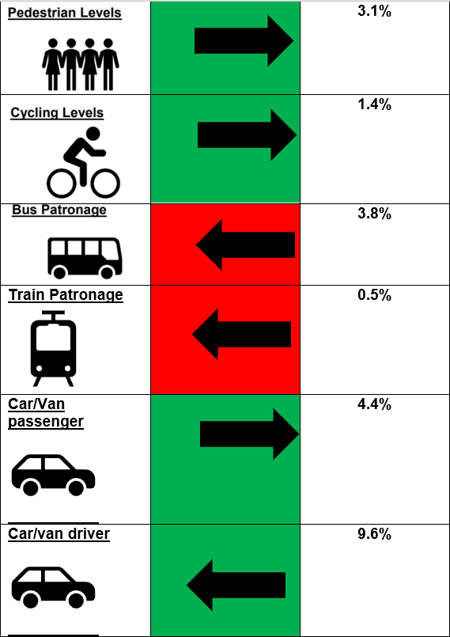
Chart 3 – City Voice Infographic
. 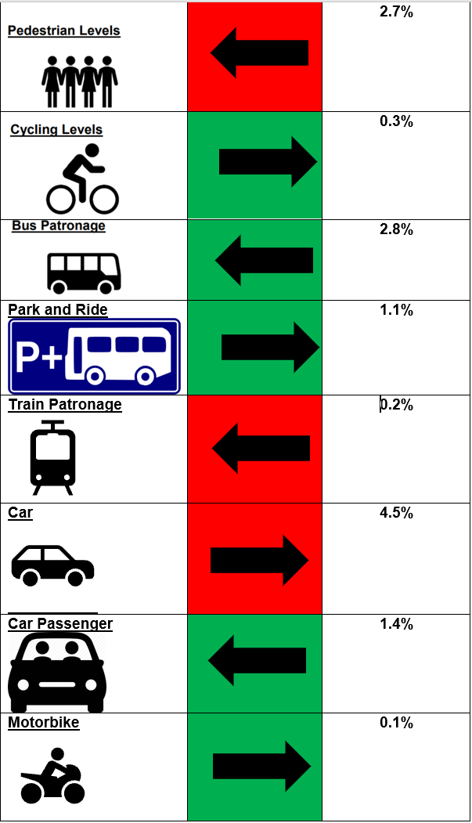

2.2.10 However, they, do not take account of the effects of COVID-19. Therefore, data was collected internally both by the Council and Nestrans, together with Transport Scotland data to examine the effect that the COVID-19 pandemic has had on the city’s transport network. The final infographic, Chart 4, below shows the change between pre-COVID figures in July 2019 and the same month in both in 2020 and 2021. This shows both the immediate effect of COVID-19 and the longer lasting effect. There was a significant rise in walking and cycling in 2020, whilst both car use and public transport usage showed significant reductions. Given that the advice was to stay at home, except for essential journeys and to work from home, this was perhaps to be expected. It was also perhaps to be expected that NO₂ levels would fall too, given that transport is a major contributor to NO₂ levels. However, by 2021, walking rates had fallen, although they were still higher than 2019 levels while car use had risen again, although still at lower levels than 2019. Cycling levels had dropped too back to 2019 levels and, although public transport use had improved, it had still not got back to 2019 levels. Emissions however, continued to fall possibly due to an increase in lower emitting vehicles.
Chart 4 – COVID Data monitoring
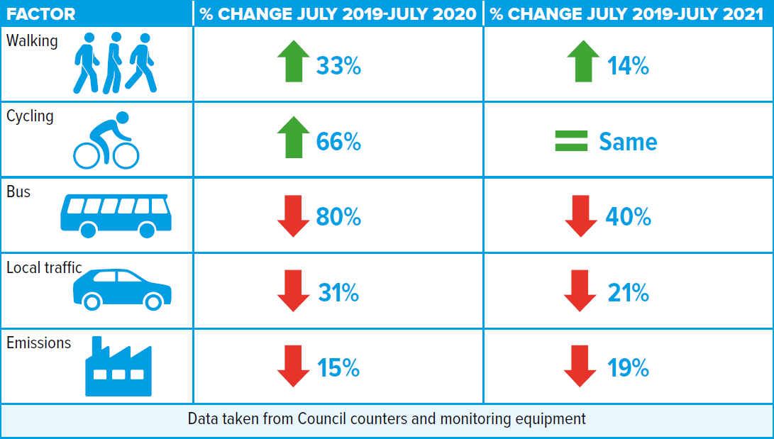
2.2.11 What is clear from the Covid infographic is the dramatic effect that a major shock, can have on the transport system. However, it also shows the opportunities that can arise if radical and ambitious policies and targets are implemented in an effort to reach net zero and achieve a true shift in travel behaviour to more sustainable travel modes. It also suggests that when there is less traffic and more segregated space, conditions for active travel become more attractive so more people want to use it.
2.2.12 Restrictions have been lifted following the second lockdown. Comparisons with February 2019 and February 2022 are shown in Table 4 below
Table 4 – Mode share changes between 2019 and 2022 (Data from Council monitoring)
Mode | % change in level in February 2022 compared with February 2019
Walking | +43%
Cycling | -32%
Bus | -40%
Traffic | -19%
2.2.13 This shows that walking levels remain higher than pre-pandemic levels. Although traffic levels and public transport usage have grown compared with levels during the pandemic they still remain lower than pre-pandemic ones. Cycling, which experienced growth during the pandemic has now reduced to below the pre-pandemic level at the monitoring sites.
2.2.14 Travel behaviour studies, undertaken at Regional level by NESTRANS during COVID-19 restrictions, show that there is still apprehension from the public about the risk of contracting Covid through using public transport with nearly 80% of people stating they have concerns. This is despite the stringent cleaning routines that operators have put in place. There is therefore a need for a publicity campaign to promote public transport as being a safe mode of transport as the recovery continues.
2.2.15 Longer term, almost half of the respondents said they would like to work more flexibly. There is also an expectation that video conferencing will become the norm with the majority (84%) of respondents to the survey in January 2022, anticipating that virtual meetings will replace some, or all, face to face business meetings/ trips once all restrictions were lifted.
2.2.16 It is clear therefore that Covid will have an effect on how we work and travel and that there will be opportunities to be gained from this change in attitudes and behaviour. The next version of the LTS must therefore take account of this change and build upon the opportunities created by the changing attitudes to travel.
Section 3 – What do public and stakeholders regard as the main issues for transport?
3.1 Main issues public consultation
3.1.1 The Aberdeen Local Transport Strategy main issues consultation was published online for responses for a period of 6 weeks from 4th October to 14th November 2021. A total of 384 online responses were received. 15 questions were asked; of which 10 were in direct relation to the local transport strategy and the remaining 5 were demographic questions.

3.1.2 The consultation was open to both members of the public and organisations. A range of key stakeholders were also contacted directly and were asked to respond to the questionnaire. In addition to the 384 online responses, 3 stakeholders also submitted written responses – NESTRANS, Aberdeenshire Council and The Aberdeen Cycle Forum. NESTRANS and Aberdeenshire Council both required committee/ board approval of their responses prior to submission so could not submit in the online survey format. The views of the Aberdeen Cycle Forum did not follow the questionnaire template but were consistent with other comments from the online survey concerning active travel, particularly around the issues.

3.1.3 Of the 387 responses received , 373 (96%) responses were from individuals, while 12 (4%) responses were on behalf of an organisation.

3.2 Challenges

3.2.1 When asked to identify what they thought were the current and future problems affecting transport, the following, shown in Table 5, emerged as the most popular answers:

Table 5 – Current and Future Challenges

Current Challenges | Future Challenges
Congestion/Traffic Bottlenecks. | Continued Car-Dependency.
Emissions/Pollution/Climate Change issues. | More Congestion/Traffic Build-up.
Lack of / Limited Public Transport Options. | Continued Pollution/Emissions.
Unreliable/Poor Bus Services. | Continued Lack of Public Transport Options.
Too Many Cars/Heavy Car-Dependency. | Further Decline of the City Centre.
Lack of Cycling Infrastructure & Facilities. | Inequality/Socio-economic Disparity.
Expensive Public Transport Fares. | Limited/Insufficient EV Charging Infrastructure.
Declining Patronage of the City Centre. | Continued Lack of Cycling Infrastructure.
Indiscriminate Parking/Lack of Parking Enforcement. | Continued User Conflict on Limited Infrastructure between Pedestrians, Cyclists, and motorised vehicles.
Lack of Integrated Public Transport Services. | Pressure on the Transport System due to New Developments.
Closure of Union Street. | Continued closure of Union Street will further exacerbate congestion around the City Centre.

3.3 Opportunities

3.3.1 When asked to identify what they thought were the current and future opportunities affecting transport, the following, shown in Table 6, emerged as the most popular answers:

Table 6 – Current and Future Opportunities

Current Opportunities | Future Opportunities
Provision of Better Bus Services including Routing, Fares, Wayfinding Information & Bus Hubs. | Improve the Public Transport System/Increase Public Transport Options such as more local Train Stations, Tram or Subway.
Increase Uptake of Active Travel / Create an Environment that facilitates more Walking & Cycling / Provide Safe Cycling Infrastructure such as protected cycle lanes, storage facilities, comprehensive network. | More Regular Bus and Train Services & Cheaper Fares.
Encourage More Clean Fuel Public Transport e.g. Hydrogen/Electric Buses/Vehicles. | Better EV Charging Network/Increase EV Charging Points.
Provide A Good Transport System That is Well-Linked & Connected. | Better Enforcement of Parking & Driving Offences.
Decrease Road Traffic/Create Less Car-centric Transport System. | Implement Safer Cycle Networks/Segregated Lanes.
Increase Access to the City Centre to  Keep It Alive. | Link Rail Transport to the Airport.
Increase EV charging Points/Infrastructure. | Increase Number of car club EVs.
Enforce the Use of Park & Rides. | Build a Park & Ride South of Aberdeen with Good Cycle Facilities.
Open Castlegate to Buses Linking It to The Beach Area. | Encourage the Use of Park & Rides also Making It a Bus Hub.
Pedestrianise Union Street/Open to Bus & Taxi. | Reduce Number of Cars On Roads.

3.3.2 Rather than opportunities – external factors or other projects which could actually assist the development of the transport network – this list read more like a list of solutions to problems. Were this exercise to be repeated it may be beneficial to amend the wording of the question. However, the feedback obtained will still prove useful in establishing what respondents consider to be the main solutions or projects to focus upon.
3.3.3 From the direct stakeholder responses, from NESTRANS and Aberdeenshire Council, the following key opportunities, shown in Table 7, emerged:
Table 7 – Key Opportunities
Changing attitudes to walking and cycling as a result of COVID-19 pandemic. | New developments where sustainable transport, and its encouragement, can be built in from the start.
Changing national standards for cycle infrastructure. | Multi-modal corridor studies.
Increasing demand for rail travel. | City centre masterplan.
Low emission zone. | Sustainable transport hierarchy.
Bus partnership fund. | Further hydrogen refuelling opportunities.
3.4 What does and does not work well
3.4.1 On the question of what currently works well or not in Aberdeen with respect to transport, there were 324 online responses to what works well and 354 online responses to what does not work well. Outlined in Table 8 below are the 10 most frequently mentioned responses.
Table 8 – What does and does not work well
What Works Well | What Does Not Work Well
Walking/Pedestrian Areas/Wide Pavement in City Centre & Beach. | Irregular Pavement Surfaces.
Easy to Navigate City by Car. | Bus Services.
The Aberdeen Western Peripheral Route Taking Through Traffic Out of The City. | Expensive Taxi Fare/Poor Late Night Taxi Availability.
Car Clubs. | Public Transport Integration/Interconnection.
Airport Shuttle Bus. | Priority Given to Cars/Car-centric Aberdeen.
Taxi Service/Some Bus Routes. | High Number of Vehicles on Union Street.
Uptake of Hydrogen Buses/ Electric Vehicles. | High Parking Charges/Insufficient Parking.
Union Street Closure/Spaces for People. | Potholes/Road Maintenance.
Lighter Traffic due to Remote Working. | Substandard Cycle Network/Short Cycle Lanes/Motorists Parking on Advisory Cycle Lanes/Lack of Segregated Cycle Lanes/Narrow Shared Use Paths.
Rail Service. | Poor Rail Network/Lack of Rail Connection to Airport/Limited Number of Train Stations/Lack of Train Stations, Tram/Tube.
3.4.2 A frequently mentioned response that has not been included in the table for what works well was the response Nothing/Not Much/Not a Lot/Unsure. Around 114 respondents registered this as their response.
3.5 Potential solutions
3.5.1 Respondents were then asked to suggest solutions for things that do not work well in Aberdeen; there were 313 online responses, and the following, in Table 9, are the most frequently mentioned:
Table 9 – Potential Solutions
1.) | Prioritise Active Travel and Provide Dedicated Cycle Infrastructure that is Segregated, Safe & Well-Linked.
2.) | Improve Bus Services by Making Fares Cheaper, Services Efficient & Reliable, Placing More Buses on More Routes, Better Co-ordination of Bus Connections.
3.) | Provide More Charging Points for Electric Vehicles.
4.) | Improve Public Transport Links and infrastructure as well as Integration with Active Travel..
5.) | Open Union Street.
6.) | Use Park & Rides/Make Bridge of Don Park & Ride a Transport Hub for the North of Aberdeen.

3.6 Other areas that transport should complement and enable
3.6.1 Respondents were next invited to rank 7 factors that the transport system should take account of in the order of most important to least important on a scale of 1 to 7 respectively (with a score of 1 being highest importance). The scores that online respondents provided for each of the activities were totalled up and divided by the number of respondents to each activity which gave the following average scores, shown in Table 10:
Table 10 – Other areas that transport should complement and enable
Factor | Score (out of 7) | Rank
Enabling communities/ people | 2.8 | 1
Environment | 3.1 | 2
Economy | 3.3 | 3
Physical Health | 3.4 | 4
Mental Health | 3.5 | 5
Land Use | 3.7 | 6
Placemaking | 4.2 | 7

3.6.2 The accompanying comments suggested that not everyone was very familiar with the concept of placemaking. Again, this may benefit from better explanation in a future questionnaire.

Section 4 – Changes to the policy and strategy context since 2016 which could impact upon a new LTS

4.1 Table 11 below shows the key Policies, Plans, Studies and Strategies at National, Regional and Local level which will inform the next LTS. These are colour coded depending on whether they are National (peach), Regional (blue) or Local (green).

Table 11 – Key Policies, Plans, Studies and Strategies

National Transport Strategy 2 | Scottish Government Hydrogen Policy Statement | Forest and Woodland Strategy for Aberdeenshire and Aberdeen
Strategic Transport Projects Review 2 | UK Hydrogen Strategy | River Dee Catchment Management Plan
Transport (Scotland) Acts 2019 | Draft infrastructure investment for Scotland 2021/2 – 2025/6 | North East Flood Risk Management Plan
National Planning Framework 4 | Consultation on changes to building standards | Aberdeen Local Development Plan
Designing Streets | Free bus travel to under 22s | Aberdeen Local Development Plan Transport and Accessibility Supplementary Guidance
National Roads Development Guide | National Flood Risk Assessment 2018 | Aberdeen Local Development Plan Planning Obligations Supplementary Guidance
Cycling by Design | Nestrans 2040 - Regional Transport Strategy | Working in Partnership for Aberdeen – Aberdeen’s SNP and Liberal Democrat Partnership agreement
Cycling Action Plan for Scotland | Nestrans Bus Action Plan | Aberdeen Local Outcome Improvement Plan
National Walking Strategy | North East Bus Alliance Quality Partnership Agreement 2018 | Mobility Strategy: Net Zero Aberdeen
Active Travel Task Force Delivery Plan | Nestrans – Fares and Ticketing Action Plan Update 2017 | Aberdeen City Council Delivery Plan
Active Travel Outcomes Framework 2019 | Nestrans State of the bus network report | Aberdeen Active Travel Action Plan
Rail Enhancements and Capital Investment Strategy | Nestrans Park and Ride Study - Final Report | Aberdeen Sustainable Urban Mobility Plan
Scotland’s Accessible Travel Framework | Nestrans Rail Action Plan | Aberdeen Electric Vehicle Framework
Smart and Integrated Ticketing and Payments Delivery Strategy 2018 | Nestrans Freight Distribution Strategy | Aberdeen Net Zero Vision and Strategic Infrastructure Plan
Scotland’s National Marine Plan | Nestrans Freight Strategy | Aberdeen City Centre Masterplan
Cleaner Air for Scotland 2 | Nestrans – Final Assessment of Freight in Aberdeen and Aberdeenshire 2020 | Aberdeen Core Paths Plan
National Low Emission Framework | Nestrans Active Travel Action Plan | Council Climate Change Plan 2021-2025
A Network Fit For The Future: Draft Vision for Scotland’s Public Electric Vehicle Charging Network (Jan 2022) | Nestrans Ultra Low Emission Vehicles Strategy | Aberdeen Hydrogen Strategy
Scotland’s Road Safety Framework to 2030. | Aberdeen City and Shire Regional Parking Strategy | Aberdeenshire Local Transport Strategy
Climate Change (Emissions Reduction Targets) (Scotland) Act 2019 | North East casualty reduction strategy | Local COVID-19 response planning
Climate Change Delivery Plan | Nestrans – Covid 19 Travel Behaviour Study | Aberdeen Adapts: Climate Adaptation Framework
Air Quality (Scotland) Regulations | North East Scotland Roads Hierarchy | North East Casualty Reduction Strategy (2017)
Climate Ready Scotland: Climate Adaptation Programme 2019-2024 | Health and Transport Action Plan | Road Safety Plan for Aberdeen City (2019-2022)
The Low Emission Zones (Emission Standards, Exemptions and Enforcement) (Scotland) Regulations 2021 | Aberdeen City and Shire Strategic Development Plan | Aberdeen Open Space Strategy
Consultation on the 20% Reduction in Car km Route Map | North East Scotland Regional Economic Strategy | North and South Dee studies
Scottish Energy Strategy | City Region Deal | Aberdeen Air Quality Action Plan
Just Transition: A fairer, greener Scotland | North East of Scotland Local Biodiversity Action Plan | Aberdeen Agglomeration Noise Action Plan

Section 5 – Turning these findings into a new LTS

5.1 Key drivers

5.1.1 Having reviewed the findings from the review of the previous LTS, the public and stakeholder consultation and examined the key policies, plans and strategies, the Key Drivers for a new LTS could be established along with a finalised list of challenges and opportunities.

5.1.2 The key drivers for the next LTS, emerging from the review of transport context, consultation and current LTS are:
Climate and Environment – Adaptation and Mitigation
- Net Zero Emissions targets (Decarbonising of the transport sector, contributing to Net Zero by 2045, SG).
- Reduction of car km by 20% by 2030 (SG Climate Change Action plan).
- 50:50 mode split between car and sustainable transport by 2040 with higher sustainable ratio in urban areas (NESTRANS RTS).
- Reduction in proportion of journeys by car drivers to less than 50% by 2030 (Net Zero Aberdeen Routemap).
- Nature crisis - Addressing the nature crisis by protecting/ managing 26% of Aberdeen’s area for nature by 2026 (ACC LOIP).
- Addressing climate change by reducing Aberdeen's carbon emissions by at least 61% by 2026 and adapting to the impacts of our changing climate (ACC LOIP).
- Declaration of a Climate and Nature Emergency in Aberdeen (Council Administration).
- Work with partners to deliver a just transition to net zero and plan to make Aberdeen a net-zero city by no later than 2045, and earlier if that is possible (ACC Partnership statement).

Health
- Air quality issues (Air cleaner than WHO standards by 2040 for transport emissions, NESTRANS RTS).
- Improve the physical health and wellbeing of people (ACC LOIP).
- Safety (Zero fatalities on the road network by 2040 (NESTRANS RTS), 50% reduction in people killed by 2030, 50% reduction in people seriously injured by 2030 , 60% reduction in children (aged <16) killed by 2030, 60% reduction in children (aged <16) seriously injured (Scotland’s Road Safety Framework to 2030).

Economy and Efficiency
- Supporting the economy (No one will suffer due to poverty by 2026, ACC LOIP).
- Need to make best use of the existing transport network (NESTRANS RTS).
- Maintenance and management.
- Improve journey efficiencies to enhance connectivity (NESTRANS RTS).

Technology
- Phase out the need for petrol and diesel cars and vans by 2030 (SG).
- Global development of Mobility As A Service (MaaS).
- Improvement to IT technologies allows more information and services to be accessed virtually.
- Evidence that young people see phone and connectivity as main status symbol nowadays rather than car.

Placemaking
- Placemaking (20 minute neighbourhoods - NPF4).
- 20% reduction in traffic needed for CCMP.
- Accessibility issues (Accessibility for all (NESTRANS RTS)).
- Promoting a positive ‘sense of place’ - design/materials/soft landscaping/maintenance.
5.2 Key Challenges and Opportunities
5.2.1 The following key challenges and opportunities emerging from the review are;
Challenges
- People do not feel safe cycling and feel there is a lack of cycling facilities on routes.
- Key destinations, such as the city centre and the bus/ rail station need better active travel links.
- People, especially children, and even more so girls, are not getting enough of their recommended exercise.
- Declining public transport patronage, exacerbated by COVID-19 restrictions.
- Cost of public transport.
- Condition of roads, footways and pathways.
- Enforcement of illegal parking and poor road user behaviour.
- Greenhouse gas emissions plus noise and air pollution from transport.
- Congestion.
- Lack of public places to charge EVs, especially for those who cannot charge at home.
- Ageing population.
- Transport inequalities.
- Declining patronage of city centre.
- Mitigating the transport impact of new developments.
- Meeting National, Regional and Local Targets.
- Social isolation brought about by transport and access inequalities.
Opportunities
- Bus Partnership Fund - Multi-modal corridor studies being undertaken to identify opportunities for active and sustainable travel and funding to develop the business case for Aberdeen Rapid Transit. The fund also offers a mechanism for delivery.
- Aberdeen Rapid Transit.
- City Centre Masterplan refresh and Beach Masterplan.
- NPF4 recognises Aberdeen Harbour, Aberdeen Rapid Transit and National walking, wheeling and cycling. network as National Developments.
- STPR2 recognises Aberdeen Rapid Transit as a major opportunity for the North East along with Active Travel freeways and cycle parking hubs, rail improvements between Aberdeen and the central belt and identifies improved port and freight opportunities.
- Partnership working to share ideas and deliver projects.
- Changes to work related travel brought about by COVID-19 – more people working from home more often.
- City Centre Low Emission Zone.
- Locking in Strategic improvements – road and rail. AWPR provides route for strategic traffic round the city to allow more space to be given to more sustainable transport modes in city. Double tracking of railway line to north-west of Aberdeen creates more capacity to facilitate more rail improvements
- Improved digital capabilities.
- External Funding opportunities from National, Regional and Local bodies are available to facilitate improvements to the transport network without being wholly reliant on Council funding .
- New Regional Transport Strategy, NESTRANS 2040, now adopted and can inform new LTS.
- Transport (Scotland) Act 2019, provides new powers and opportunities for Local Authorities around bus services, parking, enforcement, low emission zones, roadworks, smart ticketing and workplace parking licensing.
5.3 STAG Process

5.3.1 Establishing these key Drivers, Challenges and Opportunities is the first stage of the Strategic Transport Appraisal Guidance (STAG) based process.

5.3.2 Having done this, the next stage is the setting of specific Transport Planning Objectives (TPOs) to inform the content and strategic direction of the next LTS, and address the Drivers, Challenges and Opportunities.

5.4 Transport Planning Objectives

5.4.1 Eight Transport Planning Objectives (TPOs) are proposed;
- TPO1 – Climate and Environment - Reduce the negative impact of transport on the climate and the environment in Aberdeen.
- TPO2 – Health – Improve transport opportunities in Aberdeen that help enable and promote healthy lives and give access to healthcare.
- TPO3 - Safety – Improve the safety of the Aberdeen transport network and reduce safety issues for users.
- TPO4 - Economy - Ensure more efficient movement of people and goods across, into and from both Aberdeen city and the whole region.
- TPO5 - Accessibility/ inclusivity/ user-friendly – Improve the user-friendliness of the Aberdeen transport network, making it more accessible and inclusive.
- TPO6 - Resilience - Ensure the Aberdeen transport network is more resilient and can react to unplanned circumstances and extreme weather.
- TPO7 – Technology – Ensure Aberdeen has a transport network that can better adapt to changes in technology and capitalises on existing technological opportunities.
- TP08 – Modal shift – Reduce the need to travel and reduce dependency on the private car in Aberdeen.

5.4.2 Tables demonstrating how the TPOs fit with the Key Drivers, Opportunities and Challenges are shown below.
Table 12 - TPOs versus Key Drivers
Key Driver | TPO1 | TPO2 | TPO3 | TPO4 | TPO5 | TPO6 | TPO7 | TPO8
Climate and Environment - Adaptation and Mitigation
Net Zero Emissions targets (Decarbonising of the transport sector, contributing to Net Zero by 2045, SG). | X |  |  |  |  |  |  | X
Reduction of car km by 20% by 2030 (SG Climate Change Action plan). | X | X | X |  |  |  |  | X
50:50 mode split between car and sustainable transport by 2040 with higher sustainable ratio in urban areas (NESTRANS RTS). | X | X | X | X | X | X |  | X
Reduction in proportion of journeys by car drivers to less than 50% by 2030 (Net Zero Aberdeen Routemap). | X | X | X | X | X | X |  | X
Key Driver | TPO1 | TPO2 | TPO3 | TPO4 | TPO5 | TPO6 | TPO7 | TPO8
Nature crisis - Addressing the nature crisis by protecting/ managing 26% of Aberdeen’s area for nature by 2026 (ACC LOIP). | X | X |  |  |  | X
Addressing climate change by reducing Aberdeen's carbon emissions by at least 61% by 2026 and adapting to the impacts of our changing climate (ACC LOIP). | X |  |  |  |  |  |  | X
Declaration of a Climate and Nature emergency in 2023. | X |  |  |  |  |  |  | X
Work with partners to deliver a just transition to net zero and plan to make Aberdeen a net-zero city by no later than 2045, and earlier if that is possible (ACC Partnership statement). | X |  |  |  |  |  |  | X
Health
Air quality issues (Air cleaner than WHO standards by 2040 for transport emissions, NESTRANS RTS). | X | X | X |  | X
Improve the physical health and wellbeing of people (ACC LOIP). | X | X |  |  | X | X
Safety (Zero fatalities on the road network by 2040, NESTRANS RTS). 50% reduction in people killed by 2030, 50% reduction in people seriously injured by 2030 , 60% reduction in children (aged <16) killed by 2030, 60% reduction in children (aged <16) seriously injured. |  | X | X | X | X |  |  | X
Key Driver | TPO1 | TPO2 | TPO3 | TPO4 | TPO5 | TPO6 | TPO7 | TPO8
Economy and Efficiency
Supporting the economy (No one will suffer due to poverty by 2026, ACC LOIP). |  | X |  | X | X
Need to make best use of the existing transport network (NESTRANS RTS). |  |  | X | X | X | X | X | X
Maintenance and management. |  | X | X | X | X | X | X | X
Improve journey efficiencies to enhance connectivity. |  | X |  | X | X |  |  | X
Technology
Technology - Phase out the need for petrol and diesel cars and vans by 2030 (SG). | X | X |  |  |  | X | X
Mobility As A Service (MaaS). | X | X |  | X | X | X | X | X
Improvements to IT technologies. |  |  |  |  | X | X | X | X
Status symbol of cars changing to phone and connectivity. |  |  |  |  |  |  | X | X
Placemaking
Placemaking (20 minute neighbourhoods - NPF4). | X | X | X | X | X | X |  | X
20% reduction in traffic needed for CCMP. | X | X | X | X | X | X | X | X
Accessibility issues (Accessibility for all (NESTRANS RTS)). |  |  | X |  | X
Promoting a positive ‘sense of place’ - design/materials/soft landscaping/maintenance. |  | X | X | X | X | X |  | X

Table 13 - TPOs versus Challenges and Opportunities
 | TP01 | TP02 | TP03 | TP04 | TP05 | TP06 | TP07 | TP08
Challenges
People do not feel safe cycling and feel there is a lack of cycling facilities on routes. |  |  | X |  | X |  |  | X
Key destinations, such as the city centre and the bus/ rail station need better active travel links. | X | X | X | X | X | X |  | X
People, especially children, and even more so girls, are not getting enough of their recommended exercise. |  | X | X |  | X |  |  | X
Declining public transport patronage, exacerbated by COVID-19 restrictions. |  | X | X |  | X | X | X | X
Cost of public transport. |  | X |  |  | X |  |  | X
Condition of roads, footways and pathways. |  | X | X | X | X | X | X | X
Enforcement of illegal parking and poor road user behaviour. | X | X | X | X | X | X |  | X
Social isolation brought about by transport and access inequalities. |  | X |  | X | X | X
Greenhouse gas emissions plus noise and air pollution from transport. | X | X | X |  | X |  |  | X
Challenges
 | TP01 | TP02 | TP03 | TP04 | TP05 | TP06 | TP07 | TP08
Congestion. | X |  |  |  |  | X |  | X
Lack of public places to charge EVs, especially for those who cannot charge at home. | X |  |  | X | X | X | X
Ageing population. |  | X | X |  | X
Transport inequalities. |  | X | X | X | X | X |  | X
Declining patronage of city centre. | X | X | X | X | X | X | X | X
Mitigating the transport impact of new developments. | X | X | X | X | X | X | X | X
Meeting National, Regional and Local Targets. | X | X | X | X | X | X | X | X
Opportunities
Bus Partnership Fund - Multi-modal corridor studies being undertaken to identify opportunities for active and sustainable travel and funding to develop the business case for Aberdeen Rapid Transit. The fund also offers a mechanism for delivery. | X | X | X | X | X | X | X | X
City Centre Masterplan refresh and Beach Masterplan. | X | X | X | X | X | X |  | X
NPF4 recognises Aberdeen Harbour, Aberdeen Rapid Transit and National walking, wheeling and cycling. network as National Developments. | X | X | X | X | X | X | X | X
 | TP01 | TP02 | TP03 | TP04 | TP05 | TP06 | TP07 | TP08
Opportunities
Aberdeen Rapid transit. | X | X | X | X | X | X | X | X
STPR2 recognises Aberdeen Rapid Transit as a major opportunity for the North East along with Active Travel freeways and cycle parking hubs, rail improvements between Aberdeen and the central belt and identifies improved port and freight opportunities. | X | X | X | X | X | X | X | X
Partnership working to share ideas and deliver projects. | X | X | X | X | X | X | X | X
Changes to work related travel brought about by COVID-19 – more people working from home more often. | X |  | X | X |  |  | X | X
City Centre Low Emission Zone. | X | X | X |  |  | X | X | X
Locking in Strategic improvements – road and rail. AWPR provides route for strategic traffic round the city to allow more space to be given to more sustainable transport modes in city while doubletracking of railway line to north west of Aberdeen creates more capacity to facilitate more rail improvements. | X | X | X | X | X | X |  | X
 | TP01 | TP02 | TP03 | TP04 | TP05 | TP06 | TP07 | TP08
Challenges
Improved digital capabilities. | X |  |  |  |  | X | X | X
External Funding opportunities from National, Regional and Local bodies are available to facilitate improvements to transport network without being wholly reliant on Council funding . | X | X | X | X | X | X | X | X
New Regional Transport Strategy, NESTRANS 2040, now adopted and can inform new LTS. | X | X | X | X | X | X | X | X
Transport (Scotland) Act 2019, provides new powers and opportunities for Local Authorities around bus services, parking, enforcement, low emission zones, roadworks, smart ticketing and workplace parking licensing. | X | X | X | X | X | X | X | X

5.4.3 The TPOs have been assessed to ensure that they are SMART (Specific, Measurable, Attainable, Relevant and Time based). Further details are in Appendix D to the main LTS document.
5.5 Outcomes and Lifespan
5.5.1 In light of the Key Drivers, and further details which stemmed from the review of key Policies, Plans and Strategies at National, Regional and Local level, the following outcomes have been identified for the next LTS. As many of the targets in the policies, plans and strategies went up to 2030, if seems sensible to align the LTS with these. Therefore, rather than lasting for the traditional 5 years, it is proposed to align the LTS with these and ensure it covers the extended time period to 2030.

5.5.2 However, given that there are many targets in these key documents that are beyond 2030, it is suggested that these are also clearly stated so that the LTS can demonstrate that it is working towards them and they can be picked up in future LTSs. Therefore, the outcomes have been split into two.
- Those which should be realised in the lifespan of this new LTS.
- Those which will go beyond it.

5.5.3 The LTS should achieve the following outcomes, shown in Table 14 below, by 2030.
Table 14 – Outcomes for lifespan of next LTS
Outcomes up to 2030
1. Reduction in proportion of journeys by car drivers in Aberdeen to less than 50% by 2030. | 8. Improved journey time reliability for all modes in Aberdeen.
2. A reduction in car km travelled in Aberdeen by 20% compared with 2019 baseline. | 9. Improved mental and physical health of the residents of Aberdeen and improved access to healthcare.
3. Reduce PM10s and NOx to enable the removal of Air Quality Management Areas in Aberdeen. | 10. Improved accessibility to transport in Aberdeen for all.
4. A 75% reduction in greenhouse gases from transport in Aberdeen compared with 1990/5 baseline. | 11. Improved interchange opportunities between modes in Aberdeen.
5. 20% of the total cars and vans in Aberdeen City being "zero emission". | 12. Improved information about the Aberdeen transport network being available to users and planners.
6. 50% reduction in adults killed and seriously injured and 60% reduction in children killed or seriously injured using the transport network. | 13. A transport network which is able to benefit from improvements in technology for Aberdeen.
7. A more resilient transport network for Aberdeen. | 14. A transport network which is well maintained for Aberdeen.

5.5.4 These should contribute towards the following longer-term outcomes, shown in Table 15, by 2045 (Beyond the life of this LTS).
Table 15 – Longer-term outcomes
Outcomes beyond 2030
A. More journeys made by active travel and public transport together than by car in Aberdeen. | I. Zero fatalities on the Aberdeen road network and an even greater feeling of safety for users of the transport network.
B. A reduction in car km travelled in Aberdeen beyond 20% compared with a 2019 baseline. | J. Improvements in technology making the Aberdeen transport system more efficient and user friendly.
C Air quality that is cleaner than WHO standards for emissions from transport in Aberdeen. | K. Further improved journey time reliability for all modes in Aberdeen.
D. Work with partners to deliver a just transition to net zero and plan to make Aberdeen a net-zero city by no later than 2045, and earlier if that is possible. | L. Further improved interchange opportunities between modes in Aberdeen.
E. All new cars, buses and vans being zero emission at tailpipe in Aberdeen. | M. Further improved mental and physical health of the residents of Aberdeen and further improved access to healthcare.
F. All users able to access the transport network and with minimal disruption. | N. Further improved information about the Aberdeen transport network being available to users and planners.
G. People able to access key facilities  in Aberdeen from their home by  sustainable and active travel in a total journey time of 20 minutes. | O. A transport network which is  resilient and can cope with external  disruptors.
H. A traffic reduction exceeding 20% in Aberdeen city centre compared with a 2015 baseline. | P. Further funding and rollout of maintenance across the transport network.

5.5.5 Further details of the outcomes and how to measure them can be found in Appendix D to the main LTS document.

5.6 Outputs

5.6.1 The outcomes listed above would be achieved by focusing on the following outputs outlined in Table 16.
Table 16 – Outputs for next LTS
Outputs
More high quality active travel infrastructure in Aberdeen. | More EV charging and Hydrogen Refuelling Infrastructure and supporting measures in Aberdeen.
Maintenance of existing facilities  in Aberdeen. | An Aberdeen Parking Framework.
Aberdeen Rapid Transit and faster, more frequent and more reliable public transport options. | Improved sustainable transport links to, from and within Aberdeen city centre.
More Car Club cars, more Car Club locations and more people signed up as Car Club members. | . Safety improvements in Aberdeen.
Development and delivery of the Aberdeen city centre and Beach masterplan. | Mobility As A Service (MAAS) development in Aberdeen.
More hire bikes, locations and more people signed up as bike hire members. More bike refurbishment schemes. | Behaviour Change schemes and campaigns (Education, Information, Awareness raising) in Aberdeen.
Reallocation of road space in Aberdeen. | Enforcement of the Low Emission Zone (LEZ).
More interchange points between modes of transport. | Climate adaption measures built into new transport  Infrastructure.

5.7 Vision
5.7.1 In light of the key drivers, challenges, opportunities and the TPOs, Outcomes and Outputs that the LTS will need to cover, it is proposed to amend the vision that was set in the 2016 LTS to better reflect the current context. Table 16 below presents the new vision alongside the current one.
Table 17 – Existing vision and next LTS vision
New LTS Vision (2023-2045) | Previous LTS Vision (2016-2021)
“A safe, resilient, high-quality transport system that is accessible to all, supports a vibrant economy, facilitates healthy living and minimises the impact on our environment. Aberdeen's transport network should encourage people to live in, work in and visit our City”. | “A sustainable transport system that is fit for the 21st Century, accessible to all, supports a vibrant economy, facilitates healthy living and minimises the impact on our environment”.

Section 6 – Next Steps

6.1 Option Appraisal

6.1.1 Having established the main issues – the key challenges and opportunities along with the drivers, required outcomes and outputs – and set TPOs to meet them, the next stage is develop options for approaches that the LTS can take. This option generation stage has seen the following scenarios taken forward for consideration:
- Do Minimum - Committed projects only with nothing in addition, routine management and maintenance.
- Active Travel Max – Do minimum plus extra prioritised investment in the planning, implementation and promotion of walking, wheeling and cycling, infrastructure and supporting measures.
- Public Transport Max – Do minimum plus extra prioritised investment in the planning, implementation and promotion of bus and rail infrastructure and supporting measures.
- Low carbon fuels max – Do minimum plus extra investment in the planning, implementation and promotion of low carbon refuelling infrastructure – Including EV and hydrogen – and supporting measures.
- Active, sustainable and low carbon transport system (positive encouragement/ do medium) - An integrated option. Do minimum plus continuing to improve walking, wheeling. cycling and public transport infrastructure across the city, further developing plans for Aberdeen Rapid Transit and a Smart Transport App, further rollout of EV charging and hydrogen refuelling infrastructure and further encouragement of car club expansion. Supported by parking and traffic management approaches to demand management and all backed up by comprehensive awareness raising campaigns.
- Active, sustainable and low carbon transport system (Rebuilding the network/ Do maximum). – An integrated option. Do minimum plus large-scale investment and engineering works to prioritise segregated cycle lanes and bus lanes on all major corridors on approach to the city centre and road space prioritised to active and sustainable modes throughout the city centre with motorised traffic restricted where space constraints exist. Will see delivery of Aberdeen Rapid Transit, evolution of Mobility as a Service and large-scale rollout of electric vehicle charge points, hydrogen refuelling infrastructure and car club vehicles across the city. All supported by major demand management measures – parking restrictions, increased parking tariffs and banning of certain vehicle types – to further encourage use of sustainable transport. All backed up by comprehensive awareness raising and educational campaigns.

6.1.2 These six options will be taken forward to the Option appraisal stage where they will be appraised against the TPOs and the STAG criteria shown in Table 18. More details can be found in Appendix B to the main LTS Document.

Table 18 – TPOs and STAG Criteria for Option Appraisal

Transport Planning Objectives (TPOs) | Scottish Transport Appraisal Guidance (STAG) Criteria
TPO1 – Climate and Environment - Reduce the negative impact of transport on the climate and the environment in Aberdeen. | S1. Environment
TPO2 – Health – Improve transport opportunities in Aberdeen that help enable and promote healthy lives and give access to healthcare. | S2. Climate Change
TPO3 – Safety – Improve the safety of the Aberdeen transport network and reduce safety issues for users. | S3. Health, Safety and Wellbeing
TPO4 – Economy – Ensure more efficient movement of people and goods across, into and from both Aberdeen city and the whole region. | S4. Economy
TPO5 – Accessibility/ inclusivity/ user-friendly – Improve the user-friendliness of the Aberdeen transport network, making it more accessible and inclusive. | S5. Equality and Accessibility
TPO6 - Resilience - Ensure the Aberdeen transport network is more resilient and can react to unplanned circumstances and extreme weather. | S6. Feasibility
TPO7 – Technology – Ensure Aberdeen has a transport network that can better adapt to changes in technology and capitalises on existing technological opportunities. | S7. Affordability
TP08 – Modal shift – Reduce the need to travel and reduce dependency on the private car in Aberdeen. | S8. Likely public acceptability

