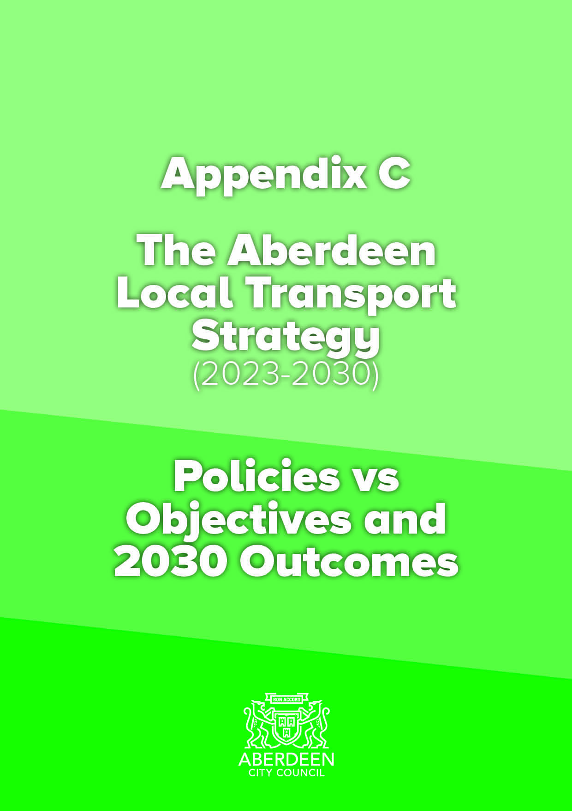
Policies vs TPOs
Topic Area | Policy | TPO1 – Climate and Environment - Reduce the negative impact of transport on the climate and the environment in Aberdeen. | TPO2 – Health – Improve transport opportunities in Aberdeen that help enable and promote healthy lives and give access to healthcare | TPO3 - Safety – Improve the safety of the Aberdeen transport network and reduce safety issues for users. | TPO4 - Economy - Ensure more efficient movement of people and goods across, into and from both Aberdeen city and the whole region. | TPO5 - Accessibility/ inclusivity/ user-friendly – Improve the user-friendliness of the Aberdeen transport network, making it more accessible and inclusive | TPO6 - Resilience - Ensure the Aberdeen transport network is more resilient and can react to unplanned circumstances and extreme weather | TPO7 – Technology – Ensure Aberdeen has a transport network that can better adapt to changes in technology and capitalises on existing technological opportunities. | TP08 – Modal shift – Reduce the need to travel and reduce dependency on the private car in Aberdeen
Climate Change mitigation and adaption | To contribute to Aberdeen’s target of net zero carbon emissions targets by 2045, or earlier, and develop and promote climate resilient infrastructure and movement. | x | x
Air Quality | Reduce the contribution of transport to poor air quality in Aberdeen and have all air quality management areas revoked. | x | x
Noise Quality | Reduce levels of noise from the transport network in Aberdeen. | x | x
Reducing the need to travel | Work with partners to create opportunities which allow people to access facilities, workplaces and information in Aberdeen without the need to travel. | x |  |  |  | x | x | x | x
Walking and Wheeling | To continue to enhance Aberdeen’s walking and wheeling environment and increase the number of people walking and wheeling, both as a means of travel and for recreation, in recognition of the significant health and environmental benefits they can bring. | x | x |  | x | x | x |  | x
Cycling | To continue to enhance Aberdeen’s cycling environment, provide further opportunities to access it and increase levels of cycling in the city, both as a means of travel and for recreation, so that cycling becomes an everyday, safe and attractive choice for all ages and abilities of cyclist. | x | x | x | x | x | x |  | x
Bus | To work with partners and, through the North East Scotland Bus Alliance, to increase public transport patronage in Aberdeen by taking forward measures to make bus travel a more attractive option to all users with speed, reliability, cost and convenience benefits to make people choose it over the car. | x | x |  | x | x | x | x | x
Aberdeen Rapid Transit | To work with partners including NESTRANS, Transport Scotland and the North East Scotland Bus Alliance to develop an integrated Mass Transit ‘step-change’ public transport solution offering quick, attractive access to, from and across the city. | x | x |  | x | x | x | x | x
Park and Ride | Work with partners to ensure that park and ride sites provide a range of attractive onward journey options, incentivise people to park on the edge of the city and continue their journey onwards by a more sustainable means and form part of the wider parking strategy in the city. | x |  |  | x | x | x |  | x
Strategic Rail Network | To work with partners to increase opportunities for rail travel to, from and within Aberdeen and to enable sustainable journeys to and from stations. | x | x |  | x | x | x |  | x
Community and Demand Responsive Transport | To continue to work with partners to deliver Demand Responsive Transport in Aberdeen for the benefit of the public. | x | x |  | x | x | x |  | x
Coaches | To ensure that coach travel remains an attractive and accessible alternative to car travel for those accessing the city, both for business and leisure. |  |  | x | x | x |  |  | x
Taxis and Private Hire Vehicles | To work in partnership with the Aberdeen taxi and private hire car trade to ensure an adequate supply of safe, clean, low-carbon and accessible vehicles and pick-up points. | x |  | x | x | x | x | x | x
Car Sharing | Continue to promote car sharing as a means of reducing emissions from transport and saving people money, and to create and support opportunities to encourage people to do so. | x |  |  | x | x | x |  | x
Car Clubs | Continue to encourage car clubs in Aberdeen as a means of giving people access to vehicles without needing to own one and to continue to work with the contracted operator in Aberdeen to expand and further develop the car club offering in the city. | x | x |  | x | x | x |  | x
Powered Two- Wheelers | To improve conditions for powered two-wheelers on Aberdeen’s roads, particularly in terms of rider safety and encourage a shift to low carbon vehicles. | x | x | x | x | x |  |  | x
Zero Emission Vehicles | In line with National Targets, to lead by example in Aberdeen and to encourage a shift to vehicles which are zero emission at the tailpipe and work with partners to ensure that users have good access to a growing network of high quality refuelling facilities. | x | x |  |  |  | x | x
Parking | To develop a parking regime for Aberdeen that supports the principle of the city centre functioning as a destination, encourages people to access and move around the city sustainably, facilitates interchange between modes, enhances the economic vitality of the City Centre and district shopping centres and still supports people with restricted mobility in accessing facilities. | x | x |  | x | x | x |  | x
Demand Management | In addition to parking and traffic management, investigate, in partnership with Aberdeenshire Council and Nestrans, the implications of introducing other demand management methods to Aberdeen. | x |  |  |  |  |  |  | x
Road Improvements | In line with the National Sustainable Investment Hierarchy, make better use of existing capacity ahead of constructing new but, where new infrastructure is required, ensure it both enables and incorporates sustainable transport and biodiversity options. |  |  |  | x | x | x
Trunk Road Network | Support improvements to the trunk road network, allowing the safe movement of people and goods to, from and around Aberdeen. | x |  | x | x |  | x
Aberdeen Western Peripheral Route (AWPR) | To continue to “lock in” the benefits of the AWPR by encouraging strategic traffic to route from and to it, creating more space for sustainable travel on Aberdeen routes and allowing the city centre to function as a destination rather than a through route. | x |  | x | x | x | x |  | x
Shipping and Ferry Services | To work with partners to ensure that Aberdeen’s Harbours remain world-class, able to grow their national and international trade. Ensure they are well linked to the city and strategic transport network for all users and continue to attract freight, engineering and cruise traffic, as well as being the main port of call in Scotland for the Northern Isles ferry services with appropriate access for all users. |  | x |  | x | x | x
Air Services | To support the future growth and improvement of Aberdeen International Airport, including surface access, in order to support the economic strength of the region and ensure continued connectivity to key businesses and leisure destinations. | x | x |  | x | x | x
Freight | To work with partners to ensure the efficient movement of freight to, from and within Aberdeen and the wider North East of Scotland across different modes. | x |  |  | x |  | x
Travel Awareness and Information | With partners, continue to ensure that there is adequate information available, via a range of means, to users of the transport network to help them make more informed transport choices. Continue to gather information from users to ensure that this best informs improvements to the transport network. | x | x | x | x | x | x | x | x
Land Use Planning | To promote and enable development in Aberdeen that reduces the need to travel, minimises reliance on the private car, provides opportunities for sustainable travel and facilitates and encourages walking, wheeling and cycling for everyday trips. | x | x | x | x | x | x |  | x
Travel Plans | To ensure that the transport impact of existing and new developments in Aberdeen are minimised by requiring workplaces, schools and developers to prepare Travel Plans and, where appropriate, Travel Packs for all sites in the city. | x | x | x |  | x | x |  | x
City Centre and Beach | Ensure that the transport network enables Aberdeen city centre and Beach to function as high-quality, accessible destinations that people wish to live in, visit, use and spend time in. Promote the movement of people ahead of vehicles and ensure that people are encouraged to move between the two areas using sustainable transport. | x | x | x | x | x | x |  | x
Biodiversity and Green Space | Improve accessibility to open spaces in Aberdeen and contribute towards the development of the green space network through implementation of core paths and appropriate mitigation and enhancement as part of transport scheme delivery. | x | x |  |  | x | x |  | x
Traffic Management and Road Safety | To create a transport network in Aberdeen where sustainable transport movements are actively encouraged and facilitated, there is a 50% reduction in adults killed and seriously injured and a 60% reduction in children killed and seriously injured. | x | x | x | x | x | x |  | x
Enforcement | To ensure the Council, and partners, manage and enforce the Aberdeen transport network to ensure safety and effectiveness for the benefit of all users. | x | x | x | x |  | x
School Travel and Young People | To ensure that all young people in Aberdeen have the opportunity to travel to school by active and/or sustainable modes of transport. They should be equipped with the necessary knowledge, skills and infrastructure to allow them to undertake local journeys safely and independently and that their parents and guardians are able to support them. | x | x | x |  | x | x |  | x
New Technologies and Initiatives | Ensure that the Council remains aware of new and developing technologies, initiatives and options which could benefit the Aberdeen transport network and, where appropriate, explore opportunities to trial these. |  |  |  |  |  | x | x
Intelligent Transport Systems (ITS) | To expand the use of ITS in Aberdeen in order to improve the efficiency and understanding of the transport network in the city. | x |  |  |  |  | x | x
Road, Carriageway and Footway maintenance | To improve the condition of Aberdeen’s road, footway and cycle networks and ensure that any improvements or new infrastructure are constructed so as to minimise future maintenance. | x | x | x | x | x | x
Winter Maintenance | To ensure the safe movement of users of Aberdeen’s transport network on carriageways, footpaths, cycle paths and pedestrian precincts and to minimise delays caused by adverse winter weather. | x | x | x | x | x | x
Structures | To ensure that all road related structures in Aberdeen that the Council is responsible for are managed and maintained, safe and fit for purpose and constructed to minimise future maintenance implications. |  | x | x | x |  | x
Resilience | To ensure that the Aberdeen transport network is as resilient as possible in dealing with unforeseen circumstances, such as accidents, extreme weather, works and other large disruptions. | x | x | x | x | x | x | x | x
Lighting | Ensure that Aberdeen’s lighting infrastructure remains fit for purpose and that appropriate lighting solutions are found which best fit the circumstances. | x |  | x |  | x | x | x | x
Monitoring | To ensure that the objectives and outcomes of the LTS are monitored with suitable sources and indicators.

Policies vs Outcomes (up to 2030) |  | 1. Reduction in number of journeys by car drivers in Aberdeen to less than 50% by 2030 | 2. A reduction in car km travelled in Aberdeen by 20% compared with 2019 baseline | 3. Reduced PM10s and NOx emissions from transport and removal of Air Quality Management Areas in Aberdeen | 4. 75% reduction in greenhouse gases from transport in Aberdeen compared with the 1990/5 baseline | 5. 20% of the total cars and vans in Aberdeen being zero emission | 6. 50% reduction in adults killed and seriously injured and 60% reduction in children killed or seriously injured using the transport network | 7. A more resilient transport network for Aberdeen | 8. Improved journey time reliability for all modes in Aberdeen | 9. Improved mental and physical health of the residents of Aberdeen and improved access to healthcare | 10. Improved accessibility to transport in Aberdeen for all | 11. Improved interchange opportunities between modes in Aberdeen | 12. Improved information about the Aberdeen transport network being available to users and planners | 13. A transport network which is able to benefit from improvements in technology for Aberdeen | 14. A transport network which is well maintained for Aberdeen
Topic Area | Policy
Climate Change mitigation and adaption | To contribute to Aberdeen’s target of net zero carbon emissions targets by 2045, or earlier, and develop and promote climate resilient infrastructure and movement. |  |  |  | X
Air Quality | Reduce the contribution of transport to poor air quality in Aberdeen and have all air quality management areas revoked. |  |  | X
Noise Quality | Reduce levels of noise from the transport network in Aberdeen. |  |  |  |  |  |  |  |  | X
Reducing the need to travel | Work with partners to create opportunities which allow people to access facilities, workplaces and information in Aberdeen without the need to travel. | x | x | x | x |  | x | x |  |  | x |  | x | x
Walking and Wheeling | To continue to enhance Aberdeen’s walking and wheeling environment and increase the number of people walking and wheeling, both as a means of travel and for recreation, in recognition of the significant health and environmental benefits they can bring. | x | x | x | x |  |  | x |  | x | x
Cycling | To continue to enhance Aberdeen’s cycling environment, provide further opportunities to access it and increase levels of cycling in the city, both as a means of travel and for recreation, so that cycling becomes an everyday, safe and attractive choice for all ages and abilities of cyclist. | x | x | x | x |  | x | x | x | x | x
Bus | To work with partners and, through the North East Scotland Bus Alliance, to increase public transport patronage in Aberdeen by taking forward measures to make bus travel a more attractive option to all users with speed, reliability, cost and convenience benefits to make people choose it over the car. | x | x | x | x |  | x | x | x |  | x
Aberdeen Rapid Transit | To work with partners including NESTRANS, Transport Scotland and the North East Scotland Bus Alliance to develop an integrated Mass Transit ‘step-change’ public transport solution offering quick, attractive access to, from and across the city. | x | x | x | x |  | x | x | x |  | x |  | x | x
Park and Ride | Work with partners to ensure that park and ride sites provide a range of attractive onward journey options, incentivise people to park on the edge of the city and continue their journey onwards by a more sustainable means and form part of the wider parking strategy in the city. | x | x | x | x |  | x | x | x |  | x | x
Strategic Rail Network | To work with partners to increase opportunities for rail travel to, from and within Aberdeen and to enable sustainable journeys to and from stations. | x | x | x | x |  | x | x | x | x | x | x
Community and Demand Responsive Transport | To continue to work with partners to deliver Demand Responsive Transport in Aberdeen for the benefit of the public. | x | x | x | x |  | x | x |  |  | x |  |  | x
Coaches | To ensure that coach travel remains an attractive and accessible alternative to car travel for those accessing the city, both for business and leisure. | x | x |  |  |  |  |  |  |  | x |  | x
Taxis and Private Hire Vehicles | To work in partnership with the Aberdeen taxi and private hire car trade to ensure an adequate supply of safe, clean, low-carbon and accessible vehicles and pick-up points. | x | x | x | x | x |  | x |  |  | x
Car Sharing | Continue to promote car sharing as a means of reducing emissions from transport and saving people money, and to create and support opportunities to encourage people to do so. | x | x | x | x |  | x | x |  |  | x
Car Clubs | Continue to encourage car clubs in Aberdeen as a means of giving people access to vehicles without needing to own one and to continue to work with the contracted operator in Aberdeen to expand and further develop the car club offering in the city. | x | x | x | x | x |  | x |  |  | x
Powered Two- Wheelers | To improve conditions for powered two-wheelers on Aberdeen’s roads, particularly in terms of rider safety and encourage a shift to low carbon vehicles. | x | x | x | x |  |  |  | x |  | x
Zero Emission Vehicles | In line with National Targets, to lead by example in Aberdeen and to encourage a shift to vehicles which are zero emission at the tailpipe and work with partners to ensure that users have good access to a growing network of high quality refuelling facilities. |  |  | x | x | x |  | x |  |  |  |  |  | x
Parking | To develop a parking regime for Aberdeen that supports the principle of the city centre functioning as a destination, encourages people to access and move around the city sustainably, facilitates interchange between modes, enhances the economic vitality of the City Centre and district shopping centres and still supports people with restricted mobility in accessing facilities. | x | x | x | x | x |  | x |  |  | x | x
Demand Management | In addition to parking and traffic management, investigate, in partnership with Aberdeenshire Council and Nestrans, the implications of introducing other demand management methods to Aberdeen. | x | x | x | x
Road Improvements | In line with the National Sustainable Investment Hierarchy, make better use of existing capacity ahead of constructing new but, where new infrastructure is required, ensure it both enables and incorporates sustainable transport and biodiversity options. |  |  |  |  |  |  | x | x |  | x
Trunk Road Network | Support improvements to the trunk road network, allowing the safe movement of people and goods to, from and around Aberdeen. | x |  | x | x |  |  | x | x
Aberdeen Western Peripheral Route (AWPR) | To continue to “lock in” the benefits of the AWPR by encouraging strategic traffic to route from and to it, creating more space for sustainable travel on Aberdeen routes and allowing the city centre to function as a destination rather than a through route. | x | x | x | x |  | x | x | x | x | x | x
Shipping and Ferry Services | To work with partners to ensure that Aberdeen’s Harbours remain world-class, able to grow their national and international trade. Ensure they are well linked to the city and strategic transport network for all users and continue to attract freight, engineering and cruise traffic, as well as being the main port of call in Scotland for the Northern Isles ferry services with appropriate access for all users. |  |  |  |  |  |  | x | x |  | x | x
Air Services | To support the future growth and improvement of Aberdeen International Airport, including surface access, in order to support the economic strength of the region and ensure continued connectivity to key businesses and leisure destinations. | x | x | x | x |  |  | x |  |  | x | x
Freight | To work with partners to ensure the efficient movement of freight to, from and within Aberdeen and the wider North East of Scotland across different modes. |  |  | x | x |  |  | x | x |  |  | x
Travel Awareness and Information | With partners, continue to ensure that there is adequate information available, via a range of means, to users of the transport network to help them make more informed transport choices. Continue to gather information from users to ensure that this best informs improvements to the transport network. | x | x | x | x | x | x | x | x | x | x | x | x | x
Land Use Planning | To promote and enable development in Aberdeen that reduces the need to travel, minimises reliance on the private car, provides opportunities for sustainable travel and facilitates and encourages walking, wheeling and cycling for everyday trips. | x | x | x | x |  | x | x | x | x | x
Travel Plans | To ensure that the transport impact of existing and new developments in Aberdeen are minimised by requiring workplaces, schools and developers to prepare Travel Plans and, where appropriate, Travel Packs for all sites in the city. | x | x | x | x |  |  | x | x | x | x
City Centre and Beach | Ensure that the transport network enables Aberdeen city centre and Beach to function as high-quality, accessible destinations that people wish to live in, visit, use and spend time in. Promote the movement of people ahead of vehicles and ensure that people are encouraged to move between the two areas using sustainable transport. | x | x | x | x |  | x | x | x | x | x | x
Biodiversity and Green Space | Improve accessibility to open spaces in Aberdeen and contribute towards the development of the green space network through implementation of core paths and appropriate mitigation and enhancement as part of transport scheme delivery. | x | x | x | x |  |  | x | x | x | x
Traffic Management and Road Safety | To create a transport network in Aberdeen where sustainable transport movements are actively encouraged and facilitated, there is a 50% reduction in adults killed and seriously injured and a 60% reduction in children killed and seriously injured. | x | x | x | x |  | x | x | x | x | x | x
Enforcement | To ensure the Council, and partners, manage and enforce the Aberdeen transport network to ensure safety and effectiveness for the benefit of all users. |  |  | x | x |  |  | x | x | x
School Travel and Young People | To ensure that all young people in Aberdeen have the opportunity to travel to school by active and/or sustainable modes of transport. They should be equipped with the necessary knowledge, skills and infrastructure to allow them to undertake local journeys safely and independently and that their parents and guardians are able to support them. | x | x | x | x |  | x | x | x | x | x |  | x
New Technologies and Initiatives | Ensure that the Council remains aware of new and developing technologies, initiatives and options which could benefit the Aberdeen transport network and, where appropriate, explore opportunities to trial these. |  |  |  |  |  |  | x |  |  |  |  |  | x
Intelligent Transport Systems (ITS) | To expand the use of ITS in Aberdeen in order to improve the efficiency and understanding of the transport network in the city. |  |  |  |  |  |  | x |  |  |  |  |  | x
Road, Carriageway and Footway maintenance | To improve the condition of Aberdeen’s road, footway and cycle networks and ensure that any improvements or new infrastructure are constructed so as to minimise future maintenance. |  |  |  |  |  | x | x | x | x | x |  |  |  | x
Winter Maintenance | To ensure the safe movement of users of Aberdeen’s transport network on carriageways, footpaths, cycle paths and pedestrian precincts and to minimise delays caused by adverse winter weather. |  |  |  |  |  | x | x | x | x | x |  |  |  | x
Structures | To ensure that all road related structures in Aberdeen that the Council is responsible for are managed and maintained, safe and fit for purpose and constructed to minimise future maintenance implications. |  |  |  |  |  | x | x |  |  |  |  |  |  | x
Resilience | To ensure that the Aberdeen transport network is as resilient as possible in dealing with unforeseen circumstances, such as accidents, extreme weather, works and other large disruptions. | x | x | x | x |  |  | x | x | x | x | x | x | x | x
Lighting | Ensure that Aberdeen’s lighting infrastructure remains fit for purpose and that appropriate lighting solutions are found which best fit the circumstances. | x | x | x | x |  | x | x |  | x | x |  |  | x | x
Monitoring | To ensure that the objectives and outcomes of the LTS are monitored with suitable sources and indicators. |  |  |  |  |  |  |  |  |  |  |  | x

