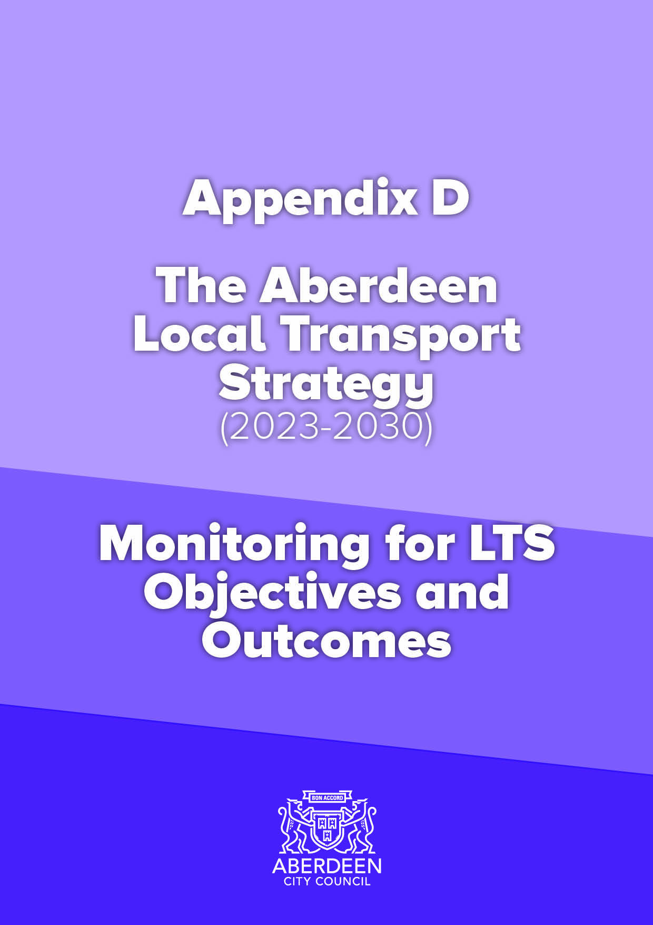

Objectives | Ways to measure | Source | Frequency | Relevant Outcomes to 2030 | Relevant Longer term outcomes | Specific | Measurable | Attainable | Relevant | Time based
TPO1 – Climate and Environment - Reduce the negative impact of transport on the climate and the environment in Aberdeen. | a) Air quality monitoring (PM10s and NOxs) – should have this annually from Council Air Quality Team.  b) Number of air quality management areas – can update on this annually.  c) Carbon dioxide emissions from road transport – From Air Quality Team. Or Local Authority Green House Gas emission data sets include information on CO2.  d) figures for cars registered in Aberdeen - UK Government gov.uk website.  e) Plug in car and van sales relative to petrol and diesel – this should come quarterly from UK Government.  f) Walking and Cycling Index (WACI) - Number of tonnes of greenhouse gas emissions (carbon dioxide, methane and nitrous oxide) saved annually by walking or wheeling instead of driving.  g) WACI - Reduction in NOx and particulates from people choosing active travel.  h) WACI - Residents who agree that the air is clean in their local area. | a) Air quality measuring stations  b) Aberdeen City Council Environmental Health Team  c) Air Quality Team  d) UK Government  e) Society of Motor Manufacturers and Traders (SMMT) and UK Government  f) Sustrans Walking and Cycling Index (WACI)  g) Sustrans Walking and Cycling Index (WACI)  h) Sustrans Walking and Cycling Index (WACI) | a) Annually (at least)  b) Annually  c) Annually  d) Quarterly  e) Quarterly  f) Every 2 years  g) Every 2 years  h) Every 2 years | 3. Reduce PM10s and NOx to enable the removal of Air Quality Management Areas (AQMAs) in Aberdeen.  4. A 75% reduction in greenhouse gases from transport compared with 1990/5 baseline.  5. 20% of the total cars and vans in Aberdeen City being "zero emission". | C. Air quality that is cleaner than WHO standards for emissions from transport in Aberdeen.  D. Work with partners to deliver a just transition to net zero and plan to make Aberdeen a net-zero city by no later than 2045, and earlier if that is possible.  E. All new cars, buses and vans being zero emission at tailpipe in Aberdeen. | Yes - Climate and environment. | Via the outcomes and the data sources quoted. | In keeping with other Plans, Policies, Strategies. | As evidenced by the main issues report. (Appendix A to the LTS). | Lifespan of LTS and, in some cases, by targets set in outcomes.
TPO2 – Health – Improve transport opportunities in Aberdeen that help enable and promote healthy lives and give access to healthcare. | a) Projects delivered,  b) City Voice “ Do you have access to a bike and, if so, how often do you use it?  c) City Voice How often do you go walking? (For this we mean a continuous walk for at least 15 minutes outdoors.)  d) City Voice - Ask a new question around if respondents feel better/ if walking and cycling makes them feel more physically and mentally well.  e) City Voice - Ask a new question about how easy they find it to travel to doctors appointments.  f) WACI - Number of serious long-term health conditions and premature deaths prevented every year by people choosing active travel. | a) Annual update from Senior Project Officer (Aberdeen City Council).  b) City Voice Survey.  c) City Voice Survey.  d) City Voice Survey.  e) City Voice Survey.  f) Sustrans Walking and Cycling Index (WACI). | a) Annually  b) Annually  c) Annually  d) Annually  e) Annually  f) Every 2 years | 9. Improved mental and physical health of the residents of Aberdeen and improved access to healthcare. | M. Further improved mental and physical health of the residents of Aberdeen and further improved access to healthcare. | Yes - mental and physical health. | Yes, via surveys (annually or every 2 years). | In keeping with other Plans, Policies, Strategies. | As evidenced by the main issues report. (Appendix A to the LTS). | Lifespan of LTS.
Objectives | Ways to measure | Source | Frequency | Relevant Outcomes to 2030 | Relevant Longer term outcomes | Specific | Measurable | Attainable | Relevant | Time based
TPO3 - Safety – Improve the safety of the Aberdeen transport network and reduce safety issues for users. | a) Percentage of the carriageway considered for maintenance treatment.  b) Monitoring of road traffic casualty statistics: killed/ seriously injured, children killed or seriously injured and slight casualty rate.  c) safety improvements delivered (lighting, infrastructure improvements.  d) City Voice. Ask people a new question about how safe they feel using different modes, already ask “Traffic and Parking in your neighbourhood: do traffic and parking arrangements allow you to move around safely and meet your needs?”).  e) WACI - number of residents who think the level of safety for walking and cycling in their local area is good.  f) WACI - number of residents who think the level of safety for walking and cycling for children is good.  g) % of Aberdeen streets covered by 20mph limit. | a) Council Roads Operations Department - Tullos.  b) National accident stats - Road Safety and Traffic Management Team (ACC).  c) Senior Project Officer (TSAP), Road Safety and Traffic Management Team (ACC), ITS and Lighting team (ACC).  d) City Voice.  e) WACI.  f) WACI.  g) Road Safety and Traffic Management Team (ACC). | a) Annually  b) Annually  c) Annually  d) Annually  e) Every 2 years  f) Every 2 years  g) Annually | 6. 50% reduction in adults killed and seriously injured and 60% reduction in children killed or seriously injured using the transport network.  14. A transport network which is well maintained in Aberdeen. | I. Zero fatalities on the Aberdeen road network and an even greater feeling of safety for users of the transport network.  P. Further funding and rollout of maintenance across the transport network. | Yes - safety. | Via the outcomes and the data sources quoted. | In keeping with other Plans, Policies, Strategies. | As evidenced by the main issues report. (Appendix A to the LTS). | Lifespan of LTS and, in some cases, by targets set in outcomes.
Objectives | Ways to measure | Source | Frequency | Relevant Outcomes to 2030 | Relevant Longer term outcomes | Specific | Measurable | Attainable | Relevant | Time based
TPO4 - Economy - Ensure more efficient movement of people and goods across, into and from both Aberdeen city and the whole region. | a) Infrastructure delivered.  b) Public transport journey times.  c) Road journey times.  d) City Voice: Moving around your neighbourhood: can you easily walk and cycle around using good quality routes.  e) Sample HGV journey time.  f) Active travel levels.  g) WACI - the net annual economic benefit for individuals and society from all active travel trips.  h) WACI - Of this, the amount from people with a car choosing active travel for transport in the past year.  i) WACI - return active travel trips made daily in Aberdeen by people that could have used a car.  j) WACI - Number of people who agree they can easily get to many places they need to visit without having to drive | a) Senior Project Officer (Aberdeen City Council).  b) Comparison of end to end journeys for 5 typical bus routes in Aberdeen - Stagecoach and First.  c) AA route planner - Journey times between 2 points on A92, A93, A96, A944, A947, A956 and A9119.  d) City Voice.  e) HGV journey time (NESTRANS)  f) Active Travel counters and footfall levels.  g) WACI.  h) WACI.  i) WACI.  j) WACI. | a) Annually  b) Annually  c) Annually  d) Annually  e) Annually  f) Annually  g) Every 2 years  h) Every 2 years  i) Every 2 years  j) Every 2 years | 8. Improved journey time reliability for all modes in Aberdeen. | F. All users able to access the Aberdeen transport network and with minimal disruption.  K. Further improved journey time reliability for all modes in Aberdeen. | Yes - Economy. | Yes, via surveys (annually or every 2 years) | In keeping with other Plans, Policies, Strategies. | As evidenced by the main issues report (Appendix A to the LTS) | Lifespan of LTS.
TPO5 - Accessibility/ inclusivity/ user-friendly – Improve the user-friendliness of the Aberdeen transport network, making it more accessible and inclusive. | a) Infrastructure delivered.  b) Usage of car club and bike hire schemes.  c) Monitoring of public transport times and public transport cost between regeneration areas to key destinations.  d) Cost of public transport vs parking.  e) City Voice: Moving around your neighbourhood: can you easily walk and cycle around using good quality routes?  f) City Voice: Public Transport for your neighbourhood: does public transport meet your needs?  g) City Voice: Traffic and Parking in your neighbourhood: do traffic and parking arrangements allow you to move around safely and meet your needs?  h) City Voice: Streets and Spaces in your neighbourhood: do buildings, streets and spaces create an attractive place that is easy to get around?  i) City Voice: Thinking about the mode of transport you use most often, why so you use this mode of travel? What is your perception of getting around in Aberdeen by each of the following modes?  j) City Voice: Which of the following modes have you tried in the last year?  k) WACI - What proportion of residents said they ‘do not cycle but would like to’?  l) WACI - Number of residents that have access to an adult pedal cycle.  m) WACI - Households within 125m of cycle routes. | a) Senior Project Officer (TSAP).  b) Car Club and Bike Hire annual usage figures.  c) Traveline Scotland.  d) Traveline Scotland, ACC and private car park operator parking charges.  e) City Voice.  f) City Voice.  g) City Voice.  h) City Voice.  i) City Voice.  j) City Voice.  k) WACI.  l) WACI.  m) WACI. | a) Annually  b) Annually  c) Annually  d) Annually  e) Annually  f) Annually  g) Annually  h) Annually  i) Annually  j) Annually  k) Every 2 years  l) Every 2 years  m) Every 2 years | 10. Improved accessibility to transport in Aberdeen for all.  11. Improved interchange opportunities between modes in Aberdeen.  12. Improved information about the Aberdeen transport network being available to users and planners. | F. All users able to access the Aberdeen transport network and with minimal disruption.  G. People able to access key facilities in Aberdeen from their home by sustainable and active travel in 20 minutes.  L. Further improved interchange opportunities between modes in Aberdeen.  N. Further improved information about the Aberdeen transport network being available to users and planners.  O. A transport network which is resilient and can cope with external disruptors. | Yes - Accessibility/ inclusivity/ user-friendliness. | Yes, via surveys (annually or every 2 years). | In keeping with other Plans, Policies, Strategies. | As evidenced by the main issues report. (Appendix A to the LTS). | Lifespan of LTS.
Objectives | Ways to measure | Source | Frequency | Relevant Outcomes to 2030 | Relevant Longer term outcomes | Specific | Measurable | Attainable | Relevant | Time based
TPO6 - Resilience - Ensure the Aberdeen transport network is more resilient and can react to unplanned circumstances and extreme weather. | a) Levels of walking and cycling.  b) Bus patronage.  c) City Voice - Ask people new question around "Over the last year, how often have your journeys in Aberdeen been disrupted by the following external factors?  d) City Voice - Which modes of transport has this affected for you? | a) Active Travel Counters.  b) Passenger Transport Unit.  c) City Voice.  d) City Voice. | a) Annually  b) TBC  c) Annually | 7. A more resilient transport network in Aberdeen. | F. All users able to access the Aberdeen transport network and with minimal disruption. | Yes - Resilience. | Yes, via surveys (annually or every 2 years). | In keeping with other Plans, Policies, Strategies. | As evidenced by the main issues report. (Appendix A to the LTS). | Lifespan of LTS.
Objectives | Ways to measure | Source | Frequency | Relevant Outcomes to 2030 | Relevant Longer term outcomes | Specific | Measurable | Attainable | Relevant | Time based
TPO7 – Technology – Ensure Aberdeen has a transport network that can better adapt to changes in technology and capitalises on existing technological opportunities. | a) Infrastructure delivered.  b) Creation and Downloads of any relevant Smart Transport app. | a) Senior Project Officer (ACC).  b) City Growth Team (ACC). | a) Annually  b) Annually | 13. A transport network which is able to benefit from improvements in technology for Aberdeen. | J. Improvements in technology making the transport system more efficient and user friendly. | Yes - Technology. | Yes, via surveys (annually or every 2 years) | In keeping with other Plans, Policies, Strategies. | As evidenced by the main issues report. (Appendix A to the LTS). | Lifespan of LTS.
TP08 – Modal shift – Reduce the need to travel and reduce dependency on the private car in Aberdeen | a) City Voice: When you travel into the city, how often do you travel using the following modes?  b) City Voice: How do you usually travel to work, the city centre and for other trips? (please select your main mode).  c) Hands up survey for school children - how do you usually travel?  d) City Voice: Number of cars or vans privately owned by household.  e) Car Club membership numbers.  f) WACI - Residents who travel by the following modes five or more days a week in Aberdeen.  g) SHS – crosschecks for car numbers and mode split.  h) WACI - number of trips made by active travel each year.  i) Car KM Travelled by Local Authority Area.  j) City Voice - Ask a new question about "Since restrictions were lifted, following the COVID-19 global pandemic, how have your travel choices been affected? Ask for each mode. | a) City Voice.  b) City Voice.  c) Hands Up Survey.  d) City Voice.  e) Car Club.  f) WACI.  g) Scottish Household Surveys.  h) WACI.  i) Dept for Transport, Traffic by Local Authority. Table TRA8905. Potential city voice question.  j) City Voice. | a) Annually  b) Annually  c) Annually  d) Annually  e) Annually  f) Every 2 years  g) Annually  h) Every 2 years  i) Annually  j) Annually | 1. Reduction in number of journeys by car drivers in Aberdeen to less than 50% by 2030.  2. reduction in car km travelled in Aberdeen by 20% compared with 2019 baseline. | A. More journeys made by active travel and public transport together than by car in Aberdeen.  B. A reduction in car km travelled in Aberdeen beyond 20% compared with the 2019 baseline.  H. A traffic reduction exceeding 20% in the city centre compared with a 2015 baseline. | Yes - mode shift. | Via the outcomes and the data sources quoted. | In keeping with other PPS. | As evidenced by the main issues report. (Appendix A to the LTS). | lifespan of LTS and, in some cases, by targets set in outcomes.

