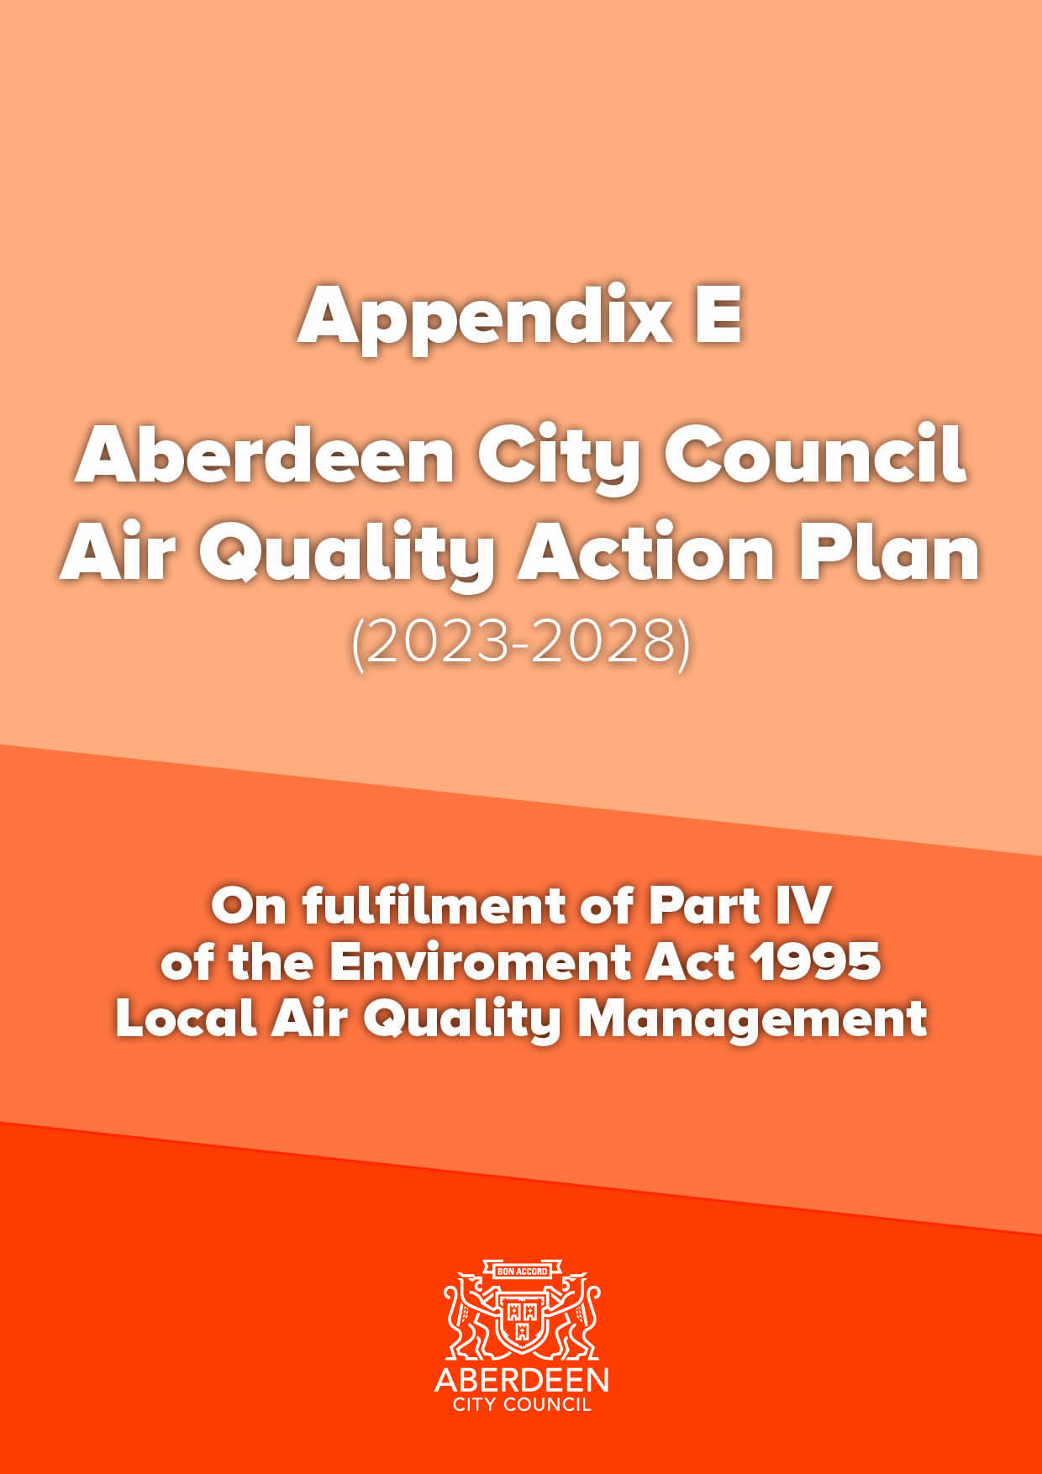

Information | Local Authority Name
Local Authority Officer | Will Hekelaar
Department | Strategic Place Planning
Address | Marischal College, Broad Street, Aberdeen AB10 1AB
Telephone | 01224 069599
E-mail | transportstrategy@aberdeencity.gov.uk
Report Reference Number | 1
Date | August 2023

Executive Summary
This Air Quality Action Plan (AQAP) has been produced as part of our statutory duties required by the Local Air Quality Management (LAQM) framework. It outlines the actions we will take to improve air quality in Aberdeen between 2023 and 2028.

This Action Plan replaces the previous Action Plan which ran from 2011-2023. Projects delivered during the past Action Plan include:

- Opening of the Aberdeen Western Peripheral Route (AWPR), contributing to reduced traffic flows and congestion throughout the city;
- A92/A96 Haudagain Roundabout Improvements, reducing queuing and emissions at this congestion hotspot;
- Formal declaration of a city centre Low Emission Zone (LEZ);
- City Centre Masterplan (CCMP) adoption and roll-out, including delivery of various traffic restriction schemes to give priority to walking, wheeling, cycling and public transport;
- Delivery of Phase 1 of the South College Street Improvement Scheme, to facilitate continued delivery of CCMP transport projects;
- Completion of the Roads Hierarchy review including a programme of city centre road reclassifications to reflect its status as a destination rather than a through-route for traffic;
- Ongoing improvements to strategic and local walking and cycling routes and the Core Path network;
- Launch of an on-street bicycle rental scheme;
- Launch of I Bike Schools and Communities projects to encourage more cycling, particularly amongst traditionally hard to reach groups;
- Launch of the Scottish Government’s Bus Partnership Fund, with a number of corridor improvement strategies underway to identify opportunities for bus priority improvements;
- Commencement of Aberdeen Rapid Transit (ART) appraisal to assess options for a high-capacity rapid public transport system in Aberdeen;
- Continued expansion and promotion of the Grasshopper integrated and multi-operator bus ticket;
- Aberdeen to Inverness Rail Improvements, including dualling of the track between Aberdeen and Inverurie and the re-opening of Kintore Station;
- Ongoing improvement and expansion of the Aberdeen Car Club;
- Ongoing expansion of the public Electric Vehicle (EV) charging network;
- Ongoing expansion of the local hydrogen fleet and hydrogen refuelling capabilities;
- Launch of the Eco Stars fleet recognition scheme to support and encourage bus, freight and van fleet operators to reduce emissions and running costs; and
- Ongoing programme of events and promotions.

There is scientific consensus that exposure to air pollution is harmful to people’s health in terms of premature mortality and morbidity. Air pollution is associated with a number of adverse health impacts, and particularly affects the most vulnerable in society: children and older people, and those with pre-existing health conditions.

This revised Plan will build upon the work that has already been undertaken to identify and implement a LEZ in Aberdeen city centre. Given that transport overwhelmingly remains the main source of pollution in Aberdeen, the plan been developed in tandem with our revised Local Transport Strategy (LTS) and complements the recently revised City Centre and Beach Masterplan, Aberdeen Local Development Plan and Net Zero Framework.

We have developed actions that can be considered under seven broad topics:
- Transport planning and infrastructure;
- Promoting travel alternatives;
- Promoting low emission transport;
- Policy guidance and development control;
- Traffic management;
- Freight and delivery management; and
- Public information;

Our priorities during the life of this AQAP are:
- Implementation of the LEZ to reduce NO₂ concentrations in the City Centre Air Quality Management Area (AQMA) to a level which achieves the air quality objectives and EU Limit Values;
- Ongoing delivery of City Centre and Beach Masterplan transport measures to discourage unnecessary vehicles from the city centre and encourage a greater uptake of less polluting forms of transport;
- Ongoing development and delivery of transport corridor improvement strategies, particularly those which have been identified as experiencing potential air quality exceedances in future years; and
- Ongoing strategic and city-wide infrastructure improvements and behaviour-change measures to promote and encourage more walking and cycling, more public transport use and further adoption of alternative fuel vehicles in preference to continued use of fossil fuel (particularly diesel) vehicles.

In this AQAP we outline how we plan to effectively tackle air quality issues within our control to meet statutory air quality objectives within the shortest possible time. However, we recognise that there are a large number of air quality policy areas that are outside of our influence, but for which we may have useful evidence, and so we will continue to work with the Scottish Government and partner organisations on policies and issues beyond Aberdeen City Council’s direct influence.

In accordance with the requirements of PG (S) (23) ACC expects Aberdeen City Council’s Air Quality Management Areas to be revoked no later than 2028 and where possible within the shortest possible time.

Responsibilities and Commitment

This AQAP was prepared by the Environmental Health and Transport Strategy and Programmes teams of ACC.

This draft AQAP will be considered by the Net Zero, Environment and Transport Committee in August 2023 prior to a period of statutory consultation. Following analysis of consultation feedback, a final AQAP will be prepared for approval by Committee, before submission to the Scottish Government, as per the requirements under the LAQM regime.

This AQAP will be formally reviewed and republished on a five-yearly cycle from date of initial publication. Progress each year will be reported in the Annual Progress Report (APR) produced by ACC, as part of our statutory LAQM duties.

If you have any comments on this AQAP, please send them to:

Transport Strategy and Programmes
Aberdeen City Council
Marischal College
Broad Street
Aberdeen
AB10 1AB
Tel: 01224 069599
transportstrategy@aberdeencity.gov.uk
Table of Contents
Executive Summary iii
Responsibilities and Commitment iv
1 Introduction 1
2 Summary of Current Air Quality in Aberdeen 4
3 Aberdeen City Council Air Quality Priorities 9
3.1 Source Apportionment 9
3.2 Required Reduction in Emissions 15
3.3 Key Priorities 16
4 Development and Implementation of Aberdeen City Council AQAP 17
4.1 Consultation and Stakeholder Engagement 17
4.2 Steering Group 17
5 AQAP Measures 18
6 Glossary of Terms 33

List of Tables
Table 1 - Air Quality Action Plan Measures 19
List of Figures
Figure 1: Aberdeen AQMAs 5
Figure 2: Annual Mean NO2 concentrations at continuous monitoring stations 6
Figure 3: Annual Mean PM10 concentrations at continuous monitoring stations 7
Figure 4: Annual Mean PM2.5 concentrations at continuous monitoring stations 8
Figure 5: South Anderson Drive source apportionment. 10
Figure 6: Wellington Road source apportionment. 11
Figure 7: Union Street source apportionment. 11
Figure 8: Union Street source apportionment. 12
Figure 9: King Street source apportionment. 13
Figure 10: King Street source apportionment. 13
Figure 11: Market Street source apportionment. 14

1 Introduction

This report outlines the actions that Aberdeen City Council will deliver between 2023-2028 in order to reduce concentrations of air pollutants and exposure to air pollution, thereby positively impacting on the health and quality of life of residents and visitors to Aberdeen.

It has been developed in recognition of the legal requirement on the local authority to work towards Air Quality Strategy (AQS) objectives under Part IV of the Environment Act 1995 and relevant regulations made under that part and to meet the requirements of the Local Air Quality Management (LAQM) statutory process.

This Plan will be reviewed every five years at the latest and progress on measures set out within this Plan will be reported on annually within ACC’s air quality Annual Progress Report (APR).

Aberdeen is situated on the east coast of Scotland by the North Sea and has a population of approximately 227,000. The city acts as a focus for employment, service and leisure activities for residents of Aberdeen and the surrounding area. There is little heavy industry within the city and much of the economy is based around services to the oil and gas industry.

Road traffic is the main source of atmospheric pollution, although the situation has much improved in recent years with the opening of the Aberdeen Western Peripheral Route (AWPR) in 2019, which has resulted in a significant shift of traffic from city streets to the new bypass. Progress has also been made on the delivery of the City Centre Masterplan (CCMP), specifically a number of restriction measures to prevent traffic from passing through the city centre unnecessarily.

Nevertheless some streets remain dominated by road traffic, which continues to have air quality implications, while the Port of Aberdeen is located in the city centre and is a thriving environment, acting as the UK’s main base for supply vessels to offshore installations.

The main local pollutants of concern in Aberdeen are nitrogen dioxide (NO₂) and fine particulate matter (PM₁₀ and PM_{2.5}). Poor air quality puts the health of Aberdeen’s residents and visitors at risk and creates an unpleasant environment for all users of the city.

This draft Air Quality Action Plan (AQAP) has been produced as part of our statutory duties required by the LAQM framework. It outlines the action we will take to improve air quality in Aberdeen between 2023 and 2028, and replaces the previous Action Plan which was published in 2011.

The majority of the measures within the 2011 AQAP were aimed at reducing the impact of road traffic. Projects delivered through the past action plan include:

- Low Emission Zone (LEZ):
  - Formal declaration of a city centre LEZ in 2022, with enforcement to commence from June 2024.
- CCMP and Sustainable Urban Mobility Plan (SUMP):
  - Adoption of the CCMP in 2015 and SUMP in 2019, with the CCMP now recalibrated in response to the COVID-19 pandemic, and extended to cover the Beachfront and George Street areas;
  - Projects delivered so far include: making Broad Street and Union Street Central largely walking, cycling and bus priority spaces; the pedestrianisation of Schoolhill; and the implementation of various bus priority and traffic restriction measures on Bridge Street, Guild Street, Market Street and Union Terrace; and
  - Completion of the Roads Hierarchy review including a programme of city centre road reclassifications to reflect its status as a destination rather than a through-route for traffic;
- Walking and Cycling:
  - Ongoing improvements to strategic and local walking and cycling routes and the Core Path network;
  - Ongoing installation of cycle and scooter parking at schools, workplaces and in public areas; and
  - Launch of an on-street bicycle rental scheme in 2022.
- Public Transport:
  - Launch of the Scottish Government’s Bus Partnership Fund, with a number of corridor improvement strategies now underway to identify opportunities for significant bus priority improvements to and from the city centre;
  - Commencement of Aberdeen Rapid Transit (ART) appraisal to assess options for a high-capacity rapid public transport system in Aberdeen;
  - Continued expansion and promotion of the Grasshopper integrated and multi-operator bus ticket;
  - Aberdeen to Inverness Rail Improvements, including dualling of the track between Aberdeen and Inverurie and the re-opening of Kintore Station, allowing an improved (in terms of both frequency and capacity) rail service between Inverurie and Montrose to be delivered.
- Clean Vehicles:
  - Ongoing improvement and expansion of the Aberdeen Car Club, offering a low emission alternative to private vehicle ownership and use, with more electric and hydrogen vehicles added to the fleet for the public to use;
  - Ongoing expansion of the public Electric Vehicle (EV) charging network, and adoption of an EV Framework to guide future EV strategy and locations of charge points;
  - Continued expansion of the local hydrogen fleet (including 15 fuel cell electric double decker buses, the first in the world, in partnership with First Aberdeen) and hydrogen refuelling capabilities, with Aberdeen now having two refuelling stations;
  - Launch of the Eco Stars fleet recognition scheme to support and encourage bus, freight and van fleet operators to reduce emissions and running costs.
- Awareness Raising and Promotion:
  - Programme of public events to mark Clean Air Day, In Town Without My Car Day, Tour of Britain, etc.;
  - Programme of school events and initiatives such as Bikeability, Play on Pedals, Road Safety Magic Shows and Travel Tracker;
  - Launch of I Bike Schools and Communities projects to encourage more cycling, particularly amongst traditionally hard to reach groups;
  - Regular updating of the Aberdeen Cycle Map and publication of various walking trail leaflets.
- Road Improvements:
  - Opening of the AWPR, contributing to reduced traffic flows and less congestion in many areas of the city;
  - A92/A96 Haudagain Roundabout Improvements to reduce queuing and delays and improve air quality at this congestion hotspot;
  - Opening of the Diamond Bridge, a new road crossing over the River Don to reduce congestion and pollution at the existing Bridge of Don;
  - Construction of Phase 1 of the South College Street Improvement Scheme, to facilitate continued delivery of CCMP transport projects.

This revised Plan will build upon the work undertaken to date, specifically the forthcoming LEZ, to further improve air quality in Aberdeen. Given that transport remains the main source of pollution, the Plan has been developed in tandem with the revised Aberdeen Local Transport Strategy (LTS) and complements the recently revised City Centre and Beach Masterplan, Aberdeen Local Development Plan and Net Zero Framework, particularly in terms of its focus on reducing traffic and the environmental impacts of traffic, which should support a reduction in carbon emissions as well as air quality improvement. The actions will also support the delivery of the United Nations’s Sustainable Development Goals: SDG (Good Health and Wellbeing) and SDB 11 (Sustainable Cities).

2 Summary of Current Air Quality in Aberdeen

This section summarises the trends in recent years and the impact of measures introduced by the Council that have contributed to improved air quality. Please refer to the latest APR from Aberdeen City Council for more detailed information on current air quality –
https://www.aberdeencity.gov.uk/services/environment/air-quality-aberdeen/air-quality-reports.

Air quality in Aberdeen is generally good, with levels of pollution well below national air quality objectives at most locations. However, monitoring and modelling indicated exceedances, or likely exceedances, of the air quality objectives for NO₂ and PM₁₀ in the city centre, a small section of Wellington Road and at locations along the Anderson Drive / Haudagain Roundabout / Auchmill Road corridor. The following 3 Air Quality Management Areas were declared, and subsequently amended as necessary, between 2001 and 2008:

- City centre: Market Street, Union Street, King Street (between Castle Street and Roslin Terrace), Virginia Street, Commerce Street, Guild Street, Bridge Street, Holburn Street (between Great Southern Road and Union Street), Victoria Road, Torry (between Queen Elizabeth II Bridge and Crombie Road) and West North Street (King Street to 100m north of junction with Littlejohn Street);
- Wellington Road (Queen Elizabeth II Bridge to Balnagask Road); and
- Anderson Drive / Haudagain Roundabout / Auchmill Road corridor: all of Anderson Drive, Haudagain Roundabout, Auchmill Road (Great Northern Road junction to Howes Road), Great Northern Road (815 Great Northern Road to Auchmill Road).

The current AQMAs are therefore: the city centre, Wellington Road, and Anderson Drive and Auchmill Road (Figure 1):

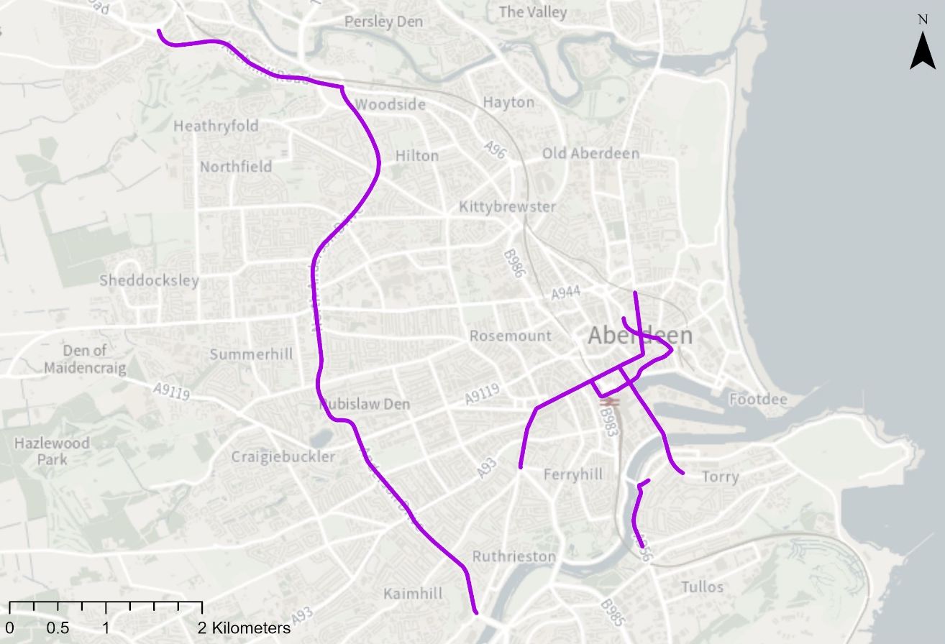
Figure 1: Aberdeen AQMAs

Annual mean NO₂ concentrations over the period 2010-2022 are shown in Figure 2. Highest concentrations are within the City Centre AQMA, particularly on Union Street, Market Street, Guild Street, Bridge Street and parts of King Street and Holburn Street where there are tenemental properties on one or both sides of the road, often within 2m of the kerb. This type of street canyon design often leads to poor dispersion of pollution and public exposure is often greater than elsewhere in the city due to the closeness of the public to exhaust emissions.

Although the Port of Aberdeen is located in the city centre, studies carried out in 2011 and 2021 indicated emissions from shipping contributed less than 10% of the total NO_{x} and PM₁₀ concentrations at relevant receptors close to the Port. Road traffic was identified as the main source of emissions both at locations close to the Port and at other congested city centre locations, accounting for approximately 50% of the total NO_{x} emissions. No other significant point or diffuse source of NO_{x} or PM₁₀ has been identified within, or in the vicinity of, any of the AQMAs.

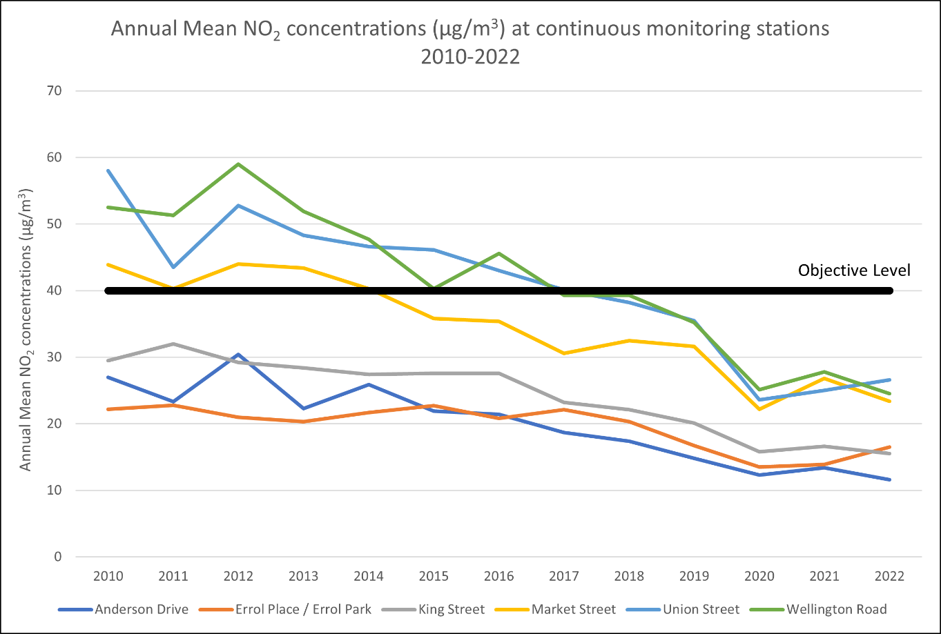
Figure 2: Annual Mean NO2 concentrations at continuous monitoring stations

Measured NO₂ concentrations have progressively decreased since the adoption of the last AQAP in 2011. Annual mean NO₂ levels at Market Street and Union Street have been below the national objective level since 2019 and there have been no exceedance of the 1-hour objective for over 5 years. Diffusion tube concentrations have also decreased at all sites, and only one site, at 39 Market Street, exceeded the annual mean objective in 2020 or 2021. This site did not exceed the objective in 2022, however two diffusion tubes installed on Bridge Street in 2022 indicated potential exceedances of the annual NO₂ objective. Bridge Street is both within the designated LEZ and will also be subjected to vehicle restriction measures in the summer of 2023. It is anticipated these measures will enable compliance with the air quality objectives at this location in future years.

Trends in NO₂ concentrations within both the Wellington Road and Anderson Drive AQMAs have followed similar patterns to the city centre. Heavy Goods Vehicles (HGVs) contribute to a higher proportion of total emissions at the Wellington Road site than elsewhere in the city. This was particularly evident in the period to 2012 due to the vibrant offshore environment. The downturn in the offshore economy resulting in less traffic, coupled with the introduction of cleaner HGVs, resulted in a substantial improvement in air quality on Wellington Road in the period 2012-2015.

The opening of the AWPR in 2019 led to a significant reduction in traffic volumes across the city, particularly within the Anderson Drive AQMA. Smaller reductions in traffic were also evident in the City Centre and Wellington Road AQMAs. The opening of a new slip road and changes to the layout at the Haudagain roundabout in 2022 further reduced congestion and should ensure compliance with the air quality objectives, in the Anderson Drive / Haudagain Roundabout / Auchmill Road AQMA.

Figures 3 and 4 show the annual mean PM₁₀ and PM_{2.5} concentrations at the continuous monitoring stations between 2010 and 2022. Trends in both pollutants within all 3 AQMAs are similar to trends for NO₂. There have been no exceedances of the annual mean or 24-hour PM₁₀ or PM_{2.5} objectives at any of the continuous monitoring stations since 2015. It is ACC’s intention to revoke the AQMAs for PM₁₀ should the trend be maintained in 2023.

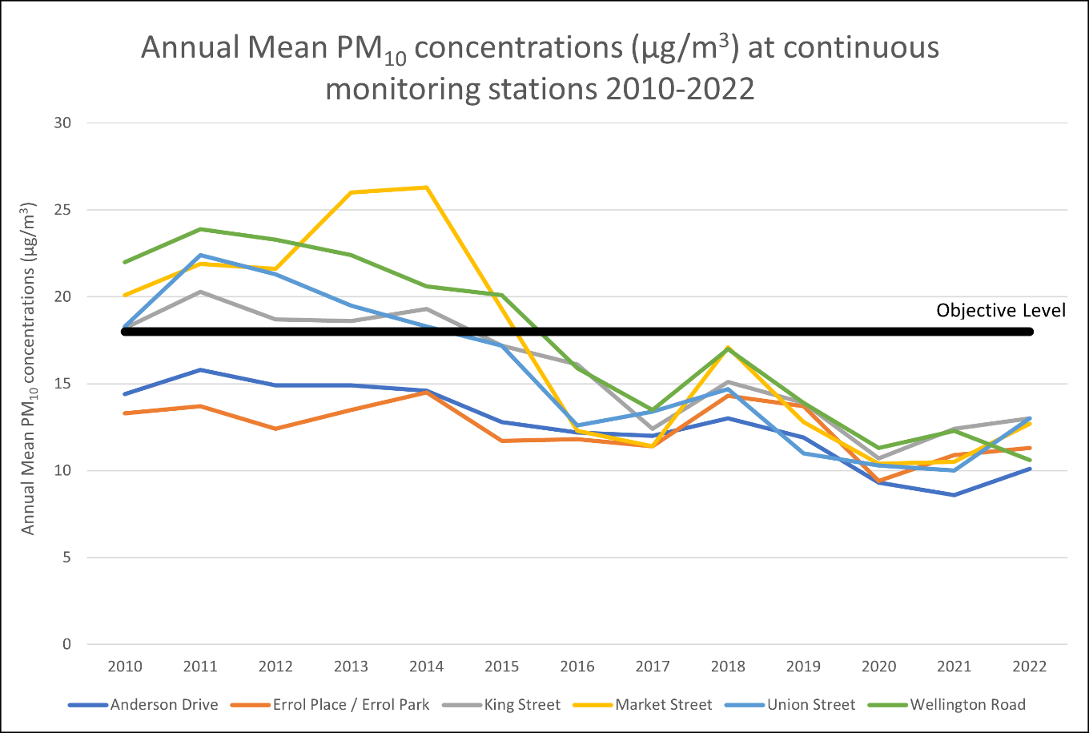
Figure 3: Annual Mean PM10 concentrations at continuous monitoring stations

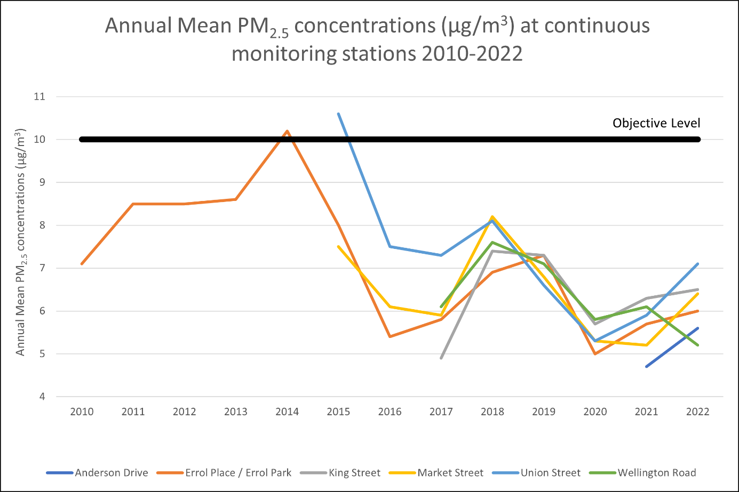
Figure 4: Annual Mean PM2.5 concentrations at continuous monitoring stations

Even before the COVID-19 pandemic therefore, NO₂ and PM₁₀ concentrations were improving at most locations across the city. The impact of the pandemic, with significantly less traffic during lockdown periods, is clearly evident as pollution concentrations decreased significantly at all sites in 2020. Furthermore, various temporary traffic restriction measures were implemented in the city centre in 2020 as part of the Spaces for People scheme to support physical distancing, and further contributed to reduced city centre pollution levels. While the majority of the temporary restrictions were removed in 2021, the vehicle restriction measures on Schoolhill and on Union Street between Bridge Street and Market Steet were retained. These have contributed to continued lower pollution levels across the city centre as cars and vans are now unable to travel directly through the area.

While there was a slight increase in concentrations in 2022 compared to 2021, which was still influenced by lockdown restrictions, concentrations were well below the objective level at all continuous monitoring stations. The significant improvement in air quality is likely to be a reflection of a sustained shift towards increased home working, less business travel and a gradual progression to cleaner vehicles.

Aberdeen City Council Air Quality Priorities

3.1 Source Apportionment

The AQAP measures presented in this report are intended to be targeted towards the predominant sources of emissions within Aberdeen City Council’s area.

Modelling carried out by the Scottish Environment Protection Agency (SEPA) in 2020 showed that road traffic emissions contribute to over 50% of the total NO_{x} concentration at locations with the highest total NO_{x} emissions. Although the Port of Aberdeen is located in the city centre, studies carried out in 2011 and 2020 indicated shipping contributed to less than 10% of the total NO_{x} concentrations at relevant locations of population exposure. The remaining 30-40% of the total NO_{x} is the background concentration and not influenced by local sources.

Particulate matter comprises a wide range of materials from a variety of sources such as construction and demolition sites, wind-blown dust, domestic fuel burning and industrial activities. Local sources contribute proportionally less of the total particulate emissions compared to NO_{x}, however road traffic is still the dominant local source at locations with the highest concentrations. The 2011 and 2020 Port of Aberdeen studies also indicated shipping contributed to less than 10% of the total PM₁₀ and PM_{2.5} concentrations at relevant locations of population exposure.

As road traffic is the dominant source of both NO_{x} and particulate emissions in Aberdeen, and there are no other significant sources of NO_{x} or PM₁₀ within, or close to the AQMAs, this AQAP focuses on measures that can be implemented to reduce NO_{x} and particulate emissions from traffic.

Modelling and traffic count surveys carried out by SEPA and Transport Scotland as part of LEZ appraisal work were used to undertake a road traffic source apportionment exercise in 2023. Six key locations were selected to illustrate the predicted NO_{x} concentrations and change in percentage source contribution in the 2019 base year and in 2024 with the LEZ operational and CCMP vehicle restrictions in place. The following charts and tables show:

- The percentage contribution to the annual average total modelled NO_{x} concentration from road traffic in the 2019 base year and in 2024 with the LEZ operational at 6 kerbside locations close to each of the 6 key locations for 6 different vehicle classifications; and
- The modelled annual average NO_{x} concentration (µgm⁻³) in the 2019 base year and in 2024 with the LEZ operational at the 6 kerbside locations close to each of the 6 key locations for the 6 different vehicle classifications.

Note that where reference is made to the LEZ being operational, it also infers that the CCMP vehicle restrictions have also been implemented.

Figures 5-11 show the results of the source apportionment study.

South Anderson Drive

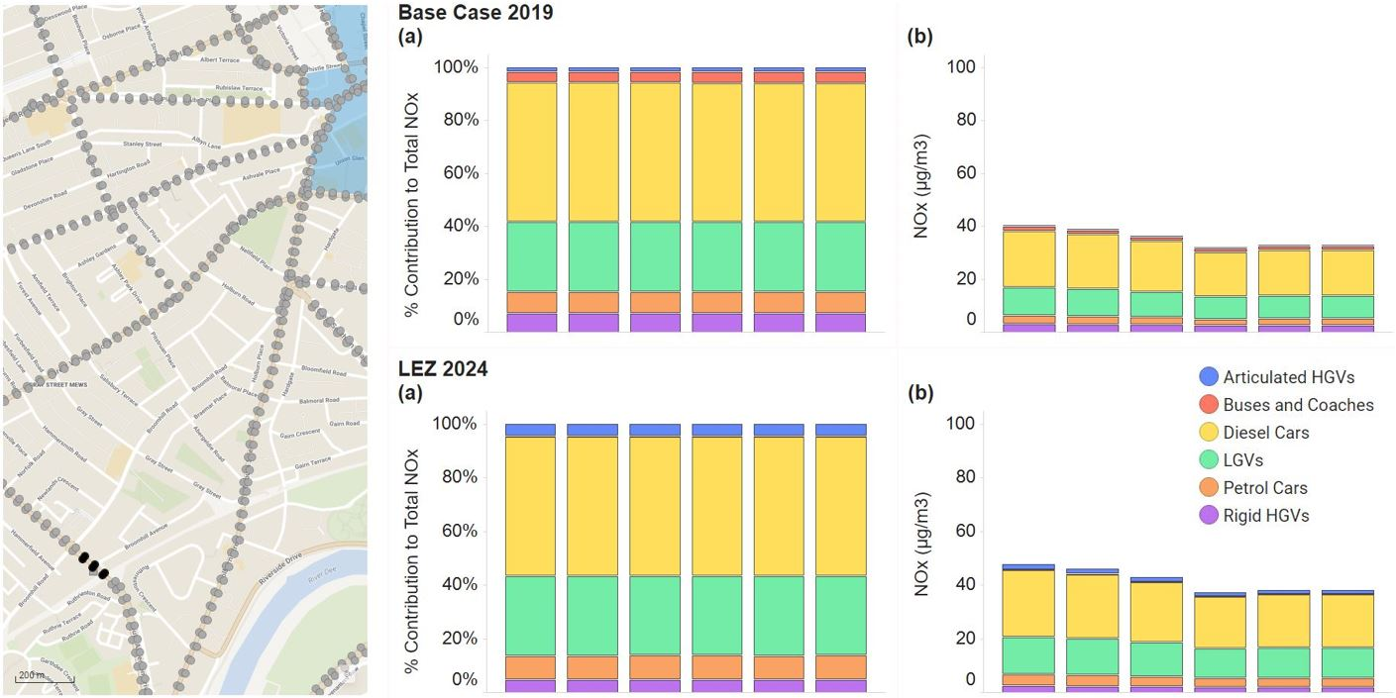
Figure 5: Percentage contribution to annual average total modelled NOx concentrations (a) and modelled annual average NOx concentrations (µg/m3) (b) for different vehicle categories in the 2019 Base and 2024 LEZ cases for the six kerbside points located close to the automatic monitor on South Anderson Drive highlighted in black on the map.

Diesel cars, followed by Light Goods Vehicles (LGVs), are the dominant source of NO_{x} at South Anderson Drive in both 2019 and 2024 scenarios. There is anticipated to be a slight decrease in the percentage contribution from coaches and buses and a slight increase from articulated HGVs, between 2019 and 2024 but little significant change. NO_{x} concentrations in 2024 are predicted to increase slightly due to an increase in traffic flow from non-compliant vehicles avoiding the LEZ and other displaced traffic unable to enter restricted areas of the city centre.

Wellington Road

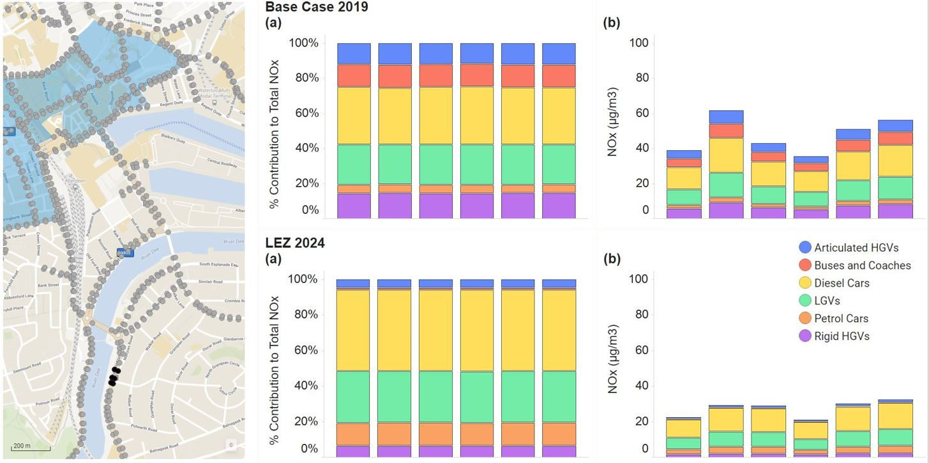
Figure 6: Percentage contribution to annual average total modelled NOx concentrations (a) and modelled annual average NOx concentrations (µg/m3) (b), for different vehicle categories in the 2019 Base and 2024 LEZ cases for the six kerbside points located close to the automatic monitor on Wellington Road highlighted in black on the map.

At Wellington Road, diesel cars and LGVs again emitted the greatest proportion of the total NO_{x} in the 2019 base, however articulated HGVs, rigid HGVs, buses and coaches also contributed more significantly compared to Anderson Drive. In the 2024 scenario, diesel cars are predicted to emit a much greater proportion of the total NO_{x}. The total NO_{x} concentration was predicted to reduce by 20-40% in the 2024 scenario across the 6 modelled receptors, with diesel cars and LGVs remaining the dominant source.

Union Street (within restricted section between Bridge Street and Market Street)

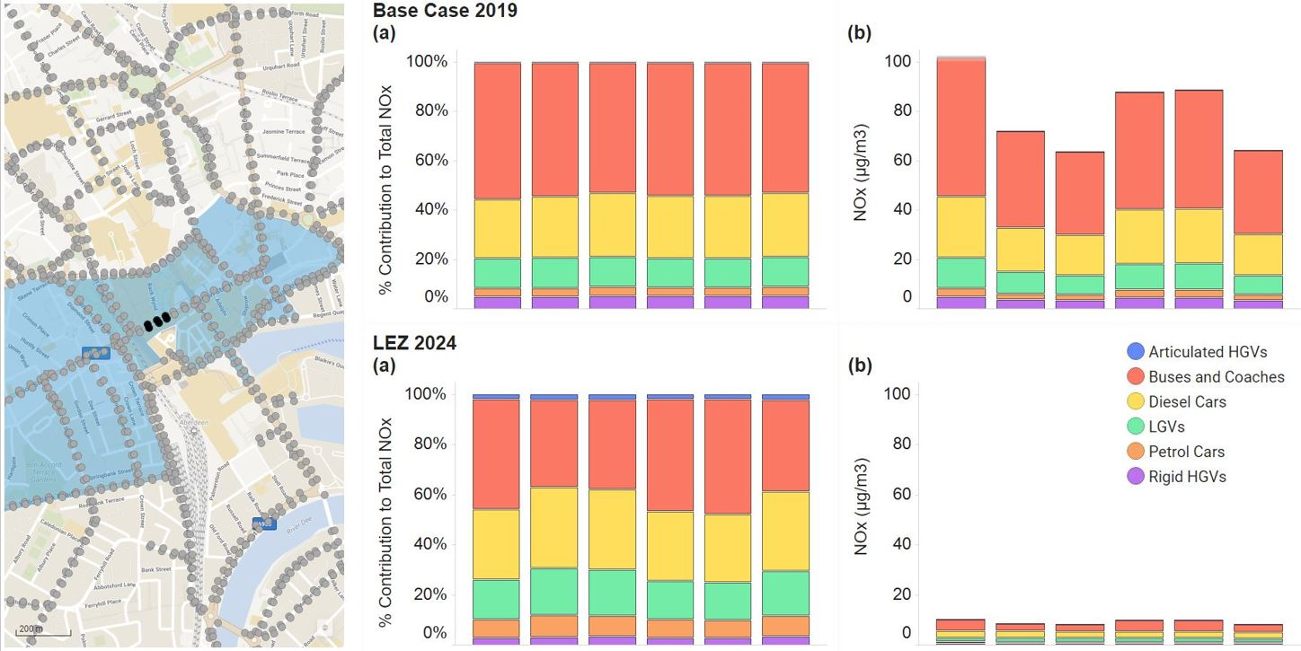
Figure 7: Percentage contribution to annual average total modelled NOx concentrations (a) and modelled annual average NOx concentrations (µg/m3) (b), for different vehicle categories in the 2019 Base and 2024 LEZ cases for the six kerbside points along Union Street highlighted in black on the map.
Union Street (outwith restricted section between Bridge Street and Market Street)

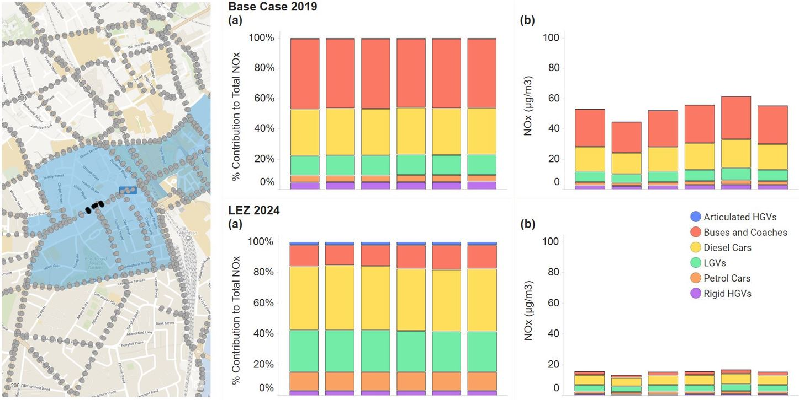
Figure 8: Percentage contribution to annual average total modelled NOx concentrations (a) and modelled annual average NOx concentrations (µg/m3) (b), for different vehicle categories in the 2019 Base and 2024 LEZ cases for the six kerbside points located close to the automatic monitor on Union Street highlighted in black on the map.

Two modelling sites were selected on Union Street, one within the CCMP restricted area between Bridge Street and Market Street, and the other outside the restricted area adjacent to the Union Street / Bridge Street junction. Only buses, taxis and specific exempt vehicles such as emergency service vehicles are permitted within the restricted area.

Buses, followed by diesel cars, are the dominant NO_{x} sources at both modelled sites in 2019. In the 2024 scenario, buses remain the dominant source in the restricted area, however the total NO_{x} concentration is predicted to reduce by 87% to less than 10µgm⁻³. This dramatic change can be attributed to the retrofitting and replacement of older, non-LEZ compliant diesel buses and the introduction of the vehicle access restrictions. Along the unrestricted area, diesel cars and LGVs are predicted to contribute the highest percentage of NO_{x} in the 2024 scenario. The NO_{x} concentration is predicted to reduce by an average of 57% across the area to less than 20µgm⁻³. Again, the cleaner bus fleet, coupled with the LEZ, are the main contributing factors to the predicted improved air quality at this site, although the vehicle access restrictions between Market Street and Bridge Street also contribute to a reduced traffic flow along Union Street and hence lower emissions.

King Street (South of West North Street/East North Street Junction)

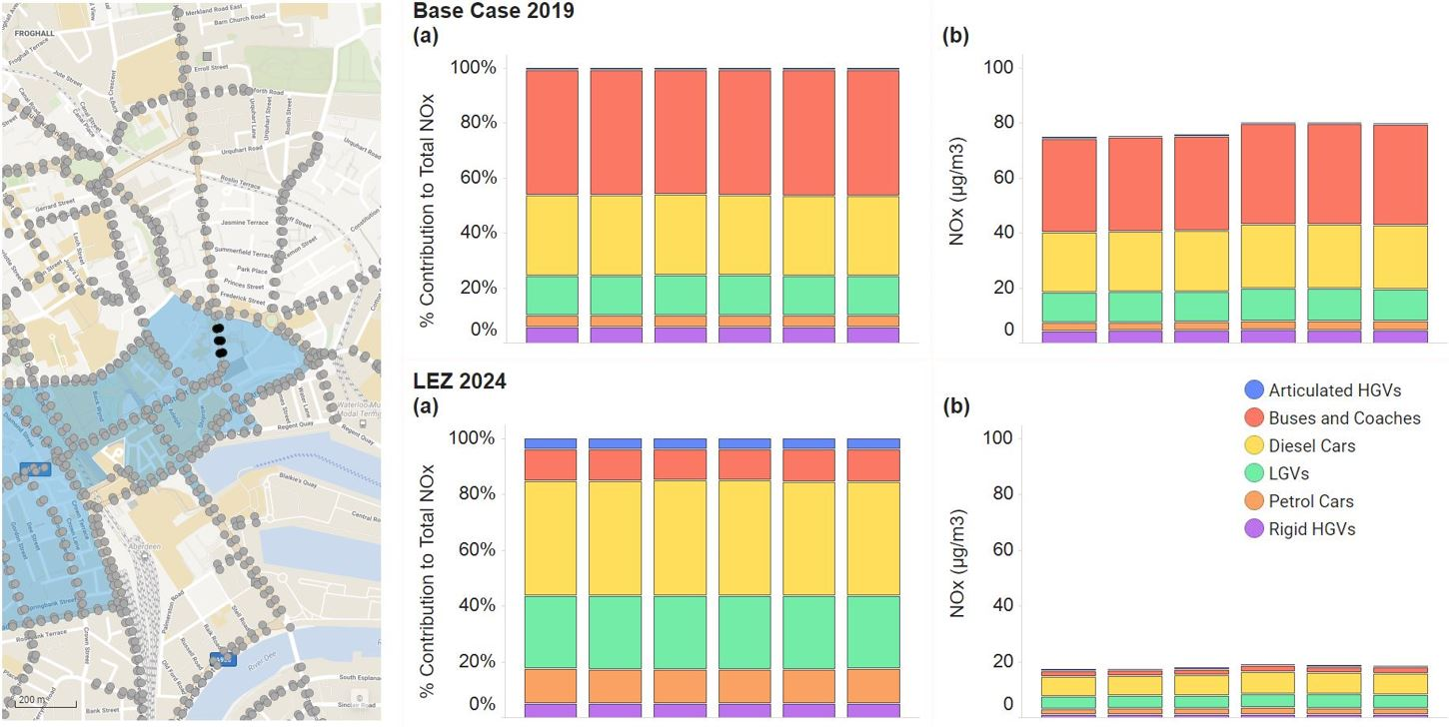
Figure 9: Percentage contribution to annual average total modelled NOx concentrations (a) and modelled annual average NOx concentrations (µg/m3) (b), for different vehicle categories in the 2019 Base and 2024 LEZ cases for the six kerbside points along King Street highlighted in black on the map.

King Street (North of West North Street/East North Street Junction)

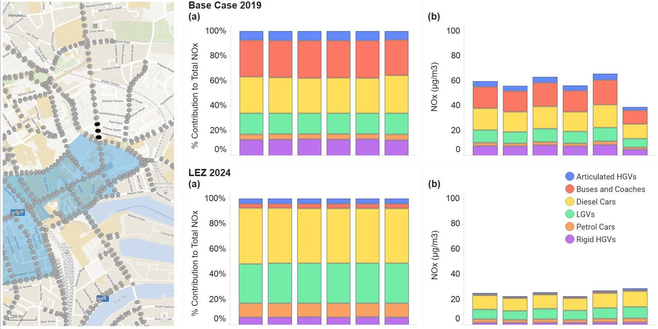
Figure 10: Percentage contribution to annual average total modelled NOx concentrations (a) and modelled annual average NOx concentrations (µg/m3) (b), for different vehicle categories in the 2019 Base and 2024 LEZ cases for the six kerbside points along King Street highlighted in black on the map.

Two modelling sites were also selected on King Street, one south of the West North Street / East North Street junction (within the LEZ) and the other to the north of junction.

The vehicle category percentage contribution to total NO_{x} in the 2019 base year at the modelled site south of the junction displayed a similar pattern to the Union Street scenario with buses the dominant NO_{x} source. North of the junction. diesel cars and buses emitted the most NO_{x}, however emissions were spread more evenly across all vehicle categories. In the 2024 scenario diesel cars and LGVs dominate at both locations. Total NO_{x} concentrations are anticipated to reduce significantly at both locations in the 2024 scenario, particularly south of the junction due to the LEZ and Union Street vehicle access restrictions.

Market Street (South of Guild Street/Trinity Quay Junction)

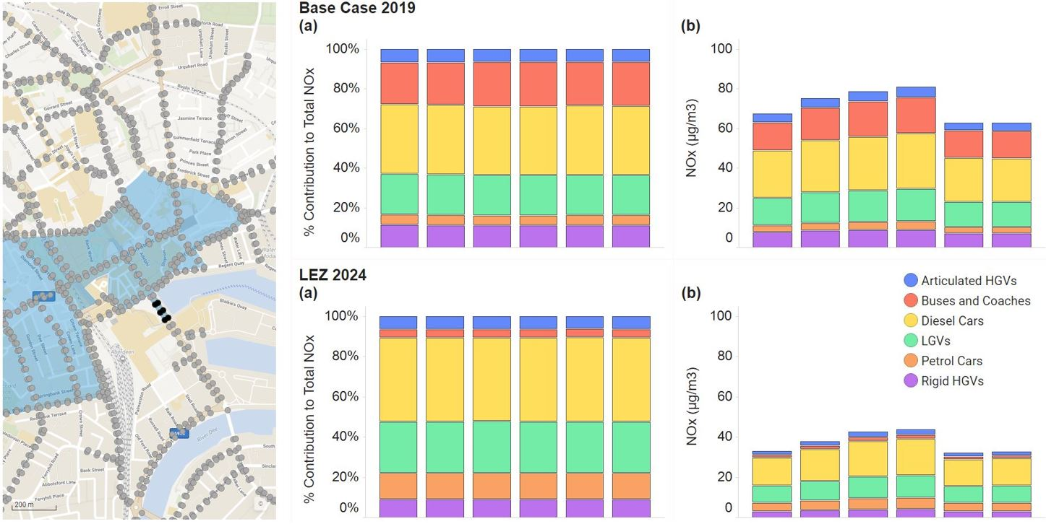
Figure 11: Percentage contribution to annual average total modelled NOx concentrations (a) and modelled annual average NOx concentrations (µg/m3) (b), for different vehicle categories in the 2019 Base and 2024 LEZ cases for the six kerbside points along Market Street highlighted in black on the map.

Emissions from diesel cars are slightly greater than other vehicle classifications at the Market Street modelling site (south of the Guild Street / Trinity Quay junction), although LGVs, buses and coaches and rigid HGVs were all significant contributors to the total NO_{x}. In the 2024 scenario total NO_{x} is anticipated to reduce by approximately 50% compared to 2019, with the greatest reduction in emissions from buses.

The source apportionment work therefore shows that total emissions from all vehicle categories are forecast to fall significantly between 2019 and 2024 due to the gradual replacement of older polluting diesel vehicles, the implementation of the LEZ and the introduction of CCMP vehicle restrictions.

Prior to 2019, a high proportion of the Aberdeen bus fleet comprised of non-LEZ compliant vehicles, therefore the greatest predicted reduction in emissions is from the improvement in the bus fleet with the majority of older, highly polluting vehicles replaced and retrofitted to ensure LEZ compliance.

The main points to note from the source apportionment analysis are therefore:

- The LEZ and CCMP are forecast to significantly reduce emissions in the city centre from 2024 by encouraging cleaner vehicles and allowing fewer vehicles through the area;
- Diesel cars and LGVs are forecast to be the main sources of pollution in all AQMAs in 2024; and
- The LEZ and CCMP may cause a slight increase in vehicles and hence emissions on Anderson Drive, however concentrations will remain well below the air quality objectives.

In terms of the final point, ACC is currently undertaking a review of the A92 Anderson Drive / Parkway corridor (Bridge of Dee to Bridge of Don) to address remaining sustainable transport challenges, road safety concerns and pinch points. Detailed Appraisal of options has progressed during 2023, with air quality improvement one of the objectives against which options are being assessed.

Required Reduction in Emissions

The modelling undertaken to support the LEZ was used to calculate predicted emissions and air quality concentrations at kerbside locations within and outside the LEZ area. The modelling results indicated that, with the LEZ implemented, the majority of the NO₂ exceedances inside the LEZ would be removed, although localised exceedances may remain, in particular on Bridge Street and Holburn Street. Potential exceedances were also predicted at the Westburn Road / Berryden Road / Hutcheon Street / Caroline Place, Skene Street / Rosemount Viaduct and Beechgrove Terrace / Rosemount Place junctions. Additional passive monitoring has commenced in these areas to assess the likelihood of future exceedances.

ACC has, however, work underway in all of these areas which, depending on the final outcomes delivered, should address these remaining exceedances. In particular:

- Traffic restrictions due to be introduced on Bridge Street in summer 2023 are forecast to reduce traffic by approximately 88% which should address predicted exceedances at this location;
- The Berryden corridor improvement scheme should bring benefits to the Westburn Road / Berryden Road / Hutcheon Street / Caroline Place junction by reducing queuing and congestion;
- Via the Scottish Government’s Bus Partnership Fund, work is underway to explore opportunities for further active travel and bus priority measures:
  - Between Ellon and Garthdee, including the Holburn Street corridor; and
  - Between Westhill and Aberdeen, including Westburn Road and Hutcheon Street.

The modelling was carried out prior to the pandemic and was based on 2019 traffic counts. Monitoring results in 2021 and 2022 showed pollution levels at the majority of locations across the city significantly below pre-pandemic levels due to reduced traffic flows. Further traffic counts are proposed in 2023 to update the 2019 traffic and air quality models in preparation for LEZ implementation. The modelling updates will provide more reliable post-pandemic predicted 2024 particulate and NO₂ concentrations and indicate whether any ‘hotspots’ are likely to remain with the LEZ operational.

For a variety of reasons therefore, ACC is currently largely compliant with the air quality objectives. Should there be a post-pandemic traffic increase at some point in the future, modelling suggests the implementation of the LEZ and the CCMP will ensure continued compliance in all but a few potential isolated areas. All of these locations are earmarked for some form of future intervention which should contribute to further pollution reduction. This, together with the implementation of the additional measures identified in this Action Plan should ensure continued compliance with the air quality objectives and continued air quality improvement, resulting in better health outcomes in the longer term.

Key Priorities

Based on the information presented in this section, therefore, ACC’s key priorities are:

- Priority 1 – full implementation and enforcement of the LEZ;
- Priority 2 – ongoing delivery of CCMP transport measures;
- Priority 3 – ongoing development and delivery of transport corridor improvement strategies, particularly those which have been identified as experiencing potential air quality exceedances in future years; and
- Priority 4 – ongoing strategic and city-wide infrastructure and behaviour-change measures to promote and encourage more walking and cycling, more public transport use and further adoption of alternative fuel vehicles, in preference to continued use of fossil fuel (particularly diesel) vehicles.

Development and Implementation of Aberdeen City Council AQAP

Consultation and Stakeholder Engagement

The AQAP has been developed alongside a revised Local Transport Strategy (LTS) to ensure a consistent approach to improving transport and air quality in Aberdeen. As a result, consultation on these documents is being undertaken in parallel.

Firstly, a Main Issues consultation to inform development of the LTS was undertaken during October and November 2021 in the form of an online survey open all members of the public and stakeholders, with 384 responses received. Key members of the business community were advised of the consultation directly, while specific engagement took place with neighbouring Aberdeenshire Council and the Regional Transport Partnership Nestrans.

Emissions and pollution were identified as both current and future problems during the consultation, with the LEZ identified as a key opportunity for addressing this. ‘Environment’ was ranked 2nd of 7 potential priority areas that the transport system should take account of, according to questionnaire respondents.

In developing/updating this AQAP, we have therefore worked with other local authorities, agencies, businesses and the local community to improve local air quality. The next stage in the process will be a period of formal public and stakeholder engagement on the AQAP alongside the LTS, including engagement with statutory consultees as required in Schedule 11 of the Environment Act 1995.

Steering Group

A Steering Group has been established to guide the LTS and subsequent AQAP. This comprises ACC officers from relevant teams (transport, planning, environmental policy, City Growth) and regional partners in Aberdeenshire Council, Nestrans and NHS Grampian.

The group is responsible for helping guide and support the development of the LTS and resulting AQAP by inputting into option generation and appraisal, agreeing LTS objectives and outcomes, agreeing a list of priority projects for inclusion in the LTS and AQAP, and supporting and promoting consultation and engagement activities.

AQAP Measures

Table 5.1 shows the Aberdeen City Council AQAP measures. It contains:

- A list of the measures that form part of the plan;
- Expected or actual completion year for measures;
- Measure status (whether the measures are planned, in progress, completed or delayed);
- The responsible individual and departments/organisations who will deliver these measures;
- How the measure will be funded (Scottish Government or other);
- Estimated cost of implementing each measure (overall cost and cost to the local authority);
- Expected benefit in terms of pollutant emission and/or concentration reduction; and
- Key milestones towards delivery.

NB: Please see future Annual Progress Report for annual updates on implementation of these measures.

In accordance with the requirements of PG (S) (23) Aberdeen City Council expects the City Centre, Anderson Drive and Wellington Road AQMAs to be revoked no later than 2028 and where possible in the shortest possible time post-declaration.

Table 1 - Air Quality Action Plan Measures
Measure No. | Measure | Category and Classification | Expected/Actual Completion Year | Measure Status | Delivery Organisation(s) | Funding Source | Funding Status | Estimated Cost of Measure | Target Reduction in Pollutant / Emission from Measure | Key Milestones | Comments
1 | Implement, enforce and monitor the LEZ | Promoting Low Emission Transport – Low Emission Zones | 2024 – Implementation complete.  Enforcement ongoing. | In progress | ACC Transport Strategy / ACC Enforcement / ACC Road Operations | Transport Scotland | Implementation – fully funded.  Ongoing funding requirement for monitoring and enforcement. | Implementation – £500k - £1 million | See Source Apportionment section. | 2022 – LEZ declared.  2024 – end of grace period; enforcement commences.
2 | Require mitigation measures for new schemes, where additional vehicle trips will impact on air quality | Policy Guidance and Development Control – Air Quality Planning and Policy Guidance | Ongoing | In progress | ACC Planning | N/A | N/A | N/A | Not quantifiable | 2023 – Aberdeen Local Development Plan adopted.  Late 2023 / early 2024 – Aberdeen Planning Guidance to be adopted. | Planning Guidance will set out the circumstances under which an Air Quality Assessment will be required.
3 | Undertake a city-wide Active Travel Network Review to identify future walking, cycling and wheeling priorities. | Transport Planning and Infrastructure – Other | 2024 | In progress | ACC Transport Strategy / Nestrans | Nestrans / ACC | Fully funded | £100k - £500k | Not quantifiable | 2023 – commencement of review.  2024 – anticipated completion of review | Part of a region-wide exercise co-ordinated by Nestrans, ACC and Aberdeenshire Council.  Completion of the review will help determine future active travel infrastructure priorities.
4 | Use the outcomes of the Active Travel Network Review to develop a revised Active Travel Action Plan. | Transport Planning and Infrastructure – Other | 2025 | Planned | ACC Transport Strategy | N/A | N/A | N/A | Not quantifiable | 2024 – anticipated completion of review.  2025 – anticipated adoption of revised Active Travel Action Plan | Current Active Travel Action Plan covers 2021-2026 period.
5 | Continue to implement the transport elements of the City Centre and Beach Masterplan | Transport Planning and Infrastructure – Other | 2028 | In progress | ACC City Centre Masterplan | ACC / Nestrans / Transport Scotland / UK Government (Levelling Up Fund) | Partially funded | >£10 million | Not quantifiable | 2025 – Schoolhill and Upperkirkgate streetscape works.  2025 – City Centre to Beach active travel improvements.  2026 –Union Street Central streetscape works.  2026 – Queen Street transformation. | Union Street Central traffic restrictions introduced in 2022.  Pedestrianisation of Schoolhill introduced on a permanent basis in 2023.  Bus priority on Guild Street, Bridge Street and Market Street introduced in 2023.  Preferred option agreed for A956/Beach Boulevard junction in 2023.
6 | Improve active travel access to interchange points such as railway stations and Park and Ride sites, including delivery of cycle parking facilities | Transport Planning and Infrastructure – Active Travel | 2028 | Planned | ACC Transport Strategy | ACC / Nestrans | Not funded | £50k - £100k | Not quantifiable. | N/A | Specific interventions are being identified via ongoing programme of corridor studies.
7 | Refresh the City's Core Paths Plan | Transport Planning and Infrastructure – Active Travel | 2025 | Planned | ACC Climate and Environment Policy | N/A | N/A | N/A | Not quantifiable. | 2025 – Adoption of revised Plan. | A complete survey of the Aberdeen Core Path Network has been undertaken. This survey will help prioritise future path improvements on the core path network
8 | Continue to work with partners to provide a "one stop shop" for sustainable transport information and engage with people through events, publicity campaigns and social media | Promoting Travel Alternatives - Intensive active travel campaign & infrastructure | Ongoing | In progress | ACC Transport Strategy / Getabout partnership | Nestrans / Smarter Choices Smarter Places | Annual ongoing funding required. | <£10k per annum | Not quantifiable. | N/A | Ongoing programme of events and campaigns underway, working with regional partners.
9 | Investigate the feasibility of developing mobility / transport hubs within Aberdeen City | Promoting Travel Alternatives - Intensive active travel campaign & infrastructure | 2028 | Planned | Nestrans / ACC Transport Strategy | N/A | N/A | N/A | Not quantifiable. | N/A
10 | Continue to raise awareness of the benefits of walking, wheeling and cycling and the opportunities available in Aberdeen via route map signage and way finding | Promoting Travel Alternatives - Promotion of walking / Promotion of cycling | Ongoing | In progress | ACC Transport Strategy / Getabout Partnership | ACC / Nestrans / Smarter Choices Smarter Places | Annual ongoing funding required. | <£10k per annum | Not quantifiable. | N/A | Wayfinding totems installed across city. Various walking trail guides available.
11 | Continue to encourage walking, wheeling and cycling with fun initiatives such as trails and challenges | Promoting Travel Alternatives - Promotion of walking | Ongoing | In progress | ACC Transport Strategy / Getabout Partnership / Sustrans | Smarter Choices Smarter Places / Sustrans | Annual ongoing funding required. | <£10k per annum | Not quantifiable. | N/A | Various walking trail guides available.
12 | Work with partners to investigate new ways to give people access to bikes and information about cycling | Promoting Travel Alternatives - Promotion of cycling | Ongoing | In progress | ACC Transport Strategy / Nestrans / Sustrans / Big Issue Sharebike | Smarter Choices Smarter Places / Sustrans / Scottish Government / Big Issue Sharebike | Annual ongoing funding required. | <£10k per annum | Not quantifiable. | N/A | 2022 – Big Issue Sharebike (on-street bike rental) launched.  IBike Schools and IBike Communities Officers in post.
13 | Continue to work with partners on education and safety campaigns and projects, such as Bikeability, adult cycle training, and encouraging drivers to behave safely and respectfully when sharing roadspace with cyclists | Promoting Travel Alternatives - Promotion of cycling | Ongoing | In progress | ACC Transport Strategy / Nestrans / Sustrans / Cycling Scotland | Smarter Choices Smarter Places / Sustrans | Annual ongoing funding required. | £100k - £500k per annum | Not quantifiable. | N/A | IBike Schools and IBike Communities Officers in post.  .
14 | Continue to promote, encourage and enable the range of different bikes and supporting infrastructure which can encourage more people into cycling | Promoting Travel Alternatives - Promotion of cycling | Ongoing | In progress | ACC Transport Strategy / Nestrans / Sustrans | Sustrans / Transport Scotland | Annual ongoing funding required. | <£10k per annum | Not quantifiable. | N/A
15 | Lead by example and encourage the use of flexible working practices in the city | Promoting Travel Alternatives - Encourage / Facilitate home-working | Ongoing | In progress | ACC | N/A | N/A | N/A | Not quantifiable | N/A
16 | Work with partners to create community hubs, allowing people to work remotely without needing to access a central office location | Promoting Travel Alternatives - Encourage / Facilitate home-working | Ongoing | Planned | ACC Transport Strategy | ACC / Nestrans / Scottish Government | Not funded | £500k - £1 million | Not quantifiable | N/A
17 | Encourage the development of Travel Plans for schools, housing developments and workplaces | Promoting Travel Alternatives – School Travel Plans / Workplace Travel Planning | Ongoing | In progress | ACC Transport Strategy / ACC Development Management / ACC Local Development Plan | N/A | N/A | N/A | Not quantifiable. | N/A | Travel plans requested for all significant trip-generating developments,
18 | Revise and implement the Council’s own Travel Plan | Promoting Travel Alternatives –Workplace Travel Planning | 2023 | In progress | ACC Transport Strategy | ACC | Annual ongoing funding required. | £10k - £50k per annum. | Not quantifiable. | 2023 – Adoption of revised Plan.
19 | Continue to encourage travel planning initiatives such as walking buses and park and stride schemes in schools | Promoting Travel Alternatives – School Travel Plans | Ongoing | In progress | ACC Transport Strategy | ACC / Sustrans / Smarter Choices Smarter Place | Annual ongoing funding required. | <£10k per annum | Not quantifiable. | N/A | School Travel Planning Guidance was updated in 2022.
20 | Continue to work with schools on targeted promotional campaigns to encourage more pupils to travel by active modes of transport. | Promoting Travel Alternatives – School Travel Plans | Ongoing | In progress | ACC Transport Strategy | ACC / Sustrans / Smarter Choices Smarter Place | Annual ongoing funding required. | <£10k per annum | Not quantifiable. | N/A | School Travel Planning Guidance was updated in 2022.
21 | Continue to facilitate active travel journeys through physical changes, such as safe routes and improving cycle and scooter parking facilities at schools | Promoting Travel Alternatives – School Travel Plans | Ongoing | In progress | ACC Transport Strategy / ACC Traffic Management and Road Safety | ACC / Scottish Government | Annual ongoing funding required. | £1 million - £10 million | Not quantifiable. | N/A
22 | Facilitate extension of the cycle hire scheme in Aberdeen | Transport Planning and Infrastructure - Public cycle hire scheme | Ongoing | In progress | ACC Transport Strategy / Big Issue Sharebike | Big Issue Sharebike | Not funded | £10k - £50k | Not quantifiable. | N/A | 2022 – Big Issue Sharebike (on-street bike rental) launched.
23 | Work with partners to develop a Bus Service Improvement Partnership (BSIP). | Transport Planning and Infrastructure – Public transport improvements-interchanges stations and services | 2028 | In progress | North East Bus Alliance | N/A | N/A | N/A | Not quantifiable. | N/A
24 | Continue to develop the Business Case for Aberdeen Rapid Transit (ART) | Transport Planning and Infrastructure – Public transport improvements-interchanges stations and services | 2028 | In progress | North East Bus Alliance | Transport Scotland | Partially funded | £500k - £1 million | Not quantifiable. | 2023 – Completion of Options Appraisal and commencement of Outline Business Case (OBC).  2025 – Anticipated completion of OBC.  2027 – Completion of Full Business Case.
25 | Take forward any actions which arise from the ART study | Transport Planning and Infrastructure – Public transport improvements-interchanges stations and services | 2030 | Not yet started | North East Bus Alliance | Transport Scotland | Not funded | >£10 million | Not quantifiable. | 2027 – Completion of Full Business Case | Will depend on outcomes of Business Case work.
26 | Complete the programme of multimodal corridor studies, identifying opportunities for enhanced bus priority on key corridors. | Transport Planning and Infrastructure – Public transport improvements-interchanges stations and services | 2025 | In progress | ACC Transport Strategy / Nestrans / North East Bus Alliance | Transport Scotland / Nestrans | Partially funded | £1 million - £10 million | Not quantifiable. | 2025 – Current programme of options appraisals and business cases due to be complete. | Various studies at different stages of option appraisal and business case development.  Corridor improvement strategies will support the delivery of ART.
27 | Implement the agreed recommendations of the multimodal corridor studies | Transport Planning and Infrastructure – Public transport improvements-interchanges stations and services | 2030 | Planned | ACC Roads Projects | ACC / Nestrans / Transport Scotland | Not funded | >£10 million | Not quantifiable. | 2025 – Completion of corridor study work; thereafter measures can move to design and delivery. | Recommended improvements still to be fully defined (dependent on action above).
28 | Work with bus companies to demonstrate the practical benefits of ultra and low emission vehicles and facilitate the retrofitting of the bus fleet operating in the city | Transport Planning and Infrastructure – Public transport improvements-interchanges stations and services | 2028 | In progress | North East Bus Alliance | Transport Scotland | Partially funded | £1 million - £10 million | Not quantifiable. | 2024 – Bus fleet to be fully LEZ-compiant.
29 | Work with operators to improve the availability and quality of bus information in Aberdeen | Public Information - Other | Ongoing | In progress | North East Bus Alliance | ACC / Nestrans / Bus operators | Annual ongoing funding required. | <£10k per annum | Not quantifiable. | N/A
30 | Continue to promote park and ride sites as multi-modal transport interchanges | Public Information - Other | Ongoing | In progress | North East Bus Alliance | ACC / Nestrans / Bus operators | Annual ongoing funding required. | Variable | Not quantifiable. | N/A
31 | Investigate the potential to provide further parking at Dyce station to allow it to function as a mini park and ride site | Transport Planning and Infrastructure – Public transport improvements-interchanges stations and services | Ongoing | In progress | ACC Transport Strategy / Nestrans | N/A | N/A | N/A | Not quantifiable.
32 | Continue to investigate the case for further rail stations and, where appropriate, encourage the safeguarding of land for future station expansion and development | Transport Planning and Infrastructure – Public transport improvements-interchanges stations and services | Ongoing | In progress | ACC Transport Strategy / ACC Local Development Plan / Nestrans | Nestrans / Transport Scoltand | Fully funded | £500k - £1 million | Not quantifiable. | 2024 - Aberdeen to Laurencekirk Multimodal Corridor Study should be complete. | Aberdeen to Peterhead and Fraserburgh study complete.  .
33 | Continue to promote rail travel to, from and within Aberdeen | Promoting Travel Alternatives - Promote use of rail and inland waterways | Ongoing | In progress | ACC Transport Strategy / Nestrans | N/A | N/A | N/A | Not quantifiable. | N/A
34 | Continue to support the decarbonisation of rail services and promote Aberdeen's willingness to be part of hydrogen rail trials | Transport Planning and Infrastructure – Public transport improvements-interchanges stations and services | Ongoing | In progress | ACC City Growth / Nestrans | N/A | N/A | N/A | Not quantifiable. | N/A
35 | Continue to encourage the shift to zero emission taxis and private hire vehicles. | Promoting Low Emission Transport - Taxi emission incentives | Ongoing | In progress | ACC Transport Strategy / ACC Licensing | N/A | N/A | N/A | Not quantifiable. | N/A
36 | Continue to promote the benefits of car sharing and the regional car sharing database | Alternatives to private vehicle use - Car & lift sharing schemes | Ongoing | In progress | ACC Transport Strategy / Getabout Partnership | N/A | N/A | N/A | Not quantifiable. | N/A
37 | Continue to promote the Car Club as a feasible alternative to private car ownership | Alternatives to private vehicle use - Car Clubs | Ongoing | In progress | ACC Transport Strategy | N/A | N/A | N/A | Not quantifiable. | N/A
38 | Continue to support the Car Club in the roll out of Ultra Low Emission Vehicles (ULEVs) | Alternatives to private vehicle use - Car Clubs | Ongoing | In progress | ACC Transport Strategy | N/A | N/A | N/A | Not quantifiable. | N/A
39 | Encourage the development of the Car Club in new locations and developments. | Alternatives to private vehicle use - Car Clubs | Ongoing | In progress | ACC Transport Strategy / ACC Development Management | N/A | N/A | N/A | Not quantifiable. | N/A
40 | Continue to support the Car Club by installation of new bays and associated infrastructure | Alternatives to private vehicle use - Car Clubs | Ongoing | In progress | ACC Transport Strategy / ACC Traffic Management and Road Safety | ACC / Developer Obligations / Scottish Government | Annual ongoing funding required. | £10k - £50k per annum | Not quantifiable. | N/A
41 | Continue to ensure that Council staff members are utilising the Car Club rather than grey fleet | Alternatives to private vehicle use - Car Clubs | Ongoing | In progress | ACC Transport Strategy | ACC | Annual ongoing funding required. | £10k - £50k per annum | Not quantifiable. | N/A | 10 low emission Car Club vehicles available to Council staff on exclusive use basis.
42 | Utilise zero and ultra-low emission vehicles within the Council’s fleet and work with fleet operators to encourage the decarbonisation of goods vehicles, and other corporate fleets, including EcoStars accreditation | Vehicle Fleet Efficiency - Fleet efficiency and recognition schemes | Ongoing | In progress | ACC Fleet Services / ACC Environmental Health | ACC / Scottish Government | Annual ongoing funding required. | £1 million - £10 million | Not quantifiable. | N/A
43 | Encourage the purchase of zero and ultra-low emission vehicles through development of emission reduction measures such as emission based parking charges, Low Emission Zones and additional infrastructure. | Promoting Low Emission Transport - Company Vehicle Procurement / LEZ / Priority parking for LEVs | Ongoing | In progress | ACC Transport Strategy | ACC / Transport Scotland / Nestrans | Annual ongoing funding required. | £1 million - £10 million | Not quantifiable. | 2022 – LEZ declared.  2024 – LEZ fully operational. | Emissions-based parking charges is one of the measures under consideration as part of the developing Car Parking Framework.
44 | Continue to develop Aberdeen’s Electric Vehicle Charging Network and Hydrogen Refuelling Station Network with Partners and investigate how this can be facilitated by renewable energy. | Promoting Low Emission Transport - Procuring alternative Refuelling infrastructure to promote Low Emission Vehicles, EV recharging, Gas fuel recharging | Ongoing | In progress | ACC Transport Strategy / ACC City Growth | ACC / Transport Scotland / EU Projects | Partly funded. | £1 million - £10 million | Not quantifiable. | N/A
45 | Encourage installation of EV infrastructure in new developments | Policy Guidance and Development Control - Other Policy | Ongoing | In progress | ACC Local Development Plan / ACC Development Management | N/A | N/A | N/A | Not quantifiable | N/A
46 | Encourage and support other organisations in putting in charging infrastructure for staff, customers and members of the public to use. | Promoting Low Emission Transport - Other | Ongoing | In progress | ACC Transport Strategy | N/A | N/A | N/A | Not quantifiable | N/A
47 | Explore opportunities to promote zero emission powered two wheelers in the city | Promoting Low Emission Transport - Other | Ongoing | Planned | ACC Transport Strategy | N/A | N/A | N/A | Not quantifiable | N/A
48 | Implement elements of the Nestrans Freight Action Plan including actions related to addressing congestion, consideration of traffic management in local areas, providing real time routing information, cleaner fleet schemes, reducing incidents between vulnerable uses and access delivery | Freight and Delivery Management - Route Management Plans/ Strategic routing strategy for HGVs | Ongoing | In progress | ACC Traffic Management and Road Safety / ACC Operations Nestrans | ACC / Nestrans / Scottish Government | Annual ongoing funding required. | £1 million - £10 million | Not quantifiable | N/A
49 | Seek to minimise HGV use of minor roads through implementing the North East Scotland Roads Hierarchy Study and findings of multi-modal corridor studies | Freight and Delivery Management - Route Management Plans/ Strategic routing strategy for HGVs | Ongoing | In progress | ACC Road Operations / ACC Traffic Management And Road Safety / Nestrans | ACC / Nestrans / Scottish Government | Annual ongoing funding required. | £1 million - £10 million | Not quantifiable | N/A
50 | Encourage deliveries to be made to the City Centre and Beach without detrimental impact on congestion and air quality. | Freight and Delivery Management - Route Management Plans/ Strategic routing strategy for HGVs | Ongoing | In progress | ACC Transport Strategy / ACC City Centre Masterplan / ACC City Growth | N/A | N/A | N/A | Not quantifiable | N/A
51 | Encourage the use of alternative vehicles and fuelled technology for making deliveries in the city | Freight and Delivery Management – Freight Partnerships for city centre deliveries | Ongoing | In progress | ACC Transport Strategy / ACC City Centre Masterplan / ACC City Growth | N/A | N/A | N/A | Not quantifiable | N/A
52 | Continue to encourage the transfer of freight from road to more sustainable modes such as rail and sea. | Promoting Travel Alternatives - Delivery and Service plans | Ongoing | In progress | Nestrans | N/A | N/A | N/A | Not quantifiable | N/A
53 | Investigate the implementation of Traffic-Free Zones and Low Traffic Neighbourhoods, to protect residential amenity, reduce noise and air pollution and the impact of traffic on communities. | Traffic Management - UTC, Congestion management, traffic reduction | Ongoing | Planned | ACC Transport Strategy / ACC Traffic Management and Road Safety | ACC / Transport Scotland | Partly funded | £1 million - £10 million | Not quantifiable | N/A | Opportunities likely to be investigated as part of multimodal corridor studies / ART mitigation measures.
54 | Consider traffic management solutions such as footway widening, improved crossing, School Travel Zones, Safe School Zones and car-free zones outside schools | Traffic Management - UTC, Congestion management, traffic reduction | Ongoing | In progress | ACC Traffic Management and Road Safety | Cycling, Walking and Safer Routes | Not funded. | £500k - £1 million | Not quantifiable | N/A
55 | Ensure that any proposals for road improvements are only taken forward once it has been evidenced that reducing the need to travel unsustainably, maintaining and safely operating existing assets and making better use of existing capacity will not solve the problem (in line with the National Sustainable Investment Hierarchy) and prioritise the benefits delivered to sustainable modes of transport. | - Traffic Management - Strategic highway improvements, Re-prioritising road space away from cars, inc Access management, Selective vehicle priority, bus priority, high vehicle occupancy lane | Ongoing | In progress | ACC Roads Projects | N/A | N/A | N/A | Not quantifiable | N/A
56 | Continue to implement the North East Scotland Roads Hierarchy to encourage people and goods to route into Aberdeen by the most appropriate routes and the city centre to become a destination | - Traffic Management - Other | Ongoing | In progress | ACC Transport Strategy / ACC Traffic Management and Road Safety | ACC / Nestrans / Transport Scotand | Annual ongoing funding required | £1 million - £10 million | Not quantifiable | N/A | Specific interventions being identified as part of programme of multimodal corridor studies.
57 | Investigate the implications of introducing other demand management methods, such as workplace parking licencing, road user charging and emissions based parking, in the city | - Traffic Management - Workplace Parking Levy, | Ongoing | Planned | ACC Transport Strategy / Nestrans / Transport Scotland | N/A | N/A | N/A | Not quantifiable. | 2025 – completion of Car Parking Framework. | Parking policies to be reviewed as part of forthcoming Car Parking Framework
58 | Ensure that new developments are accessible by a range of modes of transport and prioritise access and permeability by sustainable modes | Policy Guidance and Development Control - Promoting place-based approaches | Ongoing | In progress | ACC Local Development Plan / ACC Development Management | N/A | N/A | N/A | Not quantifiable. | 2023 – Revised Aberdeen Local Development Plan adopted. | Supporting Aberdeen Planning Guidance under development.
59 | Ensure that all new developments demonstrate that sufficient measures have been taken to minimise traffic generation through Transport Assessments, Travel Plans and Travel Packs and appropriate on-site measures | Policy Guidance and Development Control - Promoting place-based approaches | Ongoing | In progress | ACC Local Development Plan / ACC Development Management | N/A | N/A | N/A | Not quantifiable. | 2023 – Revised Aberdeen Local Development Plan adopted. | Supporting Aberdeen Planning Guidance under development.
60 | Encourage movement within and between developments which supports the Local Living concept and discourages travel by private car | Policy Guidance and Development Control - Promoting place-based approaches | Ongoing | In progress | ACC Local Development Plan / ACC Development Management | N/A | N/A | N/A | Not quantifiable. | 2023 – Revised Aberdeen Local Development Plan adopted. | Supporting Aberdeen Planning Guidance under development.
61 | Ensure that city centre residents still have access to transport choices without the need to own a private car | Policy Guidance and Development Control - Promoting place-based approaches | Ongoing | In progress | ACC Transport Strategy / ACC City Centre Masterplan | N/A | N/A | N/A | Not quantifiable. | 2023 – Revised Aberdeen Local Development Plan adopted. | Supporting Aberdeen Planning Guidance under development.
62 | Ensure maximum car parking standards are not exceeded in all new developments and provide people with alternatives to owning a car. | Policy Guidance and Development Control - Promoting place-based approaches | Ongoing | In progress | ACC Transport Strategy / ACC Local Development Plan | N/A | N/A | N/A | Not quantifiable. | 2023 – Revised Aberdeen Local Development Plan adopted. | Supporting Aberdeen Planning Guidance under development.
63 | Encourage implementation of Home Zones and low/no car housing where appropriate. | Policy Guidance and Development Control - Promoting place-based approaches | Ongoing | In progress | ACC Local Development Plan / ACC Development Management | N/A | N/A | N/A | Not quantifiable. | 2023 – Revised Aberdeen Local Development Plan adopted. | Supporting Aberdeen Planning Guidance under development.
64 | Encourage development of brownfield sites and mixed use communities in recognition of their ability to reduce travel distances | Policy Guidance and Development Control - Promoting place-based approaches | Ongoing | In progress | ACC Local Development Plan | N/A | N/A | N/A | Not quantifiable. | 2023 – Revised Aberdeen Local Development Plan adopted. | Supporting Aberdeen Planning Guidance under development.
65 | Develop a Car Parking Framework for the City covering on and off-street parking and complementing the North East Roads Hierarchy | Policy Guidance and Development Control - Promoting place-based approaches | 2025 | Planned | ACC Transport Strategy | N/A | N/A | N/A | Not quantifiable. | 2024 – Draft Framework.  2025 – Final Framework. | Strategic Car Parking Review, the outcomes of which will inform a future framework, was completed in 2019. Work was paused as a result of the COVID-19 pandemic but will restart upon adoption of a revised Local Transport Strategy.
66 | Use Intelligent Transport System (ITS) technology to improve network efficiency and manage traffic flow through transport corridors. | Traffic Management - Other | Ongoing | In progress | ACC Roads Operations | N/A | N/A | N/A | Not quantifiable. | N/A
67 | Further develop ITS to give priority to particular types of vehicles or road user, where appropriate. | Traffic Management - Other | Ongoing | Planned | ACC Roads Operations | ACC | Not funded. | £100k - £500k | Not quantifiable. | N/A
68 | Use ITS to provide reliable travel information to road users, so that they can make informed decisions before and during their journey. | Public Information - Other | Ongoing | Planned | ACC Roads Operations | ACC | Not funded. | £100k - £500k | Not quantifiable. | N/A
69 | Explore opportunities to update the travelling public on environmental conditions within the city centre. | Public Information - Other | Ongoing | Planned | ACC Roads Operations | N/A | N/A | N/A | Not quantifiable. | N/A
70 | Support and encourage measures which see the reduction of emissions from the harbour, its operations and supporting infrastructure | Promoting Low Emission Transport – Other | Ongoing | In progress | ACC Transport Strategy / Nestrans | N/A | N/A | N/A | Not quantifiable. | N/A
71 | Add to, utilise and link to blue and green infrastructure as part of transport improvement schemes | Transport Planning and Infrastructure - Other | Ongoing | In progress | ACC Roads Projects / ACC Climate and Environment Policy | N/A | N/A | N/A | Not quantifiable. | N/A
72 | Manage the installation of biomass boilers and combined heat and power (CHP) installations through Planning Permission process | Policy Guidance and Development Control – Air Quality | Ongoing | In progress | ACC Planning Policy | N/A | N/A | N/A | Not quantifiable | N/A
73 | Robust air quality controls for developments requiring Pollution Prevention and Control (PPC) permits | Policy Guidance and Development Control – Air Quality | Ongoing | In progress | SEPA and ACC  ACC Planning Policy | N/A | N/A | N/A | Not quantifiable | N/A
74 | Continue with improvements to all ACC owned properties and infrastructure to reduce non-traffic related emissions | Climate Change Plan | Ongoing | In progress | ACC Climate and Environment Policy | N/A | N/A | N/A | Not quantifiable | N/A
75 | Protection of existing trees, and encouragement of proactive tree planting at developments across the City | Policy Guidance and Development Control – Trees & Woodlands  Climate Change Plan | Ongoing | In progress | ACC Climate and Environment Policy / ACC Planning Policy | N/A | N/A | N/A | Not quantifiable | N/A

Glossary of Terms

Abbreviation | Description
ACC | Aberdeen City Council
AWPR | Aberdeen Western Peripheral Route
AQAP | Air Quality Action Plan - A detailed description of measures, outcomes, achievement dates and implementation methods, showing how the local authority intends to achieve air quality limit values’
AQMA | Air Quality Management Area – An area where air pollutant concentrations exceed / are likely to exceed the relevant air quality objectives. AQMAs are declared for specific pollutants and objectives
AQS | Air Quality Strategy
APR | Annual Progress Report
ART | Aberdeen Rapid Transit
CCMP | Aberdeen City Centre Masterplan
CHP | Combined Heat and Power
EU | European Union
EV | Electric Vehicle
HGV | Heavy Goods Vehicle
LAQM | Local Air Quality Management
LEZ | Low Emission Zone
LGV | Light Goods Vehicle
LTS | Local Transport Strategy
NO₂ | Nitrogen Dioxide
NO_{x} | Nitrogen Oxides
PM₁₀ | Airborne particulate matter with an aerodynamic diameter of 10µm (micrometres or microns) or less
PM_{2.5} | Airborne particulate matter with an aerodynamic diameter of 2.5µm or less
PPC | Pollution Prevention and Control
SEPA | Scottish Environment Protection Agency
SUMP | Sustainable Urban Mobility Plan

