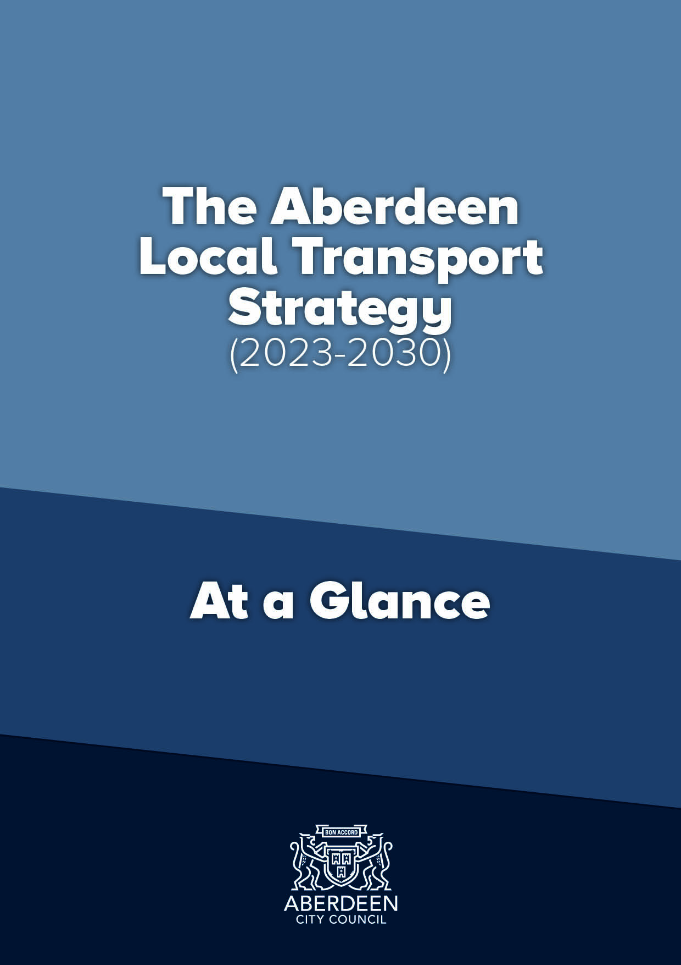
Draft Aberdeen Local Transport Strategy (2023-2030):
At a Glance

Foreword

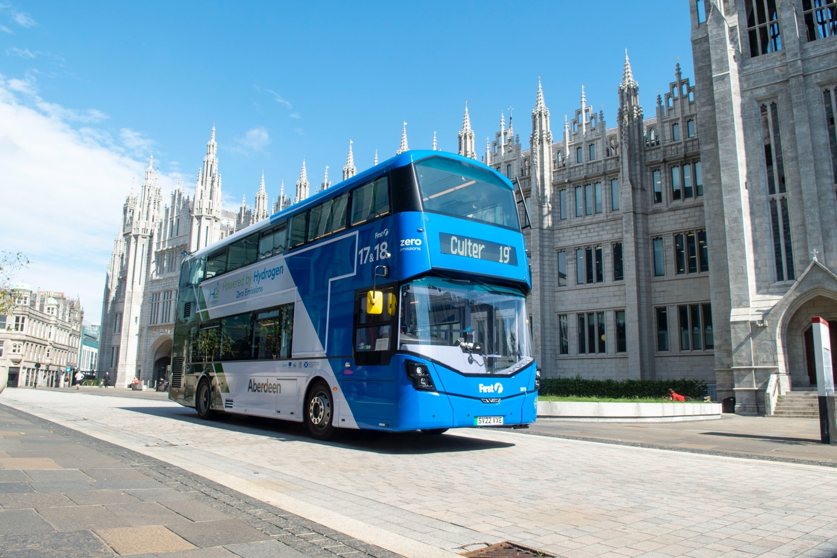
Public Realm Improvement Broad Street, Aberdeen

A successful city is one which attracts people to live, work and visit it. In the case of Aberdeen, its function as the regional centre for the North East of Scotland means that it serves not just a local population but a much wider area. People across the north east rely on Aberdeen and access facilities within the city for work, education, retail, leisure and healthcare. An effective transport system underpins this and is key in enabling the movement of people and goods and providing access to opportunities.

A Local Transport Strategy (LTS) is essential in making sure that the transport network is planned, developed and managed to make this possible. An LTS
also ensures that other policies, plans and strategies in the Council that rely on ease of mobility such as those around regeneration, economic growth, the environment, health and communities are able to be successfully realised. Ultimately, a successful transport network enables a high quality of life.

Councillor Ian Yuill
Aberdeen City Council
Co-leader

Since the previous Local Transport Strategy was adopted, the Aberdeen Western Peripheral Route (AWPR) has opened and the railway between Aberdeen and Inverurie improved. Both of these not only remove a lot of through traffic from Aberdeen but allow our city’s transport system to be reconfigured to allow better access for everyone. Although the private car will still have a key role to play in transporting people, it does not suit everyone. With an ageing population, the rising cost of living, around 16% of people in the city under the age of 16 and over 15% of households across the city without access to a car, ensuring people have user-friendly access to other modes of transport is very important.

Furthermore, configuring the transport network around the needs of the car driver has been shown to cause environmental problems, congestion and wastes a lot of space which could be used better, given over to people. Creating more walking, wheeling and cycling opportunities not only makes it easier for people to move around but has been proven to bring huge benefits to physical and mental health and to the health of a city’s economy.

Likewise, a successful public transport system is key to ensuring the majority of the population have access to transport and can move around easily. In 2020, the COVID-19 global pandemic had a massive impact on people’s lives but also saw a huge increase in walking and cycling, demonstrating that, if the conditions are right, people want to use these modes. In addition, it highlighted the key role that technology had in enabling people to continue
to work, access goods and services and, most importantly, stay in contact with one another. Sadly though, many people suffered mentally and physically by not being able to move around the same, demonstrating the importance of physical transport, both for health and social inclusion. It is therefore essential that the LTS enables a transport system that allows both the physical and the virtual aspects to work successfully.

The global climate and nature crisis continue to affect Aberdeen at local level, causing the Council to join local authorities across the world in declaring a Climate and Nature Emergency. The Council has already committed to working
with partners to deliver a just transition to net zero and plans to make Aberdeen a net-zero city by no later than 2045. The current administration want to bring this forward.

Aberdeen’s transition from an Energy City, built on Oil and Gas, to one built on renewables and the low carbon economy is also gathering pace as the city builds on the skills and knowledge amassed over several decades. Furthermore, like other cities, changing shopping habits have affected Aberdeen's city centre. Building on this, regeneration of the city,
especially in the city centre core with the City Centre and Beach Masterplans is well under way. Transport will have a huge part to play in realising all of this.

Nationally, by 2030, the Scottish Government has committed to a 20% reduction in car kilometres travelled, a 75% reduction in emissions and phasing out the need for new petrol and diesel cars and vans. There is also a local commitment to a reduction in proportion of journeys by car drivers in Aberdeen to less than 50% by 2030. To ensure it can work towards these
commitments, the Aberdeen LTS will align itself with these by covering the time period up to 2030. However, it also puts measures in place to realise the longer term goals beyond such as Net Zero by 2045.

In short, transport underpins everything that we are doing to ensure that Aberdeen, our city, is a successful place in the future and this LTS will be key in enabling us to make this happen.

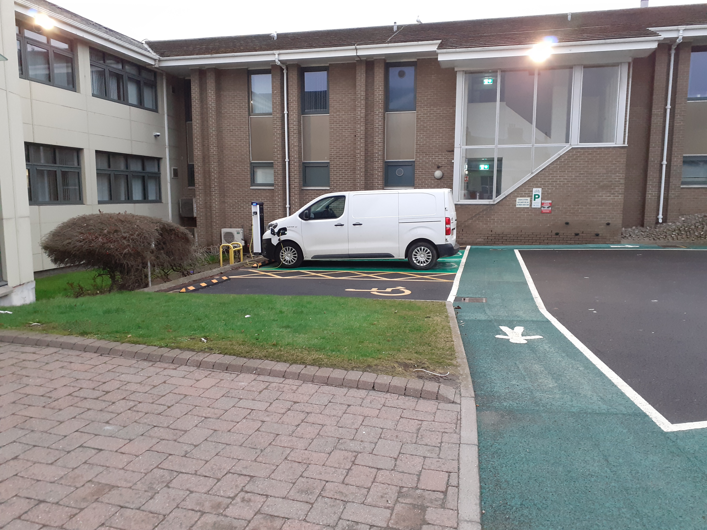
Marine Lab, Torry, Aberdeen
- What is a Local Transport Strategy?

A Local Transport Strategy (LTS) is a transport plan which looks at the
transport needs of a Council area. It includes a vision, objectives, policies and actions to meet those needs over a set period of time. To do this, a Local Transport Strategy considers transport’s relationship with wider plans such as those for communities, environment, land use, economy and health. Although the Aberdeen Local Transport Strategy focuses on Aberdeen City it also considers connections into Aberdeenshire, given the important role of Aberdeen to the wider region. The Strategy covers the period from 2023 – 2030, but will also include longer reaching outcomes towards 2045. This will provide a clear framework for more strategic decision making and investment.

The development of the Local Transport Strategy has followed a Scottish Transport Appraisal Guidance (STAG) based process to ensure a robust process has been evidenced.

- Key Drivers, Challenges and Opportunities

- Key Drivers

Climate and Environment – Adaptation and Mitigation
• Scottish national Net Zero Emissions targets.
• Scottish national commitment to a reduction of car km by 20% by 2030.
• Regional aim of 50:50 mode split between car and sustainable transport by 2040 with higher sustainable ratio in urban areas.
• Local aim of reduction in proportion of journeys by car drivers to less than 50% by 2030 in Aberdeen.
• Local aim of addressing the nature crisis by protecting/ managing 26% of Aberdeen’s area for nature by 2026.
• Local aim of addressing climate change by reducing Aberdeen’s carbon emissions by at least 61% by 2026 and adapting to the impacts of our changing climate.
• Declaration of a Climate and Nature Emergency in 2023.
• Local commitment to work with partners to deliver a just transition to net zero and plan to make Aberdeen a net-zero city by 2045 (Net Zero Routemap). There is an aspiration to bring this forward if possible.

Health
• Regional commitment to achieve air cleaner than World Health Organisation (WHO) standards by 2040 for transport emissions. Transport is the primary source of poor air quality in Scotland.
• Local commitment to improve the physical health and wellbeing of people in Aberdeen.
• Regional aim of zero fatalities on the North East Scotland road network by 2040.

Economy and Efficiency
• Local commitment that no one will suffer due to poverty in Aberdeen by 2026.
• Scottish national aim to make best use of the existing transport network before building new infrastructure.
• Requirement of Council, as Roads Authority, to maintain and manage the transport network.
• Regional aim to improve journey efficiencies to enhance connectivity.

Technology
• Scottish national commitment to phase out the need for petrol and diesel cars and vans by 2030.
• Global development of Mobility As A Service (MaaS) concept. (A service that enables users to plan, book, and pay for multiple types of mobility or transport services or trips and through one account).
• Improving IT technologies allow more information and services to be accessed virtually.
• Evidence that young people see phone and connectivity as main status symbol nowadays rather than car.

Placemaking
• Scottish national commitment to create 20 minute neighbourhoods.
• Locally, a 20% reduction in traffic needed to deliver Aberdeen City Centre Masterplan).
• Regional commitment to improve accessibility issues (physical access, financial access and geographic access) in North East Scotland.
• Scottish national aim to promote a positive ‘sense of place’ – design/materials/soft landscaping/maintenance.

B – Challenges
• People do not feel safe cycling in Aberdeen and feel there is a lack of cycling facilities on routes.
• Key destinations, such as Aberdeen city centre and the bus/ rail station need better walking, wheeling and cycling links.
• People, especially children, and even more so girls, are not getting enough of their recommended exercise nationally.
• Declining public transport patronage, exacerbated by COVID-19 restrictions nationally.
• Condition of roads, footways and pathways in Aberdeen.
• Enforcement of illegal parking and poor road user behaviour in Aberdeen.
• Greenhouse gas emissions plus noise and air pollution from transport nationally.
• Congestion in Aberdeen.
• Lack of public places to charge electric vehicles (EVs), especially for those who cannot charge at home in Aberdeen.
• Ageing population nationally.
• Transport inequalities nationally.
• Declining patronage of Aberdeen city centre.
• Mitigating the transport impact of new developments in Aberdeen.
• Meeting national, regional and local targets.
• Social isolation brought about by transport and access inequalities.
• Cost of public transport.
• Large numbers of households do not have access to a car so cannot rely on this as a means of getting around.

C – Opportunities
• Bus Partnership Fund – Multi-modal corridor studies being undertaken to identify opportunities for walking, wheeling, cycling and public transport and funding to develop the business case for Aberdeen Rapid Transit. The fund also offers a mechanism for delivery.
• Aberdeen Rapid Transit. (https://www.nestrans.org.uk/projects/Aberdeen-rapid-transit/)
• City Centre Masterplan refresh and Beach Masterplan.
• Scotland’s Fourth National Planning Framework (NPF4) recognises Aberdeen Harbour, Aberdeen Rapid Transit and national walking, wheeling and cycling network as National Developments.
• The second Scottish Strategic Transport Projects Review (STPR2) recognises Aberdeen Rapid Transit as a major opportunity for the North East along with Active Travel Freeways (segregated walking, wheeling and cycling routes connecting urban centres to outlying areas and major destinations) and cycle parking hubs, rail improvements between Aberdeen and the central belt and identifies improved port and freight opportunities.
• Partnership working to share ideas and deliver projects.
• Changes to work related travel brought about by COVID-19 – more people working from home more often.
• City centre Low Emission Zone.
• Locking in strategic improvements – road and rail. Aberdeen Western Peripheral Route (AWPR) provides route for strategic traffic round the city to allow more space to be given to more sustainable transport modes in city. Double tracking of railway line to north-west of Aberdeen creates more capacity to facilitate more rail improvements.
• Improved digital capabilities.
• External Funding opportunities from National,
Regional and Local bodies are available to
facilitate improvements to transport network
without being wholly reliant on Council funding.
• New Regional Transport Strategy, Nestrans 2040, now adopted and can inform new LTS.
• Transport (Scotland) Act 2019, provides new powers and opportunities for Local Authorities around bus services, parking, enforcement, low emission zones, roadworks, smart ticketing and workplace parking licensing.

3. The Overarching Strategy

Vision

Taking account of the context outlined in the previous section, the Vision for this Local Transport Strategy is for Aberdeen to have by 2030:
“A safe, resilient, high-quality transport system that is accessible to all, supports a vibrant economy, facilitates healthy living and minimises the impact on our environment. Aberdeen’s transport network should encourage people to live in, work in and visit our city.”

Objectives

To best deliver the vision, the eight Transport Planning Objectives (TPOs), set as part of the STAG-based appraisal process, were carried forward into the main strategy. These are listed below in Figure 1;

Figure 1 – Objectives
TPO1 – Climate and Environment – Reduce the negative impact of transport on the climate and the environment in Aberdeen.
TPO2 – Health – Improve transport opportunities in Aberdeen that help enable and promote healthy lives and give access to healthcare.
TPO3 – Safety – Improve the safety of the Aberdeen transport network and reduce safety issues for users.
TPO4 – Economy – Ensure more efficient movement of people and goods across, into and from both Aberdeen city and the whole region.
TPO5 – Accessibility/ inclusivity/ user-friendly – Improve the user-friendliness of the Aberdeen transport network, making it more accessible and inclusive.
TPO6 – Resilience – Ensure the Aberdeen transport network is more resilient and can react to unplanned circumstances and extreme weather.
TPO7 – Technology – Ensure Aberdeen has a transport network that can better adapt to changes in technology and capitalises on existing technological opportunities.
TP08 – Modal shift – Reduce the need to travel and reduce dependency on the private car in Aberdeen.

The Outcomes

In light of the Key Drivers, and further details which stemmed from the review of key Policies, Plans and Strategies at National, Regional and Local level, the following outcomes have been identified for this LTS. As many of the targets in the policies, plans and strategies go up to 2030, if seems sensible to align the LTS with these. Therefore, rather spanning the traditional 5 year period, it is proposed to align this LTS with these and ensure it covers the extended time period to 2030.

However, given that there are many targets in these key documents that go beyond 2030, the LTS should demonstrate that what it sets out to do up to 2030, is supporting a future beyond 2030. Therefore, the outcomes have been split into two.

• Those which should be realised in the lifespan of this new LTS (up to 2030).
• Those which will go beyond it.

Outcomes up to 2030

The LTS should achieve the following outcomes, shown in Figure 13 below, by 2030.

Figure 2 – Outcomes for lifespan of LTS (2023-2030)
1. 1. Reduction in number of journeys by car drivers in Aberdeen to less than 50% by 2030. | 8. 8. Improved journey time reliability for all modes in Aberdeen.
2. 2. A reduction in car km travelled in Aberdeen by 20% compared with 2019 baseline. | 9. 9. Improved mental and physical health of the residents of Aberdeen and improved access to healthcare.
- 3. Reduced PM10s and NOx emissions from transport and removal of Air  - Quality Management Areas in Aberdeen. | 10.10. Improved accessibility to transport in Aberdeen for all.
4. 4. A 75% reduction in greenhouse gases from transport in Aberdeen compared with the 1990/5 baseline. | 11.11. Improved interchange opportunities between modes in Aberdeen.
5. 5. 20% of the total cars and vans in Aberdeen being zero emission. | 12. 12. Improved information about the Aberdeen transport network being available to users and planners.
6. 6. 50% reduction in adults killed and seriously injured and 60% reduction in children killed or seriously injured using the transport network. | 13. 13. A transport network which is able to benefit from improvements in technology for Aberdeen.
7. 7. A more resilient transport network for Aberdeen. | 14.14. A transport network which is well maintained for Aberdeen.

Outcomes beyond 2030

These should contribute towards the following longer-term outcomes, shown in Figure 14, by 2045 (Beyond the life of this LTS).

Figure 3 – Longer-term outcomes

A. A. More journeys made by active travel and public transport together than by car in Aberdeen. | I. I. Zero fatalities on the Aberdeen road network and an even greater feeling of safety for users of the transport network.
B. B. A reduction in car km travelled in Aberdeen beyond 20% compared with the 2019 baseline. | J.J. Improvements in technology making the Aberdeen transport system more efficient and user friendly.
C. C. Air quality that is cleaner than WHO standards for emissions from transport in Aberdeen. | K. K. Further improved journey time reliability for all modes in Aberdeen.
D. D. Work with partners to deliver a just transition to net zero and plan to make Aberdeen a net-zero city by no later than 2045, and earlier if that is possible. | L. L. Further improved interchange opportunities between modes in Aberdeen.
E. E. All new cars, buses and vans being zero emission at tailpipe in Aberdeen. | M.M. Further improved mental and physical health of the residents of Aberdeen and further improved access to healthcare.
F. F. All users able to access the Aberdeen transport network and with minimal disruption. | N.N. Further improved information about the Aberdeen transport network being available to users and planners.
G.G. People able to access key facilities in Aberdeen from their home by sustainable and active travel in a total journey time of 20 minutes. | OO. A transport network which is resilient and can cope with external disruptors.
H. H. A traffic reduction exceeding 20% in Aberdeen city centre compared with 2015 baseline. | P.P. Further funding and rollout of maintenance across the transport network.

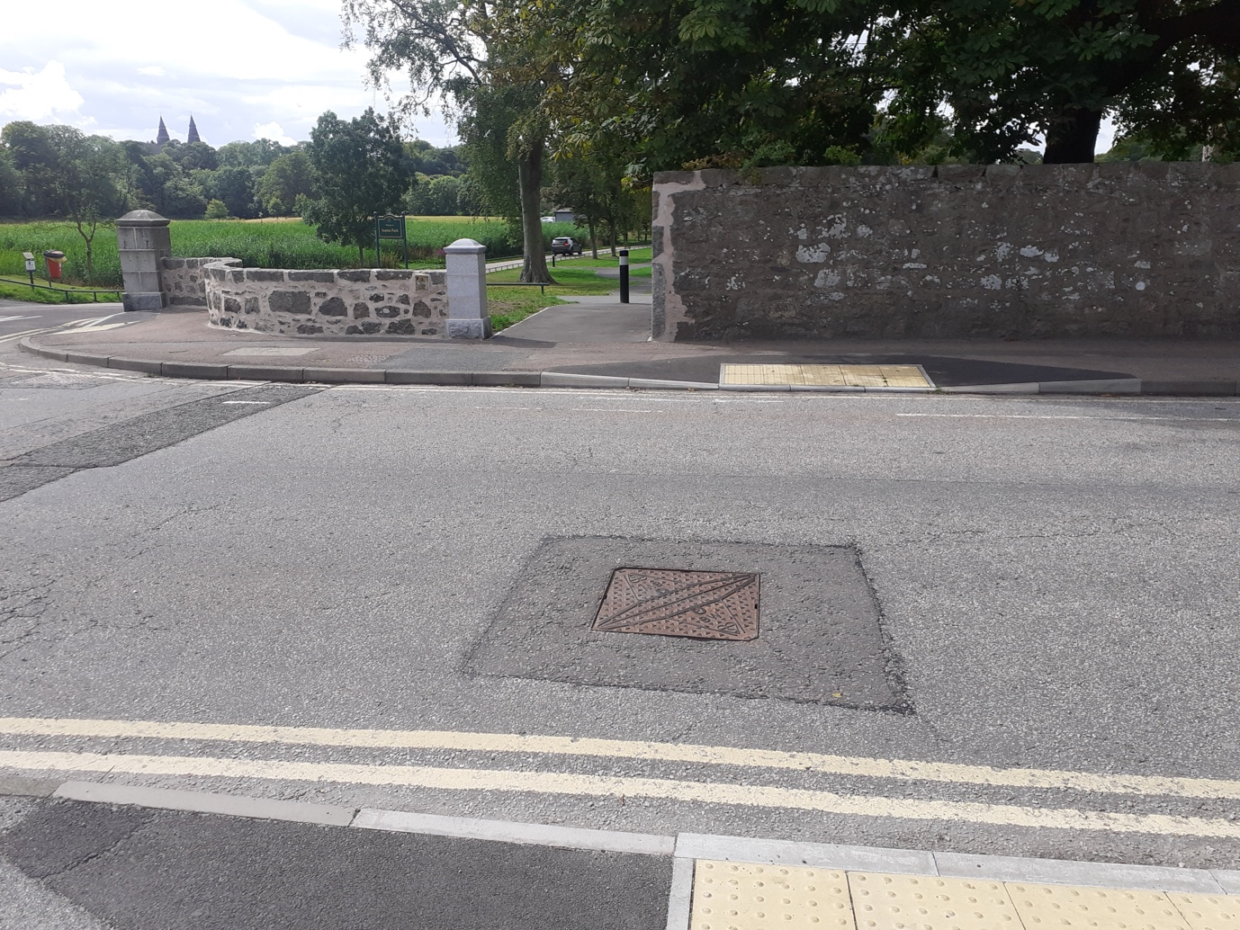
Seaton Park Entrance

Outputs
These outcomes would be achieved by focusing on the following outputs (actual things delivered), shown in Figure 15.

Figure 4 – Outputs

More EV charging and hydrogen refuelling infrastructure and supporting measures in Aberdeen. | More high quality active travel infrastructure in Aberdeen.
An Aberdeen Parking Framework. | Maintenance of existing facilities in Aberdeen.
Improved sustainable transport links to, from and within Aberdeen city centre. | Aberdeen Rapid Transit and faster, more frequent and more reliable public transport options.
Safety improvements in Aberdeen. | More Car Club cars, more Car Club locations and more people signed up as Car Club members.
Mobility As A Service (MAAS) development in Aberdeen. | Development and delivery of the Aberdeen city centre and Beach masterplan.
Behaviour Change schemes and campaigns (education, information, awareness raising) in Aberdeen. | More hire bikes, locations and more people signed up as bike hire members. More bike refurbishment schemes.
Enforcement of the Aberdeen Low Emission Zone (LEZ). | Reallocation of road space in Aberdeen.
Climate adaption measures built into new transport infrastructure. | More interchange points between modes of transport.

- Topic areas and Policies for the Local Transport Strategy
These are listed below.
POLICY 1: CLIMATE CHANGE MITIGATION AND ADAPTION
To contribute to Aberdeen’s target of net zero carbon emissions targets by 2045, or earlier, and develop and promote climate resilient infrastructure and movement.
POLICY 2: AIR QUALITY
Reduce the contribution of transport to poor air quality in Aberdeen and have all air quality management areas revoked.
POLICY 3: NOISE QUALITY
Reduce levels of noise from the transport network in Aberdeen.
POLICY 4: REDUCING THE NEED TO TRAVEL
Work with partners to create opportunities which allow people to access facilities, workplaces and information in Aberdeen without the need to travel.
POLICY 5: WALKING AND WHEELING
To continue to enhance Aberdeen’s walking and wheeling environment and increase the number of people walking and wheeling, both as a means of travel and for recreation, in recognition of the significant health and environmental benefits they can bring.
POLICY 6: CYCLING
To continue to enhance Aberdeen’s cycling environment, provide further opportunities to access it and increase levels of cycling in the city, both as a means of travel and for recreation, so that cycling becomes an everyday, safe and attractive choice for all ages and abilities of cyclist.
POLICY 7: BUS
To work with partners and, through the North East Scotland Bus Alliance, to increase public transport patronage in Aberdeen by taking forward measures to make bus travel a more attractive option to all users with speed, reliability cost and convenience benefits to make people choose it over the car.
POLICY 8: ABERDEEN RAPID TRANSIT
To work with partners including NESTRANS, Transport Scotland and the North East Scotland Bus Alliance to develop an integrated Mass Transit ‘step-change’ public transport solution offering quick, attractive access to, from and across the city.
POLICY 9: PARK AND RIDE
Work with partners to ensure that Park and Ride sites provide a range of attractive onward journey options, incentivise people to park on the edge of the city and continue their journey onwards by a more sustainable means and form part of the wider parking strategy in the city.
POLICY 10: STRATEGIC RAIL NETWORK
To work with partners to increase opportunities for rail travel to, from and within Aberdeen and to enable sustainable journeys to and from stations.
POLICY 11: COMMUNITY AND DEMAND RESPONSIVE TRANSPORT (DRT)
To continue to work with Partners to deliver Demand Responsive Transport in Aberdeen for the benefit of the public.
POLICY 12: COACHES
To ensure that coach travel remains an attractive and accessible alternative to car travel for those accessing the city, both for business and leisure.
POLICY 13: TAXIS AND PRIVATE HIRE VEHICLES
To work in partnership with the Aberdeen taxi and private hire car trade to ensure an adequate supply of safe, clean, low-carbon and accessible vehicles and pick-up points.
POLICY 14: CAR SHARING
Continue to promote car sharing as a means of reducing emissions from transport and saving people money, and to create and support opportunities to encourage people to do so.
POLICY 15: CAR CLUBS
Continue to encourage car clubs in Aberdeen as a means of giving people access to vehicles without needing to own one and to continue to work with the contracted operator in Aberdeen to expand and further develop the car club offering in the city.
POLICY 16: POWERED TWO-WHEELERS
To improve conditions for powered two wheeler riders on Aberdeen’s roads, particularly in terms of rider safety and encourage a shift to low carbon vehicles.
POLICY 17: ZERO EMISSION VEHICLES
In line with national targets, to lead by example in Aberdeen and to encourage a shift to vehicles which are zero emission at the tailpipe and work with partners to ensure that users have good access to a growing network of high quality refuelling facilities.
POLICY 18: PARKING
To develop a parking regime for Aberdeen that supports the principle of the city centre functioning as a destination, encourages people to access and move around the city sustainably, facilitates interchange between modes, enhances the economic vitality of the city centre and district shopping centres and still supports people with restricted mobility in accessing facilities.
POLICY 19: DEMAND MANAGEMENT
In addition to parking and traffic management, investigate, in partnership with Aberdeenshire Council and Nestrans, the implications of introducing other demand management methods to Aberdeen.
POLICY 20: ROAD IMPROVEMENTS
In line with the National Sustainable Investment Hierarchy, make better use of existing capacity ahead of constructing new but, where new infrastructure is required, ensure it both enables and incorporates sustainable transport and biodiversity options.
POLICY 21: TRUNK ROAD NETWORK
Support improvements to the trunk road network, allowing the safe movement of people and goods to, from and around Aberdeen.
POLICY 22: ABERDEEN WESTERN PERIPHERAL ROUTE (AWPR)
To continue to “lock in” the benefits of the AWPR by encouraging strategic traffic to route from and to it, creating more space for sustainable travel on Aberdeen routes and allowing the city centre to function as a destination rather than a through route.
POLICY 23: SHIPPING AND FERRY SERVICES
To work with partners to ensure that Aberdeen's harbours remain world class, able to grow their national and international trade. Ensure they are well linked to the city and strategic transport network for all users and continue to attract freight, engineering and cruise traffic as well as being the main port of call in Scotland for the Northern Isles ferry services with appropriate access for all users.
POLICY 24: AIR SERVICES
To support the future growth and improvement of Aberdeen International Airport, including surface access, in order to support the economic strength of the region and ensure continued connectivity to key businesses and leisure destinations.
POLICY 25: FREIGHT
To work with partners to ensure the efficient movement of freight to, from and within Aberdeen and the wider North East of Scotland across different modes.
POLICY 26: TRAVEL AWARENESS AND INFORMATION
With partners, continue to ensure that there is adequate information available, via a range of means, to users of the transport network to help them make more informed transport choices. Continue to gather information from users to ensure that this best informs improvements to the transport network.
POLICY 27: LAND USE PLANNING
To promote and enable development in Aberdeen that reduces the need to travel, minimises reliance on the private car, provides opportunities for sustainable travel and facilitates and encourages walking, wheeling and cycling for everyday trips.
POLICY 28: TRAVEL PLANS
To ensure that the transport impact of existing and new developments in Aberdeen are minimised by requiring workplaces, schools and developers to prepare Travel Plans and, where appropriate, Travel Packs for all sites in the city.
POLICY 29: CITY CENTRE AND BEACH
Ensure that the transport network enables Aberdeen city centre and Beach to function as high-quality, accessible destinations that people wish to live in, visit, use and spend time in. Promote the movement of people ahead of vehicles and ensure that people are encouraged to move between the two areas using sustainable transport.
POLICY 30: BIODIVERSITY AND GREEN SPACE
Improve accessibility to open spaces in Aberdeen and contribute towards the development of the green space network through implementation of core paths and appropriate mitigation and enhancement as part of transport scheme delivery.
POLICY 31: TRAFFIC MANAGEMENT AND ROAD SAFETY
To create a transport network in Aberdeen where sustainable transport movements are actively encouraged and facilitated, there is a 50% reduction in adults killed and seriously injured and a 60% reduction in children killed and seriously injured.
POLICY 32: ENFORCEMENT
To ensure the Council, and partners, manage and enforce the Aberdeen transport network to ensure safety and effectiveness for the benefit of all users.
POLICY 33: SCHOOL TRAVEL AND YOUNG PEOPLE
To ensure that all young people in Aberdeen have the opportunity to travel to school by active and/or sustainable modes of transport. They should be equipped with the necessary knowledge, skills and infrastructure to allow them to undertake local journeys safely and independently and that their parents and guardians are able to support them.
POLICY 34: NEW TECHNOLOGIES AND INITIATIVES
Ensure that the Council remains aware of new and developing technologies, initiatives and options which could benefit the Aberdeen transport network and, where appropriate, explore opportunities to trial these.
POLICY 35: INTELLIGENT TRANSPORT SYSTEMS
To expand the use of Intelligent Transport Systems in Aberdeen in order to improve the efficiency and understanding of the transport network in the city.
POLICY 36: ROAD, CARRIAGEWAY AND FOOTWAY MAINTENANCE
To improve the condition of Aberdeen’s road, footway and cycle networks and ensure that any improvements or new infrastructure are constructed so as to minimise future maintenance.
POLICY 37: WINTER MAINTENANCE
To ensure the safe movement of users of Aberdeen’s transport network on carriageways, footpaths, cycle paths and pedestrian precincts and to minimise delays caused by adverse winter weather.
POLICY 38: STRUCTURES
To ensure that all road related structures in Aberdeen that the Council is responsible for are managed and maintained, safe and fit for purpose and constructed to minimise future maintenance implications.
POLICY 39: RESILIENCE
To ensure that the Aberdeen transport network is as resilient as possible in dealing with unforeseen circumstances, such as accidents, extreme weather, works and other large disruptions.
POLICY 40: LIGHTING
Ensure that Aberdeen’s lighting infrastructure remains fit for purpose and that appropriate lighting solutions are found which best fit the circumstances.

- Monitoring
In order to ensure that progress on the LTS is properly monitored, a monitoring plan has been devised. This looks at the objectives and outcomes set for the LTS and identifies the sources that will be used to monitor them.
The full details can be found in Appendix D – Monitoring for LTS Objectives and Outcomes.
POLICY 41: MONITORING
Ensure that the objectives and outcomes of the Aberdeen LTS are monitored with suitable sources and indicators.
and indicators.

- Next Steps
The draft Aberdeen Local Transport Strategy (2023-2030), Appendices and Supporting Documents will be available for public and stakeholder consultation for 8 weeks in Autumn 2023.
Following this consultation and any subsequent feedback, work will then take place to turn the draft Local Transport Strategy (2023-2030) into a final version. A document outlining the consultation feedback and how it has been incorporated into the final document will form an appendix to the final LTS. It is intended to report the final LTS to the relevant Council committee for adoption in Spring 2024.
Following the approval of the LTS (2023-2030) by Council Committee, the next stage will be to create the accompanying LTS Delivery Plan. This will look at;
- The Actions that the LTS has set out to achieve.
- The timeline for achieving them.
- The relevant teams or resources which will
be required to carry these out.
- The cost of doing so.
- What funding already exists.
- What has already been undertaken.
It is intended that this will be reported to the relevant Council committee in 2024.

- More details
The full draft Aberdeen Local Transport Strategy (2023-2030) document can be found here https://www.aberdeencity.gov.uk/services/roads-transport-and-parking/local-transport-strategy

