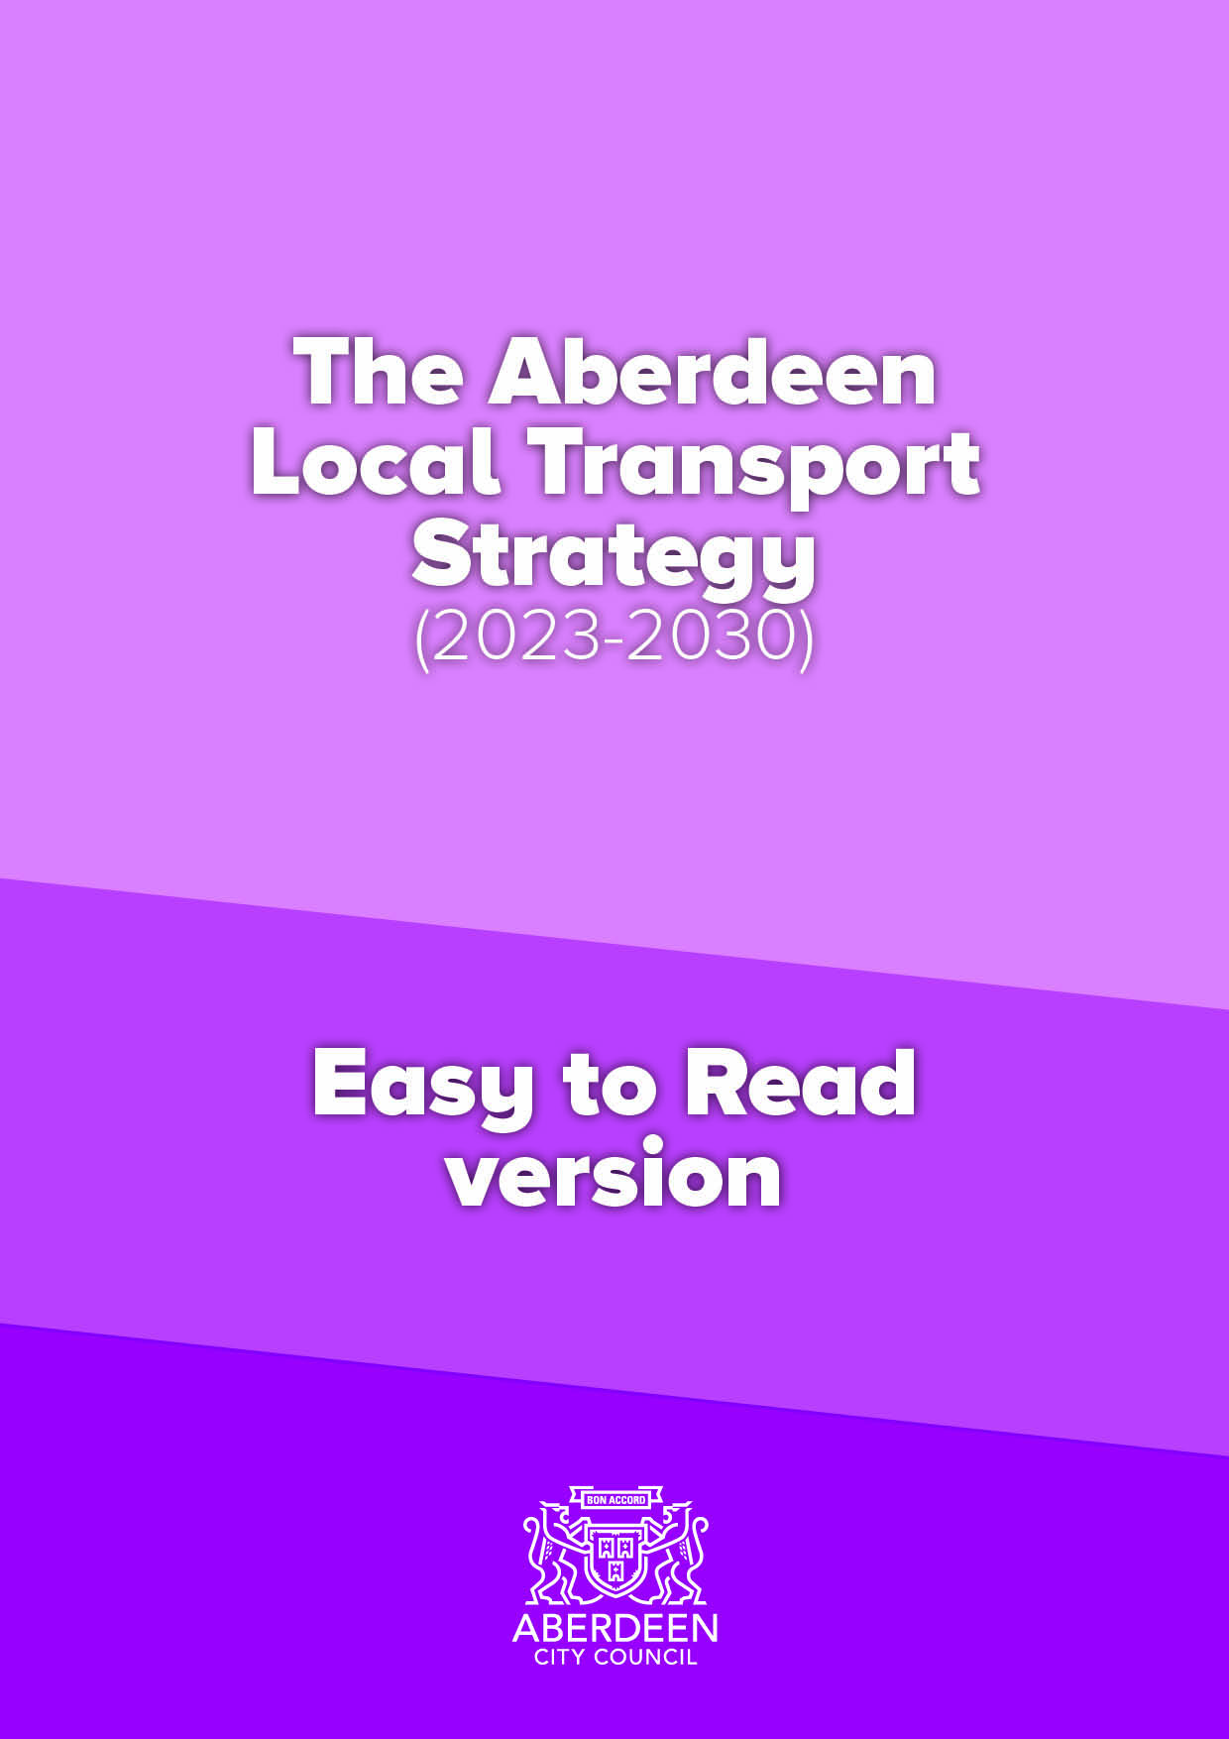

Draft Aberdeen Local Transport Strategy (2023-2030)
Easy to Read version

What is a Local Transport Strategy?

A Local Transport Strategy (LTS) is a transport plan which looks at the
transport needs of a Council area. It includes a vision, objectives, policies and actions to meet those needs over a set period of time. To do this, a Local Transport Strategy considers transport’s relationship with wider plans such as those for communities, environment, land use, economy and health. Although the Aberdeen Local Transport Strategy Focuses on Aberdeen City it also considers connections into Aberdeenshire, given the important role of Aberdeen to the wider region. The Strategy covers the period from 2023 – 2030 but will also include longer reaching outcomes towards 2045. This will provide a clear framework for more strategic decision making and investment.

The strategy recognises that a transport network which is dependent on private cars is not in the best interests of residents, commuters and visitors to the city. This is not accessible to all, can lead to congestion and health issues, does not make best use of space and can cause environmental problems. Therefore, the importance of giving people choice and making it easier to get around by other modes of transport will be key to a successful city and better movement of goods and people.

The Vision, Objectives, Outputs and Outcomes for the Local Transport Strategy are outlined below.

Vision

A safe, resilient, high-quality transport system that is accessible to all, supports a vibrant economy, facilitates healthy living and minimises the impact on our environment. Aberdeen's transport network should encourage people to live in, work in and visit our city.

Objectives

TPO1 – Climate and Environment – Reduce the negative impact of transport on the climate and the environment in Aberdeen.
TPO2 – Health – Improve transport opportunities in Aberdeen that help enable and promote healthy lives and give access to healthcare.
TPO3 – Safety – Improve the safety of the Aberdeen transport network and reduce safety issues for users.
TPO4 – Economy – Ensure more efficient movement of people and goods across, into and from both Aberdeen city and the whole region.
TPO5 – Accessibility/ inclusivity/ user-friendly – Improve the user-friendliness of the Aberdeen transport network, making it more accessible and inclusive.
TPO6 – Resilience – Ensure the Aberdeen transport network is more resilient and can react to unplanned circumstances and extreme weather.
TPO7 – Technology – Ensure Aberdeen has a transport network that can better adapt to changes in technology and capitalises on existing technological opportunities.
TP08 – Modal shift – Reduce the need to travel and reduce dependency on the private car in Aberdeen.

Outcomes up to 2030
1. Reduction in proportion of journeys by car drivers in Aberdeen to less than 50% by 2030. | 8. Improved journey time reliability for all modes in Aberdeen.
2. A reduction in car km travelled in Aberdeen by 20% compared with 2015 baseline. | 9. Improved mental and physical health of the residents of Aberdeen and improved access to healthcare.
3. Reduce PM10s and NOx to enable the removal of Air Quality Management Areas in Aberdeen. | 10. Improved accessibility to transport in Aberdeen for all.
4. A 75% reduction in greenhouse gases from transport in Aberdeen compared with 1990/5 baseline. | 11. Improved interchange opportunities between modes in Aberdeen.
5. 20% of the total cars and vans in Aberdeen being "zero emission". | 12. Improved information about the Aberdeen transport network being available to users and planners.
6. 50% reduction in adults killed and seriously injured and 60% reduction in children killed or seriously injured using the transport network. | 13. A transport network which is able to benefit from improvements in technology for Aberdeen.
7. A more resilient transport network for Aberdeen. | 14. A transport network which is well maintained for Aberdeen.

Outcomes beyond 2030
A. More journeys made by active travel and public transport together than by car in Aberdeen. | I. Zero fatalities on the Aberdeen road network and an even greater feeling of safety for users of the transport network.
B. A reduction in car km travelled in Aberdeen beyond 20% compared with a 2019 baseline. | J. Improvements in technology making the Aberdeen transport system more efficient and user friendly.
C Air quality that is cleaner than WHO standards for emissions from transport in Aberdeen. | K. Further improved journey time reliability for all modes in Aberdeen.
D. Work with partners to deliver a just transition to net zero and plan to make Aberdeen a net-zero city by no later than 2045, and earlier if that is possible. | L. Further improved interchange opportunities between modes in Aberdeen.
E. All new cars, buses and vans being zero emission at tailpipe in Aberdeen. | M. Further improved mental and physical health of the residents of Aberdeen and further improved access to healthcare.
F. All users able to access the transport network and with minimal disruption. | N. Further improved information about the Aberdeen transport network being available to users and planners.
G. People able to access key facilities  in Aberdeen from their home by  sustainable and active travel in a total journey time of 20 minutes. | O. Further funding and rollout of maintenance across the transport network.
H. A traffic reduction exceeding 20% in Aberdeen city centre against a 2015 baseline. | P. A transport network which is  resilient and can cope with external  Disruptors.

Outputs
More high quality active travel infrastructure in Aberdeen. | More EV charging and hydrogen refuelling Infrastructure and supporting measures in Aberdeen.
Maintenance of existing facilities  in Aberdeen. | An Aberdeen Parking Framework.
Aberdeen Rapid Transit and faster, more frequent and more reliable public transport options. | Improved sustainable transport links to, from and within Aberdeen city centre.
More Car Club cars, more Car Club locations and more people signed up as Car Club members. | Mobility As A Service (MAAS) development in Aberdeen.
Development and delivery of the Aberdeen city centre and Beach masterplan. | An Aberdeen Parking Framework.
More hire bikes, locations and more people signed up as bike hire members. More bike refurbishment schemes. | Behaviour Change schemes and campaigns (education, information, awareness raising) in Aberdeen.
Reallocation of road space in Aberdeen. | Enforcement of the Low Emission Zone (LEZ).
More interchange points between modes of transport. | Climate adaption measures built into new transport Infrastructure.

Monitoring

The Local Transport Strategy progress will be monitored every year with performance measured against the Objectives and Outcomes.

More details

The full draft_ Aberdeen Local Transport Strategy (2023-2030) document can be found here h\ps://www.aberdeencity.gov.uk/services/roads-transport-and-parking/local-transport-strategy

